## **C:\Users\Tzedric\AppData\Local\Temp\ksohtml8884\wps1.pngE-Mayor: Scheduling Appointment System**

A Capstone Project

Presented to the

Faculty of College of Computer Studies

Laguna State Polytechnic University

Sta. Cruz Campus

In Partial Fulfillment of the requirements for the Degree

**BACHELOR OF SCIENCE IN INFORMATION TECHNOLOGY**

**By:**

**SANTOS, TZEDRIC KRISTIANN V.**

Under the supervision of:

**MIA V. VILLARICA, D.I.T**.

**FEB 2021**

**VISION:** The Laguna State Polytechnic University is a center of sustainable development initiatives transforming lives and communities

**MISSION:** LSPU provides quality education through responsive instruction, distinctive research, and sustainable extension and production services for improved quality of life.

**QUALITY POLICY:** LSPU delivers quality education through responsive instruction, distinctive research, sustainable extension, and production services. Thus, we are committed with continual improvement to meet applicable requirements to provide quality, efficient and effective services to the university stakeholders' highest level of satisfaction through an excellent management system imbued with utmost integrity, professionalism and innovation.

**Goals of the College:** The College of computer studies aims to develop quality competitive graduates equipped with knowledge, skills and values necessary for information technology education program in undertaking instruction, extension and production.

**Objectives of BSIT Program**

**Instruction**

1. To expose students to globally competitive it atmosphere.
2. To develop locally and globally competitive graduates with desirable work values and attitudes.
3. To initiate creative and innovative professional enhancement among instructors an student through skills and training, on-the-job training industry.

**Research and Development**

1. Strengthen competencies of both instructors and students in field of research that will serve us a basis for technological problem-solving.
2. Conduct information technology survey, interview an feasibility studies to meet the demands of the changing world through information technologies and processes.
3. Produce IT researchers and researchers to serve as a self-generating critical mass of human resources for research and development in formation technology area.

**Extensions**

1. Conduct outreached program such as basic and advanced computer literacy program and the like.
2. Create training plans and information technology package to supply the needs of the community.
3. Provides assistance for project development.

**Production**

1. Produce information systems and technologies that can be used as income generating project of the college.
2. Construct improvised and innovative teaching materials, tools and equipment

Republic of the Philippines

Laguna State Polytechnic University

Province of Laguna

**COLLEGE OF COMPUTER STUDIES**

**APPROVAL SHEET**

This Capstone Project entitled “**E-Mayor Scheduling System**” prepared and submitted by Tzedric Kristiann V. Santos in partial fulfillment of the requirements for the degree Bachelor of Science in Information Technology is hereby recommended for approval and acceptance.

Date **MIA V. VILLARICA, D.I.T**

**Adviser**

APPROVED by the Committee on Final Oral Examination with a grade of ___on _______.

**MARK P. BERNARDINO MSCS ALLIANA M. ABLAN**

Specialization Expert Technical Editor

**RINA J. ARCIGAL, Ed.D CAEZAR D. PAMIN Ph.D** Statistician Language Critic

**REYNALEN C. JUSTO, MM-ITM, LPT**

Chairman

===============================================================

ACCEPTED and APPROVED in partial fulfillment of the requirements in Bachelor of Science in Information Technology.

Date **REYNALEN C. JUSTO, MM-ITM, LPT**

Associate Dean, CCS

Research Contribution Number **RINA J. ARCIGAL, Ed. D**

Chairperson, Research and Development

**ACKNOWLEDGEMENT**

The researcher would like to extend their sincerest gratitude to the following individuals who helped them to make this research possible.

To the **LAGUNA STATE POLYTECHNIC UNIVERSITY** – our beloved Alma Mater, for providing the right tools that helped in our career advancement as a Bachelor of Science in Information Technology graduates; To the Associate Dean of the College of Computer Studies **REYNALEN C. JUSTO, MM-ITM**, for sharing her technical expertise, advices, comments and suggestions;

To my research adviser, **MIA V. VILLARICA, D.I.T**, for her undying love, continuous support, patience, effort, and immense knowledge that she had given me throughout the development of the study; To my specialization expert, **MARK P. BERNARDINO, MSCS**, for sharing his knowledge, advices and helping the researchers to produce the intended project output;

To my technical editor, **ALLIANA M. MIRANDA-ABLAN**, for the patience and guidance she had given to the researchers in checking this manuscript; To my statistician, **RINA J. ARCIGAL, Ed. D** my statistician for helping the researchers to get the right statistical treatment of data. To my language critic, **CAEZAR D. PAMIN Ph. D** for her efforts as my grammarian.

To my client, **THE MAYORS OFFICE OF THE STA.CRUZ LAGUNA MUNICIPALITY,** for giving their time and effort as well as sharing their insights regarding the system during the development stage of this research; To the **BS INFORMATION TECHNOLOGY BATCH 2021**, my classmates and friends, for their endless support, genuine help and motivation; My **FAMILY**, for giving us their unconditional love, support and encouragements from the beginning till the end; Above all to our **GOD ALMIGHTY**, for giving the life, countless blessings, intellectual guidance, strength, confidence and wisdom for the success of the study.

*T.K.V.S*

**ABSTRACT**

Current technology, mostly contributes to the advancement of entertainment like games and gadgets; and services in business, hotel, banks, restaurants, and hospitals. E-Mayor is a cross platform based application that helps mediate between two parties mainly the Mayors’ Office and the people of Sta. Cruz Laguna. The study aims to demolish their current process of people needing to physically go to the Office in order to just request meeting only for him to be declined because of the busy schedule of the Mayor. To lessen the use of paper trails in which it can be misplaced, a fire hazard and a hassle to store if it piles up. Upon developing the system, the researcher used cross platform based type of application in which the user can access the system in both android phone and laptop also, the prototyping model was used which helps the researchers to produce the software in rapid succession by using enhancing the system with each review.

To measure the user’s acceptance towards the developed systems, the researchers utilizes questionnaires based on the Technology Acceptance Model. A total of 63 respondents including persons with occupations that will benefit the developed system, the Secretary of the mayor and secretaries of other offices have answered the questionnaires, results have shown that the system is highly accepted by the users. Also, in order to test the functionality of the system, the researchers adopted the black box testing in which IT Experts was invited to join and test the developed system.

***Keywords:*** *E- Government, descriptive research, Data collection method, Black box testing, Test case questionnaire, TAM questionnaire.*

**TABLE OF CONTENTS**

**Preliminaries Page**

Title Page i

Vision, Mission, Quality Policy, Goals and Objectivesii

Approval Sheetiv

Acknowledgements v

Abstractvii

Table of Contentsviii

List of Tablesx

List of Figuresxi

List of Appendicesxii

Operational Termsxiii

Technical Termsxiv

**Chapter**

1. **INTRODUCTION AND ITS BACKGROUND**

Project Context3

Research Objective5

Conceptual Framework6

Project Purpose7

Scope and Limitation8

1. **REVIEW OF RELATED LITERATURE AND STUDIES**

Impact of E-Government9

Needs of E-Government to Succeed15

Difficulties in Implementing E-Government20

E-Mayor Software Development 22

Appointment Booking26

Management Information System SMS with Notification35

Record Management System39

Research Design43

System Development Testing and Evaluation44

Synthesis46

1. **RESEARCH METHODOLOGY**

Research Design48

Population of the Study50

Sampling Design51

Data Collection Method53

Statistical Treatment54

Software Methodology Model56

Testing and Evaluation Procedure57

1. **RESULTS AND DISCUSSION**

Research Objective No. 168

Research Objective No. 271

Research Objective No. 381

1. **SUMMARY, CONCLUSION AND RECOMMENDATION**

Summary90

Conclusion91

Recommendation92

Bibliography94

**LIST OF TABLE**

**Table Page**

1 Respondents of the Study50

2 Occupation of the Testers51

3 Likert Scale55

4 Testing Questionnaire Admin user Accept/Reject (Mobile)58

5 Testing Questionnaire End User Requesting Appointment (Website)60

6 Testing Questionnaire Admin User Accept/Reject (Website)61

7 Testing Questionnaire Admin User Manual Input Schedule (Website)63

8 Black box Testing Feedback of the IT Experts76

9 Black box Testing Admin User Accept/Reject (Mobile)76

10 Black box Testing End User Request Appointment (Website))77

11 Black box Testing Admin User Accept/Reject (Website)78

12 Black box Testing Admin User Manual Input Schedule (Website)81

13 Evaluation Result - Quality Factor84

14 Evaluation Result - Perceived Ease of Use85

15 Evaluation Result - Perceived Usefulness86

16 Evaluation Result - Attitude Towards87

17 Evaluation Result - Behavioral Intentions to Use88

18 Evaluation Result - Experience88

19 Overall Mean Result89

**LIST OF FIGURES**

**Figure Page**

1 Conceptual Framework7

2 Prototyping Model56

3 Black Box Testing57

4 ISO/IEC 201510 Software Quality Metrics65

5 Technology Acceptance Model (TAM) 66

6 Register Form71

7 Calendar71

8 Login Interface71

9 Demographics of E-Mayor Age Bracket82

10 Demographics of E-Mayor Barangay Bracket83

11 Demographics of E-Mayor Educational Attainment Bracket83

12 Demographics of E-Mayor Computer Literacy Bracket83

**LIST OF APPENDICES**

**A. TECHNICAL BACKGROUND**

Process Flowcharts

Use Case Diagram

System Context Diagram

Data Flow Diagrams

Data Dictionary

Hierarchical Input Process Output Model

Project Schedule

Hardware and Software Resources

Input / Output / Reports Screen Shots

Testing and Evaluation Instruction

Implementation Plan

User’s Manual

Relevant Source Code

**B. COMMUNICATION LETTER & FORMS**

Request Letter

Pre-proposal Approval

Proposal Approval

Recommendation for Final Oral Defense

**C.CURRICULUM VITAE**

**Operational Terms**

The operational terms are results of a process of operationalization and are used to define in terms of a process. It is needed to determine the presence of the system.

**Admin** - An authorized person who can access the whole system and can manipulate the permissions, restrictions and data’s.

**End – user** – A person who will use the system

**Android Phone** – a mobile operating system based on a modified version of the Linux kernel and other open source software, designed primarily for touchscreen mobile devices such as smartphones and tablets.

**Mobile Application** – an application software developed for smartphones and tablets with various operating systems: iOS, Android, KaiOS, OS, Tizen, and others.

**Cross – Platform Application** – a computer software that is implemented on multiple computing platforms.

**E-Mayor** – cross platform based application system which is exclusively developed Mayors Office

**Hardware Requirements** – the hardware needed in order to develop the system.

**Software Requirements –** the software needed in order to develop the system.

**Black box testing –** it involves testing a system with no prior knowledge of its internal workings. A tester provides an input, and observes the output generated by the system under test.

**Descriptive research –** It is a type of research method that aims to accurately and systematically describe a population, situation or phenomenon.

**Developmental research –** It is a systematic study of designing, developing, and evaluating instructional programs, processes, and products that must meet criteria of internal consistency and effectiveness.

**Technical Terms**

The technical terms with the specific meaning, this term are used in developing the E-Mayor Scheduling System

**Programming Language** – a vocabulary and set of grammatical rules for instructing a computer or computing device to perform specific task.

**MySQL -** An open source relational database management system (RDBMS) based on structured query language (SQL). MySQL runs on virtually all platforms, including Linux, UNIX, and Windows. This is the database where the data will be stored.

**PHP (recursive acronym for PHP: Hypertext Preprocessor) -** a programming language and development environment created by Microsoft. It is an extension of the BASIC programming language that combines BASIC functions and commands with visual controls.

**Bootstrap4 -** Bootstrap is a powerful front-end framework for faster and easier web development. It includes HTML and CSS based design templates for creating common user interface components like forms, buttons, navigations, dropdowns, alerts, modals, tabs, accordions, carousels, tooltips, and so on.

**JavaScript** - is a programming language commonly used in web development. JavaScript is a client-side scripting language, which means the source code is processed by the client's web browser rather than on the web server.

**CHAPTER I**

**INTRODUCTION**

As population grows bigger, the hunger for improvements in life grows bigger too. Since then, innovation of technology is born to support the quality life of people in various aspects and objectives. Manual transactions are by then replaced by vast advanced technologies. Technology lessens the time of works, creates mobility, encourages creativity, easier and faster communication, and provides better opportunities in any field. Current technology, mostly contributes to the advancement of entertainment like games and gadgets; and services in business, school, banks, hotel, restaurants, and hospitals. The term information technology (IT) was used by these services to describe the processes they used to store information. With the use of advanced technology, transactions, processing and operations becomes faster, accurate and effective. A schedule or a timetable, as a basic time-management tool, consists of a list of times at which possible tasks, events, or actions are intended to take place, or of a sequence of events in the chronological order in which such things are intended to take place. Every person has a timetable or schedule of their work or pace in their daily lives. They can be a simple dinner date to appointments with the mayor, people jot down it in their calendars or simply remember themselves mentally to remind themselves that they have somewhere to go to in this date, of this time of a specific month. There are 44 national offices in the Philippines and making appointments for every important figure is a way to address the public of its concerns. The Municipality of Sta. Cruz is consisted of 26 barangays with 117,605 population with a large scope area that qualifies as first class municipality. The municipal hall of Sta. Cruz, Laguna is located at Poblacion III near the town plaza. With the overall population of 11,605 in Sta. Cruz Laguna the mayor must make time to address the concerns of his citizens, with this huge population the Mayor‘s office is having a conundrum how to address every citizen with each of their concerns personally in the span of the mayors available time.

In the past few decades, modern technology has been interchanging rapidly and this can actually be considered as a primary tool of many industries such as health industry, business industry, educational industry and many other organizational institutions with multi transaction. Getting an appointment with the mayor through the secretary physically is the traditional way of doing things. In this era of technology where inquiring things through social media, SMS and E-Mails is used the Mayor ‘s Office is the focal point of office that is being inquired if the mayor is available for having an appointment with them. The current process of the mayors’ office of making appointments with the mayor is by going there personally and requesting one with the secretary, or by the mayors’ consent. Making an appointment with the mayor is a time consuming pursuit because of the mayors schedule is ever changing with many people making appointments or the mayors schedule on that time is canceled, with this reason the secretary changes the mayors schedule every time. The people needs to make appointments with the mayor because there are certain inputs, advice, permissions that can only be resolved by the mayor.

In this study the researcher proposes a website and mobile application where the information about the mayors schedule is publicly given except for ones that are confidential where it is accessed by various users ranging from civilians to office staffs and barangay staffs, where the mayors’ office staff has a more access to the website and mobile applications where they can add, and delete appointments, the proposed system also comes with an SMS notification function where the appointee is notified if their appointment is accepted or not. With the use of advance technology, transactions, processing and operations becomes faster, accurate and effective. As time goes by, having an automated system with the use of advance technology became very useful for it minimizes the amount of time needed to accomplish of such a specific or multi task. And at this generation, computer machines can now be considered as one of the primary necessities in many institutions. The Progression or the advancement of technology like computer machines, mobile phone and other hardware devices were growing up to make our task easier, better and the mode of being accurate and reliable output promoting to gain more encouragement and acknowledgement.

**Project Context**

The Municipality of Sta. Cruz is consisted of 26 barangays with 117,605 population with a large scope area that qualifies as first class municipality. The municipal hall of Sta. Cruz, Laguna is located at Poblacion III near the town plaza. The present administration is headed by the Mayor Egay San Luis. Santa Cruz is also the seat of the provincial government since 1885, giving the municipality an additional administrative function over the entire province**.** Providing services under the LGU (Local Government Unit) is the 17 offices of the municipality’s craft. The municipality of Sta. Cruz, Laguna under the REPUBLIC ACT NO. 7160 cited as a “Local Government Code of 1991” whereas hereby declared the policy of the State that the territorial and political subdivisions of the State shall enjoy genuine and meaningful local autonomy to enable them to attain their fullest development as self-reliant communities and make them more effective partners in the attainment of national goals. The municipality of Sta. Cruz, Laguna also functions as the service center for transportation, commerce, health, education, and other social services for the predominantly rural north-eastern municipalities of the province. Boosting the economy of the municipality are the incipient and fast-growing agribusiness industries such as livestock raising, horticulture and aquaculture. One of those offices is the Mayors office, where the services provided by this office are (1) Approval of Aids to Individual Crisis Situation (AICS) (2) Issuance of Guarantee Letter (3) Scheduling Wedding and Preparation of Marriage (4) Permit for Procession/ Motorcade/ Parade (5) Issuance of Certification (for Meralco) (6) Issuance of Mayors Clearance of Local Employment (7) Scheduling of Set-up Tent, Sound System and Monoblock Chairs (8) Approval of Request's Letter to NGO’s, Barangays and Civil Society.

The current system of the mayors office of making appointments with the mayor is the civilian needs to visit the mayors office to inquire if the mayor is available at his specified date, time and month where it takes effort and time just to travel from a large distance just to get told that the mayor cant make time with him at his specified date, time and month because the mayor already has a schedule for that time. If the civilian succeeded in making an appointment with the mayor, with the paper trail where it is recorded to, there are times that the appointment is lost or destroyed because of unforeseen circumstances like fire, or human error. And with this traditional way of recording an appointment via paper, and with the hundreds or thousands of people making an appointment the workplace of the secretary tends to get cluttered with various documents ranging from the services of the Mayors office to the Schedule of the Mayor.

When the preliminary investigation on the current manual process, the researcher found out the following problems: (a) The staff use file cabinets and labeled folders and data file storage (b) the city hall staff needs to manually search for files and data through labeled folders, if misplaced more problems may arise for retrieval (c) the client needs to visit the office to check if there is an available time and date to meet the mayor where there are times that human traffic will occur, with the pandemic today it is imperative to have minimal contact with other people (d) if the secretary wants to put in an appointment they would have to use paper trail where it can easily be accidentally destroyed either by natural concurrences or human error (e) Generally the research questions were formulated as enumerated, (1) to design and develop a system that will enhance the storing and retrieving of documented appointments, as well as monitoring the on-going appointments. (2) to test the functionalities of the developed system. (3) How to assess the user acceptance, perceived usefulness and behavioral intention to the developed system. (4) How to evaluate the perceived usefulness of the developed system.

**Research Objective**

Generally, the study aims to develop, test and evaluate the E-Mayor appointment management system of the Sta.Cruz Laguna Municipality that supports the Mayors Office in monitoring particularly the needs of the people of Sta.Cruz Laguna.

Specifically, the study focuses on achieving the following objectives.

1. to design and develop a system that supports E-Mayor appointment management
2. to test the functionalities of the developed system based on the behavior of the system during the test case focusing on its major features:

a. Online Inquiry

b. Scheduling Portability

c. SMS response

d. User Management

3. To assess the developed system with regards to user acceptance and behavioral intention to use the system using technology acceptance model (TAM) criteria in terms of:

a) Quality Factors

b) Perceive Ease of Use

c) Experience

d) Perceived Usefulness

e) Attitude Towards Using

f) Behavioral Intention to Use

**Conceptual Framework**

The study used the input, process, output (IPO) model in order to determine the effectiveness in the implementation of E-Mayor Website and Mobile Application. Input is identifying the most applicable method to meet the identified needs; process is accessing the implementation of the system and last is the out of works.



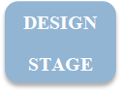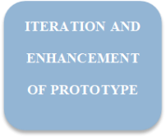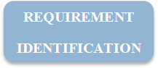

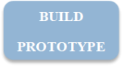

**Figure 1.** Conceptual Framework. Illustrates the process and flow of the model used in making the E-Mayor Website and Mobile Application.

**Project Purpose**

The researcher have come up with a study entitled “Sta. Cruz Laguna Municipality E-Mayor” that will benefit the town itself. The researchers’ study is aimed to develop a website and mobile app that comes up with SMS notification in displaying the schedule of the mayor. The civilians and various people intending to have an appointment with mayor needs to go the mayors physically where they need to go the process of making an inquiry, request an appointment, and being confirmed by the mayor of the request before they can have the appointment. This project, E-Mayor Website aims to give resolution to their existing problems which will help them. The following are the beneficiaries of the system: (1) Civilians: The members will get the chance to check the mayors schedule online without having to go to the tedious process of going there personally and getting rejected of an appointment with the mayor. (2) Researchers: This study helps the researchers to gather the important and very useful information that make an additional to their knowledge. By doing this study, the researcher will improve his skills and can learn new techniques in terms of developing the system; monitoring and managing a system improves his work ethic and research gathering skills. (4) Future Researchers: This study can be used by the future researchers as a reference or a guide for their research study with same concept. The future developers who will make a system with the same concept will get an idea to make their system, they will also be motivated to and inspired to develop a system software that is very useful and can enhance the process of work in many ways.

**Scope and Limitation**

In order to suffice the objectives of the study, scopes are needed to expound. The scope of the study entitled “Sta. Cruz Laguna Municipality E-Mayor” are as follows:

* Helps civilians conveniently by having the mayors schedule online
* Helps the secretary by lessening his/her workload
* Minimizes paper trail
* Keeps previous schedule recorded

Nevertheless, the following are the limitations of the study:

* The system’s data is all about Municipality of Sta. Cruz mayors schedule.
* The study is only government related issues.
* Helps stalkers check on the mayors daily, monthly or yearly schedule

**CHAPTER II**

**REVIEW OF RELATED LITERATURE**

This chapter includes different citations from different related article and literature written by different authors. These are used by the researcher to help them in the creation of their study as a basis and guidelines of different concepts and ideas.

**Impact of E-Government**

According to the study of Oyekunle (2016) entitled “An Overview of E-Government Technological Divide in Developing Countries” in this study discussed the technologies that are useful to the government such as enhance the quality, speed of delivery and reliability of services to citizen and businesses. The researcher develop a E-Mayor Scheduling system that helps the Mayors Office of the Sta. Cruz Laguna to maximize efficiency, reduce the use of paper, safekeeping of records and with the recent pandemic this year helps reduce the face-face contact of people that wants to meet the Mayor.

While in a study by Yang, (2017) entitled Towards a New Digital Era: Observing Local E-Government Services Adoption in a Chinese Municipality The advent of electronic government (e-government) has lifted a worldwide management reform movement in governance area to this day, evolving from delivering to citizens efficient, transparent and effective services to promoting open data, e-democracy, and so forth. This study says that with the ever changing times especially in these trying times of a Global Pandemic, an advent of Digitization has sprung forth, in which one of them is E-Government.

As cited by a study of Giri, Shakya & Pande (2018) entitled “E-Governance Implementation: Challenges of Effective Service Delivery in Civil Service of Nepal” E-government has been a means of new governance with the use of ICTs to promote a more efficient and cost-effective government in the present-day world. This study is connected to the researchers study since it is concerned on what is the advantage of practicing E-Government in todays’ new normal in todays times of Global Pandemic.

According to the study Meijer, & Bolívar (2015) entitled “Governing the smart city: a review of the literature on smart urban governance” said that Although ‘smart city’ is a theme studied in areas of knowledge such as urban planning and technology management in government, currently there does not seem to be consensus on the definition of the term. This study says that the term ‘smart’ is associated with the development of solutions to urban problems using technology.

This is further supported by the study of Garcia, Pardo, & Nam (2015) entitled “What makes a city smart? Identifying core components and proposing an integrative and comprehensive conceptualization” that E-governance may include information and knowledge exchanges between multiple social actors and government entities. It is related to the researchers that it could also enable participation and engagement in collective decision-making efforts about important public affairs in which a technology centered government can have an efficient and cost effective government in the present day world.

In which it is further supported by a study Berlilana, Hariguna, & Lai (2018) entitled “Effects of Relationship Quality on Citizen Intention Use of E-government Services: An Empirical Study of E-government System” E-Government can be defined as a medium that can connect the interaction between citizen, business actors or government with government by utilizing information and communication technology in which it exists because of the problems in society today that needs precise handling. This study supports the researchers study in building the E-Mayor for mediation between the Mayor and his constituents.

In another study of Pandey, Prasad (2017) entitled “Challenges of the Grievance handling in Public Service Delivery and the Use of Information Technology” Now the role of the government is not limited only in the security of the citizens but it is expanded on the public welfare, development-oriented activities, information dissemination, public awareness and researches. This study is connected to the researchers study since it is connected to the study of Giri, Shakya & Pande, (2018) in the study entitled “Reform of civil service of Nepal with e-government practice” of what is the advantage of practicing Information Technology in Governments vs to the standard procedures aka Manual Process

While it said in the article Upadhyay et. al (2016) entitled “Does E-Readiness of Citizens Ensure Better Adoption of Government’s Digital Initiative. A Case Based Study” the used of e-government services made the citizen anxious on the security and safety of the online services and transaction being automated. The study captured the existing obstacle on the acceptance of several technologies that will help government initiatives in implementing e-governance in the future with more success. The success of e-governance rely on the e-readiness of the citizen to embrace e-governance services that will benefit both government and the citizen on progressing to a better future.

In the study of Przeybilovicz, Cunha, & Meirelles. (2018) entitled “The use of information and communication technology to characterize municipalities: who they are and what they need to develop e-government and smart city actions” That literature on e-government and smart cities places particular emphasis on ICT infrastructure in local governments. The first studies carried out in Europe and the USA in the field were followed by research in developing countries. Based on the concept of e-government and smart cities, this shows ICT infrastructure as a necessary, albeit insufficient, condition for the materialization of potential e-government gains. The article is related to researchers’ studies importance of e-government that has always been a try and try topic issue for the common practitioners of said users of E-Government or the E-Mayor.

According to a study by Teryima, & Sunday. (2015) entitled the role of information communication technology (ICT) in enhancing productivity in local government administration in Benue State, Nigeria. It is stated in their study that it has played a positive role in areas of computerization of internal accounting, payroll operations, word processing and budget planning and administration, job costing, scanning documentation and mapping, decision support, online training/learning, urban planning among others in the 23 local government areas of Benue State, Nigeria which coincides in the needs of the population of the researchers study.

This is further supported by Aashis, & Kim (2016) entitled “Information Communication Technology Development in Nepal” Developing and least developed countries should be encouraged to develop their ICT infrastructure and services such that they could match up with other countries which Philippines is also included in one the least developed countries in the development of E-Government

In an article of of Rose, Persson, Heeager, & Irani, Z. (2015) entitled “Managing e‐Government: value positions and relationships” The management of e-Government is a specialized form of public administration as it involves responsibility for the deployment of Information Technology which the fast sending and retrieving of public and classified data. This study is supported by Reyes & Tangkeko. (2017) entitled “Interoperability Framework for Government E-Services of the Philippines” that Government e-services or the government services provided by any electronic means for example internet/website, mobile devices or kiosk have also become more prevalent in the e-government domain as opposed to the standard of going there personally.

In the study of Giri & Shrestha (2018). Entitled “Reform of civil service of Nepal with e-government practice” that E-governance has been essential to increase effectiveness, liability and to improve the service delivery and participation of the people in all aspects of government activities. This is connected to the study because E-government is being deployed not only to make smooth civil services but also for public sector efficiency purposes.

This study is supported by Otieno & Omwenga(2015) entitled “Citizen-centric critical success factors for the implementation of e-government: A case study of Kenya Huduma Centres.” that E-government has emerged as a new way of using ICT to promote innovative, efficient, cost-effective and more transparent ways of serving the public. This study says that E-governance is more efficient in terms of running a Government.

Meanwhile it is mentioned by Hariguna & Min & Chung & Shih (2017) entitled "Understanding information system quality on public e-government service intention: an empirical study that E-government service shows that higher usability and credibility may improve performance, increase public satisfaction and increase public intention. This study says that E-Government enhances the efficiency, performance, increase public satisfaction and increase public intention.

This is supported by Alenezi, Tarhini, & Sharma (2015) entitled “Development of quantitative model to investigate the strategic relationship between information quality and e-government benefits. Transforming Government: People, Process and Policy. E-government services aim to improve the quality and assurance of government services, increase the efficiency of administrative processes and facilitate effective participation and engagement with service users in which it is also researcher’s motive to increase the efficiency of the Administrative process of Sta.Cruz Laguna Municipality. This study supports the article above that E-Government aims to improve the efficiency in serving the People.

According United Nations Publications. (2017). entitled “United Nations E-Government Survey 2016: E-Government in Support of Sustainable Development”. That over time, countries have been improving in indicators related to e-government and cities across the planet are implementing actions to become smarter, creating strong urban solutions based on technology. The aim is to improve the lives of people living in cities, the quality of resource management and engage citizens like the the researchers study. This study is related to the researcher’s objective in improving the lives of the Sta.Cruz Laguna Citizens or any User of the E-Mayor Website and Mobile Application.

The study above is supported by Alshehri, & Drew (2015) entitled “E-government principles: implementation, advantages and challenges” E‐government implementation refers to the process of putting an e‐government practice or programme into place. E‐government initiatives are implemented in various contexts by the public sector in order to obtain various envisioned benefits including efficiency and effectiveness in operations and services. This is related to the researchers’ study in which he is maximizing the efficiency and effectiveness of the Government of Sta. Cruz Laguna through the use of E-Mayor Scheduling System.

**Needs of E-Government to Succeed**

A study by Nulhusna, Sandhyaduhita, Hidayanto, & Phusavat (2017) entitled “The relation of e-government quality on public trust and its impact on public participation. Transforming Government: People, Process and Policy” in which the article said, one factor that would play an important role in the implementation of e-government is the maturity of trust between the public and the government. This study is related to the lack of trust of Digital Government by the citizens of Sta.Cruz because it is the first time for the government in using E-Goverment

The study above is supported by Waller, & Genius (2015) entitled “Barriers to transforming government in Jamaica. Transforming Government: People, Process and Policy” that e-government which has the potential to improve transparency, responsiveness and accountability of a government will only be used if the public considers that the system can be trusted. Therefore, trust is presumably one of the factors that determine public acceptance of e-government implementation. Several studies of e-goverment had addressed trust as a multi-dimensional concept. This study is related to the researcher study that those studies asserted that trust, which consists of dispositional trust, institutional trust and interpersonal trust, is essentially required in the development of the trust concept in E-Government or the E-Mayor.

It is also mentioned in the study of Fakhoury & Aubert. (2015) entitled “Citizenship, trust, and behavioral intentions to use public e-services: The case of Lebanon.” that Trustworthiness, defined as trust in the Internet and trust in government, should enhance e-government adoption. This study say that a lack of trust represents a strong barrier to the use of the Internet, due to security, privacy, and transparency concerns by users.

According to Tan & Sutherland (2015) entitled “Online Consumer Trust. Journal of Electronic Commerce in Organizations”, in the article it states that Dispositional trust describes the general belief towards others trust in general others, institutional trust portrays situational belief towards specific settings and interpersonal trust depicts the specific belief towards others trust in specific others which means if one is using the researchers developed mobile application and Website further trust will ensue.

On the other hand it is stated by Gracia & Ariño (2015) entitled “Rebuilding public trust in government administrations through e-government actions”. In today’s society, most governments are carrying actions to: (1) improve the levels of citizens’ trust in the public administration (levels that have been dramatically reduced in the last few years), and (2) provide citizens with public e-services adapted to current citizen’s needs. Accordingly, this work explores how e-government related actions (such as investing in e-service quality or in public administration communication to promote its advantages) may help develop trust in the public administration. To date, most studies like the researchers study have considered that trust in government will lead to more e-government adoption or just analyze how to increase trust in public e-services perceived by citizens as risky which impacts the researchers study in moving forward.

According to the study of Urbina & Abe (2017) entitled “Citizen-centric Perspective on the Adoption of E-Government in the Philippines.” the adoption of e-government is a major policy challenge for the international community, especially for developing countries such as the Philippines. With the low rates of Internet penetration in the country, the trend of e-government adoption in the country may be lethargic, if not, defiant. Since it is by the widespread use of the Internet that developments in the adoption of e-government may be sustained, the digital divide is deemed a major barrier in realizing the potential benefits of e-government. Which is why the divide of the public trust towards e-government, specifically the researchers study E-Mayor or anything with technology is hugely met with skepticism.

However cited in the article by Iuliia, Aleksei, & Mikhail (2015) in the study entitled “Trust in digital government as a result of overcoming knowledge access inequality and dissemination of belief in e-democracy” E-government can be considered as an answer to society digitization. At the same time research findings demonstrate the lack of citizens' trust in e-initiatives what is explained with the lack of knowledge and motivation to use electronic resources. The proposed research is devoted to the question how open education helping to overcome knowledge access inequality is used in the form of e-learning to gain citizens' trust in e-government. This related to study of the researcher in which questions the issue on how to tackle the citizens trust in E-Government in which it affects the E-Mayor Scheduling system in how skeptic the citizens use of E-Government

Where in the study of Ølnes, S., & Jansen, A. (2015) entitled “What Is This Thing Called e-Service? Interoperability Challenges in e-Service modelling” that the general public thinks or said that “Is the government offering us a ‘service’ when we pay taxes or a business is reporting information decreed by law to public agencies, just because Internet is used as a communication channel? This study has little consensus on the meaning of the concept ‘e-service’” The skepticism of people is not unfounded before trusting various technologies introduced by the government. This being related to the trust of the citizens towards E-Government.

According to Meijer, A., & Bekkers, V. (2015) entitled “A metatheory of e-government: Creating some order in a fragmented research field” that they are aware of a need to be more holistic and have a greater understanding of what is involved in e-government. We identify a tendency that some research and implementation focus is rather “blind” for democratic dimensions of e-government, and at the same time, a focus on public administration practice and also research tend to be “blind” for the importance and role of technology when conceptualizing and developing government. This study is related with the researchers study in which it helps build more material to study for future E-Government related studies.

In the study of Hariguna, Lai, Hung, Chen, 2017 entitled “Understanding information system quality on public e-government service intention: an empirical study” E-government service shows that higher usability and credibility may improve performance, increase public satisfaction and increase public intention use. This relates to researchers study in increasing increase public satisfaction and increase public intention use of E-Government through the E-Mayor Scheduling System.

To further support the cause of e-government success a study of Mohamd Y.A. (2015) entitled “e-Government: A proposed Legal and Regulatory Framework” suggests that E-government system should be first, supported by national laws and regulations for the sake of its legitimacy and legality.

While in the article by Zając, J. F., & Bała, M. ł. M. (2019) in the study entitled “Public media as a tool for dissemination of evidence-based information”. The internet is becoming a more and more popular source of all kinds of information. The aim of the presented work is to describe advantages and difficulties connected with dissemination of evidence-based information in social media. The researcher analyzed types of topics and some strategies to broaden our audience. It explains that some information sometimes projects fake news that leads to people losing trust in it.

It is stated by Wamoto, 2015 entitled “E-government Implementation in Kenya, an evaluation of Factors hindering or promoting e-government successful implementation” However, successful implementation of e-government initiatives requires careful planning and other issues that take into consideration a number of factors alongside technology. This is related to the study of the researcher in which the researcher gathers data from the secretaries of Sta.Cruz Laguna Municipality for a more careful planning for the E-Mayor Process Flow.

**DIFFICULTIES IN IMPLEMENTING E-GOVERNMENT**

According to a survey by the United Nations Publications. (2018) enttiled United Nations E-Government Survey 2017: E-Government in Support of Sustainable Development, e-services in government can be found in different sectors such as in education , health, finance, welfare, labor, and environment. However, literature on e-government revealed various challenges that affect the implementation of e- government and e-services. The study says that with how countries in succeeding E-Government the data or more specifically related literature on e-government is lacking for a successful implementation with various problems like lack of funds adding to the mix.

It is supported by a study of Oseni , Dingley , & Hart. (2015) entitled “Barriers facing e-Service Technology in developing countries: A structured literature review with Nigeria as a case study” barriers facing the government e-services adoption in developing countries included lack of funding, usability issues, political contests, leadership, and IT infrastructural weakness. The study says in implementing E-Government in Sta.Cruz Laguna they must first solve the various problems which includes funding, usability issues, political contests, leadership, and IT infrastructural weakness

According to Melin, U., & Wihlborg, E. (2018) entitled “Balanced and integrated e-government implementation–exploring the crossroad of public policy-making and information systems project management processes” That the e-government field is still emerging, both in terms of our conceptual understanding of e-government and in the ways that it operates in practice in contemporary processes of public sector digitization. The study says that E-government researchers still struggle to address the core dimensions in terms of public values and democratically based polices.

As cited by Joshi, Islam, 2018 A digital divide among the people, poorly offered e-government services, and availability and access to the technology by the people are some of the critical issues faced with e-government projects. The study says that although occurrences of these issues in the developing countries are inevitable, if appropriate measures are taken when designing e-government projects, governments would be able to achieve wider participation from stakeholders in e-government activities. One of the practices that may give e-government critical success.

According to Hatsu, S., Ngassam, E. K. (2016) entitled “A framework for the monitoring and evaluation of e‐governance projects in developing countries” One of the major causes of the failure of e-Gov projects in developing world has been due to a lack of monitoring and evaluation and a failure by sponsoring bodies to realize that the projects that worked in the developed world may not necessarily do so in the developing world because of differences in socio-economic realities. In this study it is stated that even though the developed system by the researcher will work in todays developed world it may not necessarily work in the future developing world.

While as cited by Mtshali, (2015) entitled “A review of the monitoring and evaluation system to monitor the implementation of early childhood development within Gauteng Department of Health” Success and effectiveness in e‐government implementation can be associated with the presence of adequate monitoring practices. The study says that such successes and effectiveness can result from the routine tracking of progress.

Whereas it said by Ostasius, Laukaitis, 2015 entitled “Reference model for e‐government monitoring, evaluation and benchmarking.” that “Monitoring e‐government implementation” refers to the process of keeping track of and comparing the characteristics of implementation and improvement in different periods, in order to then measure improvements after the development of changes in e‐government solutions in a given setting. The study says that in order to have a success in the development of E-Government it is needed to be monitored and implement improvements along the way.

**E-MAYOR SOFTWARE DEVELOPMENT**

According to Paredes and Hernandez (2017) in the study entitled “Measuring the quality of user experience: A case of the university in the Philippines,” the user experience (UX) is a vital benchmark for rating the effectivity of a website. The more user friendly it is, the higher the score. It is very important because many online users are now of old age. It is related to the researchers study in which the flow, and design is User Friendly.

In the article written by Jain (2014) entitled “Review of Different Responsive CSS Front-End Frameworks,” Responsive design is an approach to web page creation that makes use of flexible layouts, flexible images and cascading style sheet media queries. The goal of responsive design is to build web pages that detect the visitor’s screen size and orientation and change the layout accordingly. The article is related to the website development for it can be accessed via a computer or a mobile phone and it must be responsive based on the device the user is handling.

In relation to the article above, another article authored by Robert and Amanda (2019) entitled “How to make a Website Accessible,” the article presents suggestions for making websites accessible for the disabled. It previews a user-friendly webpage that can be fully understand by any person and can adapt to the nature of said person. The website must be developed thru the needs of any individual. The article is related to the study’s objective to make the website a user-friendly platform

According to Dela Torre (2017) in the study entitled “Crowdsourcing Is a Portmanteau of Crowd and Outsourcing,” the author said that an E-complaint system is a vital way in reporting crime related incidents which is now gaining attention because of fast responsiveness and convenience. Nowadays, everyone is on the internet that is why it is faster in that way. Local government has now in the move to make every LGUs and barangays to be fully internet connected. That kind of feature will lessen the workload in collecting complaints about crime and accident-related matters.

In the study conducted by the Abra State Institute of Science and Technology Philippines (2016) entitled “A Responsive Website: Development and Traffic Analysis,” internet access is now more mobile than ever because of the introduction of internet enabled devices such as Smart-watch, Smartphones, Tablets, Phabletsin addition to the Laptops and Palmtops. The study developed a responsive website and provided a website traffic analysis. The study is related to the website’s features in terms of portability of the Mobile Application. It is also related on the usage of internet and adaption of the Government to the internet.

In an article conducted by Esmeria and Seva (2017) presented at the DLSU Research Congress, De La Salle University, Manila, Philippines entitled “Web Usability: A Literature Review,” the continuing growth in the use of internet has transformed the world into a virtual marketplace. The dependability of several web applications has become more important to the users. The fast growth of online applications available in the internet drives the user interface designers to become more competitively creative. Websites are expected to provide the users a satisfying experience at the least. The study is related to the website’s usability to any individual and how the Government can contribute to the virtual marketplace in which the researchers study about the digitization of the Mayors Scheduling system.

While as cited by Ziemba, E., Papaj, T., Zelazny, R., & Jadamus-Hacura, M. (2015) entitled “Building and evaluating classification framework of critical success factors for e-government adoption.” That e-government successful adoption can benefit governments in many ways. This is related to the researchers’ study in which E-government has the potential to bring about higher quality and cost effective government services in which the researchers study aims to do by developing the E-Mayor, and better relationships between government units at the state and local levels as well as between government units and their clients, like citizens and businesses.

According to the study of Navimipour, N. J., Rahmani, A. M., Navin, A. H., & Hosseinzadeh, M. (2015) entitled “Expert Cloud: A Cloud-based framework to share the knowledge and skills of human resources” The results show that the Expert Cloud improves the HR utilization, decreases customer response time and task completion time in order to achieve high level of customers’ satisfaction and better performance of HR in organization. We conclude the paper with some suggestions for future researches and practices. This related to the researchers study in minimizing the HR Utilization or Human Resource Utilization in this case it’s the Secretary of the Sta.Cruz Laguna Municipality.

Based on the study of Cheok, & Wong. 2015) entitled “Predictors of e-learning satisfaction in teaching and learning for school teachers: A literature review. International Journal of Instruction” Users satisfaction is the extent to which users believe the system meet their information requirements. This is related to the researchers’ studies’ functionalities in which it is met.

In accordance to the study of Bakunzibake, Klein, Islam, 2019 entitled “E‐government implementation and monitoring: The case of Rwanda's ‘one‐stop’ E‐government”. That introducing formal methodological approaches at local government level and in all stages of the implementation and improvement process in the central government, while paying increased attention to back‐end process performance aspects, could improve the monitoring practice and increase project benefits. This relates to the researchers study that in all stage the monitoring of implementation and iteration of each function is needed.

According to the study of Guzman, Manaloto, Senina, Portus, 2017 entitled “Usability Testing of Online Movie Ticket Reservation in the Philippines” it is stated that SM being one of biggest film chains has applied a ticketing system in which client could reserve and purchase tickets on their location. With the researchers having done surveys of 9, results have shown the clients is mostly with the websites content. However, the site was wasteful and clients were unsatisfied with the format of data exhibited. Also, clients discovered trouble when utilizing the website for the first time. The clients were additionally unsatisfied with a portion of the highlights and recommended various enhancements. The study has shown that the contents and function of a web-based system is important, because even though the content is beautiful, if a single client cannot even use it the making of the website makes the production of it moot.

It is also cited that in the article by Crotty, (2015) entitled “Prevalence and Risk Profile of Unread Messages to Patients in a Patient Web Portal” Overall, secure messaging appears a safe form of communication, but systems to notify senders when messages are unread may have value. While most clinical messages were read, many outreach messages were not, providing caution for relying on such systems for information dissemination. This study shows that some messages are still unread, that questions the credibility of the information.

**APPOINTMENT BOOKING**

According to a study of Jeng, C. R. (2019) entitled The Role of Trust in Explaining Tourists’ Behavioral Intention to Use E-booking Services in Taiwan That E-booking means making a reservation or appointment for a service via the internet. Accordingly, e-booking or online booking engines are usually defined as tools to store, publish, and dynamically update data on availability and prices, and additionally provide users with a regular reservation process. Mobile travel booking, as a new means of booking, refers to consumer’s use of a mobile phone, computer or other portable mobile terminal equipment, through General Packet Radio Service (GPRS), 3G, Wi-Fi, and other wireless networks to book air tickets, hotels, resorts, and other tourism products or services in which study has stated that the relevance of e-booking has been signifant throughout the lives of the Taiwanese. This study is related to the researchers study in which the E-Mayor is a cross platform Booking Appointment System that has a mobile application and Website.

It is cited in the study of Mohamad, Jiga, Rahma, Azla, Rahman, & Saptari. (2019) entitled “Online Booking Systems for Managing Queues at The Road Transport Department”. That appointment scheduling systems are utilized in managing access to service providers. The performance of appointment systems is affected by few factors, such as variability in arrival and service times, available information technology, client and provider preferences, and the scheduling staff’s experience level. An online booking system makes it possible for individuals to book their appointment online conveniently and securely. This study is related to the researchers’ study that opposed traditional queuing method, client satisfaction could be significantly improved by the web-based appointment system with effective registration and reduced total waiting time. The study further insinuates that booking, appointment or anything with regards to the said systems is a major convenience to various people.

This study of Ismail, N. S., Kasim, S., Jusoh, Y. Y., Hassan, R., & Alyani, A. (2017) entitled “Medical appointment application” supports the study above in that scheduling of appointments and reservations is an important task in the operations of all sized organizations, from companies and enterprise corporations, right down to service-based small businesses. This further proves the researchers study that a scheduling of appointments and reservations is important in which the E-Mayor will help the Sta.Cruz Laguna Municipality will have a more efficient routine.

As cited by Mendoza, S., Padpad, R. C., Vael, A. J., Alcazar, C., & Pula, R. (2019) entitled “A Web-Based “InstaSked” Appointment Scheduling System at Perpetual Help Medical Center Outpatient Department”. The patient's fulfillment and solace are the needs of each hospital. With the customary arrangement system, patients have been encountering long holding waiting time, which causes dissatisfaction. This research made another electronic arrangement booking system the "InstaSked" which could decrease the holding up time experienced by patients. It is intended for patients (booking their arrangement), medical secretaries (overseeing patient rundown), specialists, doctors and management (observing patients). The system utilizes a coordination of the Six Sigma system, DMADV (define, measure, analyze, design, and verify), and BPM (business process management). This research has shown that having made specifically made system like the “IntaSked” has helped skimped and scraped out time for the patients. Like this system the E-Mayor Website and Mobile Application is also targeting a specific audience, which is the Present and Future users of the E-Mayor Website and Mobile App while it said by System and method for providing web-based management solutions.

While it said by Ordiyasa, Nugroho, Santosa, Ferdiana, & Kumorotomo. (2015) entitled “Review: Interoperability model of e-Government services.” the article says that interoperability is very important in supporting a good service in electronic government (e-Government). E-Government use to give a lot of service for the customers' and to achieve a one-stop government in a country. In the other hand, interoperability in an e-Government services is a part requirement for designing and implementing various e-Government applications for certain goal. This relates to the researchers study of developing a system that caters to a specific need of the Mayor and his Staff in the Sta. Cruz Laguna Municipality.

According to McEvoy, (2016) entitled “Booking system and Method“ tells on how to enable owners on make money out of their online portfolios that contains information about the business, name, address, phone number hours and other kinds of data. Mr. McEvoys study focuses on how to utilize these public information by advertising it in a web-based booking interface using an Interactive Voice Recognition (IVR) System. The software of the present invention calls the restaurants telephone using the IVR and confirms or rejects the booking. For further management and security, the client must pay an instalment before having an appointment booked. Credit is still made because of the installment to those who have canceled or no-show called bookings which shows how much mediating between people is important. This study says that in order to have a more secure meeting with the Mayor, the constituent must first provide with his ID, E-Mail Address, Contact Information.

In the article by Sivarajah, Irani, & Weerakkody, V. (2015) entitled “Evaluating the use and impact of Web 2.0 technologies in local government” Second generation web-based technologies (Web 2.0) such as social media and networking sites are increasingly being used by governments for activities ranging from open policy making to communication campaigns and customer service. However, this in turn has brought about additional challenges. By its very nature, Web 2.0 technologies are more interactive than the traditional models of information provision or creation of digital services. This study is related to the researchers’ study in which the E-Mayor Scheduling System is a new set of benefits in itself with its costs and risks to those government authorities who make use of these social and digital media to enhance their work.

In regards to the study of Bernardino, Nuqui, Mayleen, Castro, Custodio (2017) entitled “Managing Customer Reservations of BulSU Hostel through the Development of Online Information and Reservation System Nuqui, Mayleen, Castro, Custodio” In this examination, the advocates considered variables like consumer loyalty and positive experience upon the stay in a lodging which began in the booking strategy. So as to oversee client reservations of Bulacan State University (BulSU) Hostel, the advocate's plan and build up an "Online Information and Reservation System for BulSU Hostel". Various functionalities were consolidated into the created framework like the production of various client represent the staff/front work area and online clients, costs refreshes through online administrator entryway, installments through ledger, affirmation through email after reservation, reportage concerning pay, number of clients and month to month report, checking the quantities of watchers and settings for rates, duties and different limits. This study related to researchers study that it shows that having an Information System that would help the client understand the process of their work, their schedules, and inquiries. While having also integrated a reservation helps lessen the burden and increases the efficiency of secretaries to managing the schedule of the Mayor rather than a manual tabulation of things before sending back reports monthly.

According to the study of Purohit, (2015) entitled “Method and system for scheduling activities” they have observed that in one method, a request to book an appointment for an activity in a particular schedule is initially received. In response, time slots available in the schedule for booking the activity are determined, and a set of the time slots is provided as possible appointment choices. The time slots in the set are temporarily locked. A next set of time slots or more time slots may be requested (if the time slots provided are not acceptable or desirable), in which case additional time slots may be provided. Thereafter, a selection for one of the time slots is received. In response, the activity is booked in the selected time slot and previously locked time slots are released. The locked time slots may also be released if no selection is received after a particular amount of time. In which this study correlates with the study of the researcher in which way that the mayors schedule is displayed but only the super user and admin user specifically the secretaries of the mayor’s office is the only one that can add reservations for this specific time, date, and month

As cited by the study of Huang, 2015 entitled “Online appointment booking system**“** An online booking system and method relating to same which can be used by any user, person, business, professional or facility. More particularly this invention relates to an on line calendar system and computer implemented method for online calendar appointments; embodiment's of which can be used for example by, doctors, dentists, restaurants, barber shops, and the like. The person, business or professional sets up the calendar(s) online and users can book. Where it is also the target of the researcher to spread the website locally for the Sta. Cruz Laguna Municipality to use but has limitations where they can only browse the schedule of the mayor.

According to the study of Johnston, (2020) entitled “What are the Advantages and Disadvantages of an Online Booking and Online Scheduling System? ” that states an online booking system is software which allows a potential customer to book and pay for an activity or service directly through your website. That means from the moment a customer decides they want to book to choosing a date, and picking a time, everything is handled online, greatly reducing the workload on your staff and removing the opportunity for double-bookings. Advanced systems like this allow client users to book through a variety of methods online, including mobile, greatly expanding the potential for bookings for your business, and better leveraging an increasingly social internet.

While in the study of O'Sullivan, Irminger, and Cheikh, 2015 entitled “Reservation system and method” A reservation system for travel, accommodation, venue ticketing and other purposes may be accessed on-line, for example via a social networking website. A user enters their social networking identification into the reservation system, which is stored for future use. When a subsequent user makes a reservation, they also enter their social networking ID and the system retrieves a list of associated parties from the social networking website, which may be a friends or contacts list, and searches for reservations made by any of those parties which have an overlapping criterion, such as date and destination. This relates to the study of the researcher in which a user enters his/her networking identification in to the E-Mayors System to receive an OTP which will be needed to reserve an appointment. The OTP will have the users’ social network identification.

As cited in the study of Samorani, LaGanga, 2015 entitled “Outpatient appointment scheduling given individual day-dependent no-show predictions. European Journal of Operational Research” One of the biggest obstacles to efficient appointment scheduling in outpatient clinics is ‘‘patient no-shows’ which leads to provider under-utilization and delayed patient access. A common solution is to overbook, that is scheduling more appointments than the capacity would allow, in order to increase the provider’s utilization. Although overbooking allows more patients to be seen, it also introduces patient waiting time and clinic overtime while it is desirable to maximize the number of patients seen, it is desirable to limit patient waiting time and clinic overtime. This study says in which supports that overbooking as a countermeasures to no-shows or canceled appointments.

While it opposed to it cited in Ansell, Crispo, Simard, Bjerre, 2017 entitled “Interventions to reduce wait times for primary care appointments: a systematic review” Open access scheduling focuses on reducing and eliminating delays without adding staffing resources. Where the study coincides with the objectives of the researcher where he focuses on eliminating delays without more work force and giving convenience to the community.

While it said in Byahe: A Web and Mobile-Based Commuting App Luta, Padasas, Herana, 2018. The client needs to choose a spot that they need and select the vehicle accessible for them to bounce in, and hold for a seat most easily to do, at that point they will never again need to stress for a ride even amid times of heavy traffic. This is related to the researchers’ study in which it shows the convenience of a mobile application and website that can prevent or lessen the tedious process of waiting for a ride.

While in the study of Kaushik, Agrawal, Rahman, 2015 entitled “Tourist behaviour towards self-service hotel technology adoption: Trust and subjective norm as key antecedents.” The huge demand of mobile phones has additionally benefited the hotel industry in business promotions and operations. A majority of the hotels have started using the mobile network system for delivering services such as check-in and checkout facilities. Some hotels have introduced Apple iPad rental services for offering similar services to guests who do not have smart phones. This study is related with the researchers study in which it shows the the demand of user mobility and convenience through mobile phones and websites has been widely spread.

According to Richardson, Daly. and Thorpe (2015) entitled "An Investigative Study on the Impact of the Online Appointment Scheduling System and the Pharm Partner System to Users Quality of Working Life," the University of Technology, Jamaica implemented technologies in its health care facilities to better serve the staff and patients. The purpose of this study was to investigate the impact of these technologies on the quality of working life for users in a small healthcare environment and add to the body of knowledge for future research on this topic. The findings supported that the systems improved users' quality of working life. Reduced waiting time for patients to access doctors and receive their prescription from both facilities. Pharmacists were able to disburse drugs to patients at a faster rate. Most manual functions at both facilities were automated: the retrieval of patient's appointment scheduled information at health clinic and the retrieval of patient's records at the pharmacy. Pharmacy inventory system was automated, patients at the health clinic were able to go online and see doctors available for appointments. This correlates with the researchers’ study in which it reduces time for the constituent in having a waiting time.

**Management Information System SMS with Notification**

As the study claimed by Gutman et. al. (2015) entitled "Sending a Notifications as a Service" indicates in this study the method on how the system send a notification communication on the users device. Each notification is associated with one or more tags associated with content of the notification. The developing system of the current researchers the violator will notify if the appointment request is approved or not. This saves time and money for the requester to not go back and forth to the Mayors’ Office just to request an appointment with the mayor.

In the article by Batitis, 2019 in the study entitled “SMS Notification Implementing Internet” said that most of the barangays and government are still not prepared incorporate in this kind of new technology. One of them is Brgy. Labas as one of the 18 barangays of the City of Santa Rosa, Province of Laguna. The barangay is using manual processing to contact the Municipal Hall just to meet the mayor. The SMS Notification Implementing Internet of Things for Barangay Labas, City of Santa Rosa Laguna is system will help the barangay in processing appointment request and delivering the fastest information to its users. This study can process a documents request in a fastest and convenient way and delivering information to its end users in the fastest way through the help of Short Message Service Technology (SMS). In this study it explains that SMS notification helps information dissemination in a fast and convenient way.

According to the study of Susanto, Goodwin, 2015 entitled Factors influencing citizen adoption of SMS-based e-government services that the use of Short Messaging Service (SMS) technology to enhance the access to and delivery of government services to benefit citizens, business partners, and government institutions is defined as SMS-based e-government. SMS-based e-government systems have enabled governments to communicate with and to provide a range of services for citizens, businesses and other government organizations through the SMS channel. This is related to a function of the researchers study in which when his/her appointment has been either approved or rejected an SMS Notification will be automatically sent to the given contact number of the End User.

This is supported by the study of Salonen, 2017 entitled “Booking method and system” explained that the invention is about a method and system to synchronize different booking systems. The system comprises at least one booking system; at least one service provider; a mediator service; a client, and at least one client terminal device that can be a mobile device and that includes a dialog. The client uses the dialog to enter information into the system and the mediator receives inquiries and answers from the at least one booking system, the at least one service provider, and the at least one client. The mediator transfers and adapts information between them. The method and system are particularly suited for use with the researchers’ study in which it is also a mediator between the Mayor and his Constituents. One mediator between the Mayor and his Constituent is through SMS.

According to a book authored by Bhatti (2015) entitled “Logged On”. That when SMS is not a good medium to disseminate information, Robocalls or Interactive Voice Response (IVR) methods are good alternatives. Calls are slightly more expensive than SMS but are extremely useful in reaching people who cannot use text. Robocalls are able to convey to inform citizens that they are about to receive a text message and to ask for their feedback. The call alerts the citizen that if he/she is unable to read or respond to the SMS feedback solicitation, they should seek help from someone else to reply to the inquiry. Cited in this book that information dissemination is implemented with a help of AI system Robocalls it is the same way as SMS notification.

While as cited by Ellis, P. (2015) entitled “System and method for providing web-based management solutions” that their work, A web-based system and technique for overseeing arrangements having a User Interface that communicates with at least two or more to show at least things on client input, an administration module associated with the User Interface and designed to get information identified with planning an appointment, decides at least one potential appointment depending on the information, it presents at least one potential appointment, it get a client choice from at least one potential arrangements, and marks down the arrangement choice on the client selection, and at least one arranged to store the details of an appointment, at least one database are associated with the administration module and wherein the information involves a date and schedule opening and at any rate one of an office, an administration, and a servicer. This study shows the help of a decision making system in an interface. It also shows the part of where a mediator is still needed, specifically the (Consituent-System- Secretary)

Supported by the study Joshi 2015 entitled “Short Message Service (SMS) based Information Systems (SMSbIS)” provide an excellent alternative to a traditional approach of obtaining specific information direct (through phone) or indirect (IVRS, Web, Email) probing. Information and communication technology and afar reaching mobile penetration has opened this new research trend. Several applications such as SMS based information access using database management services, SMS base information retrieval through internet (search engine), SMS base information extraction, and question answering, image retrieval, etc. emerged. Based on this article SMS help extract information fast and information dissemination through internet (Web, e-mail) with different features like question answering etc.

It is also cited by in a study by Williams, M.D., Rana, N.P. and Dwivedi, Y.K. (2015), entitled "The unified theory of acceptance and use of technology (UTAUT): a literature review" which presents a comprehensive model of E-government adoption research by considering the most frequently used 37 relationships. The weight of each predictor is also mentioned to show its strength, and to demonstrate the most effective predictors, in which the SMS based E-Government System has 589 respondents which indicates the extensive use of SMS based systems. This study correlated with the researchers study in which the developed system uses a SMS based system and it shows how SMS based systems is used frequently in E-Government.

**RECORD MANAGEMENT SYSTEM**

As cited in an article by Jassen et al (2017) entitled “Record Management System (RMS)” is the management of records for an organization throughout the records-life cycle. The activities in this management include the systematic and efficient control of the creation, maintenance, and destruction of the records along with the business transaction associated with them. RMS is part of the company’s broader activities record management is associated with governance, risk, and compliance policies. The benefits of RMS are: 1.) Elimination of redundant data; 2.) Increase of productivity and accountability in the organization; 3.) Reduction in research for the right information. Resources are saved from time-consuming research for data retrieval; 4.) Record management brings in the capability to adopt new technologies for recording keepings; 5.) By providing easy and better access to relevant records, it helps in better governance and corporate decision making. This study correlates with the researchers study in which it also aims to achieve the benefits of the RMS stated in this study.

According to the study Eludire, A. (2015) entitled “The Design and Implementation of Student Academic Record Management System” that Record Management System is the systematic control of all records from their creation or receipt, through their processing, distribution, organization, storage, and retrieval to their ultimate disposition. Because information is such an important resource to organizations the records management function also includes information management. Therefore records management is also known a records and information management. The related study shows that record management is an important means in every organizations it includes different important things. Records is one of the most important thing in every establishments because it holds all the records and information needed in the organizations

While in the study of Manikas, K. (2015) Records Management and Electronic Records Management Opportunities and Limitations. A case study in Greek companies. Electronic Records Management is both the electronic management of paper records and electronic records. Naturally, nowadays, the type of the records is different than that it was in the past. Many documents exist in electronic form while in the past existed in paper form. The researchers study is related by how the necessity, the usefulness and the aim of the Records Management remains the same and this is to boost and to enhance the business process of any organization including Governments.

As stated in the study mentioned by Herkert, 2016, entitled “Records Management Environment”, that the Records Management profession as a whole, especially in private sector that will continue to expand. As more and more information is being generated and is in need of being managed, the importance of the records manager role in organizations will increase. In their new capacity, record managers must take full advantage of available tools to manage information. This study mentions that the Records Management profession is very important. As long as different companies and sectors will expand there will be more information and records that need to be managed and in our generation the most efficient way to manage the information is to have a computerized recording of management

While it said in the study of Sengol and Usha 2015 entitled “Web based document management system in life science organization” indicates that having a document management system gives an advantage in managing records can be accessible whenever the user needs it and enables the users to access the system in with the use of a device. The system also enables to use the internet for easier communication with other users. In this article the method on how the user enables to access records will be an easier gathering of information. This is related to the researchers’ developed systems function the, Archive in which it will function as a storage for deleted schedules, rejected schedules, and done schedules.

According to a study by Delmar, 2015 entitled “RECORD KEEPING SYSTEM”, the medical record system, must be one that fits the facility and satisfies the needs of the providers. Usually medical record systems are adapted for a particular facility using certain common components. Whatever system is used, the management of medical records must provide easy retrieval of information. Wording must be easily understood and grammatically correct. The study have been observed and noted that using a record management system is a big thing and a big help for retrieving a data even if there’s a lot of data in there, it provides faster transaction and provides data encapsulation for a long term data loss prevention, but wording and grammar is a must. This literature relates to the proponents study that the E-Mayor Website as a Booking (mediator), and Mayors Schedule (Record Keeping) helps people be efficient to their time and transactions,

While it is said in a study of Mott, 2015 entitled “RECORD KEEPING SYSTEM” that keeping paper records secure involves guarding them against unauthorized access and the risks of fire, flood, or other emergencies and disasters. Protecting the integrity of digital payment record means protecting your physical data systems from the theft and disasters as well as protecting your data from corruption, loss, misappropriation, hacking and misuse. File cabinet may take up more space than computers do, but they can easier to manage from a security perspective. In addition to equipment and data risk, you must guard against the prospects of HIPAA violations that can occur if you fail to install adequate system protections. Back up and strategies rely on offsite location to protect drivers or discs from loss stemming from an event that compromises your equipment. It is shown in the study that record keeping using a database with security functions is more essential for a department or establishments for their data. Whereas the E-Mayor Website and Mobile Application is having backups via hardware and soft wares. It can prevent data loss, data redundancy and keeps records in one place, no file systems or record books needed that is prone to disaster or fire and will provides more space to store them, in record digitalization, we can keep records in one hand and organize the system. Also securing and protecting the hardware were the data are stored.

**RESEARCH DESIGN**

In a study by Mohamad, Jiga, Rahmat, Azlan, Rahman, Saptari, 2019 entitled “Online Booking Systems for Managing Queues at The Road Transport Department“. The prototyping model is considered as one of the systems development method (SDM) that allows a prototype to be built, verified, and then revised as necessary until it achieves an acceptable prototype that can be used to develop the complete product or system. Prototyping was utilized to develop the online booking system.

This is further proven by a study of Ismail, Kasim, Jusoh, Hassan, Alyani 2017 “MEDICAL APPOINTMENT APPLICATION”. That The Prototyping Model is a systems development method in which a prototype, an early approximation of a final system is built, tested, and then reworked as necessary until an acceptable prototype is finally achieved from which the complete system or product can now be developed. This model works best in scenarios where not all of the project requirements are known in detail ahead of time. It is an iterative and trial and-error process in which it is also used by the researcher to develop a system.

**SYSTEM DEVELOPMENT TESTING AND EVALUATION**

Stated by Haute (2017) entitled “Sampling Techniques” Stratified Sample are divided into groups according into their units of analysis based on one or more characteristics. Usually socio demographic characteristics is composed of individuals. Each sample are commonly proportional – the sample size of each groups relative to their size in the population distribution. The research used stratified random sampling to gain the population of the organization and analyse the possible respondents of the study. The researcher also base their distribution of TAM questionnaire on the population of the study using stratified random sampling to the respondents to gain reliable data of user acceptability of the developed system.

As stated by Ankur (2014) in his study entitled “Methods for decision-making in survey questioners based on Likert scale” in his study he stated that the Likert scale is a psychometric scale commonly involved in research based on survey questioners the researcher has identified that there are different kinds of Likert rating scale where the commonly used Likert scale is a five or seven point scale which is used to identify the individual to express how much they agree with a particular statement.

According to an article by Survey: Dichotomous Questions. (2017). The SAGE Encyclopedia of Communication Research Methods that One popular and often-used format is a dichotomous question that provides only two possible answers. This type of question is especially prominent in educational assessments. The question becomes a closed-ended question because the choices are supplied by the investigator. The dichotomous question format is used when the issue under consideration most likely is thought of in two possible values. However, any topic or variable that can be divided into two possible values permits use of this format. After a couple of examples of dichotomous questions to further clarify their format, this entry examines the advantages and disadvantages of dichotomous questions in surveys.

**SYNTHESIS**

These Local and Foreign literature's and studies mentioned and discussed above are related to the present study since they discussed how e-government is important to the present community of Sta. Cruz Laguna, Municipality. In the Impact of E-Government in which if the studies there were all summarized it discussed that with the use of ICTs it is to promote a more efficient and cost effective government in the present-day world and with the use of E-Government it may just be the thing to have a more effective government that may serve the constituents of the Sta. Cruz Laguna. While it is stated in the studies containing in the Needs of E-Government to succeed, if summarized is that even if the Sta. Cruz Laguna Municipality implements an E-Government way, with it being a new thing for the constituents of Sta. Cruz Laguna it would be faced with scrutiny, and mistrust because of the abrupt changing of doing things. Whereas in the studies under Difficulties in Implementing E-Government states that in order to have an efficient, cost effective and effective path for the E-Government to be implemented is it needs to solve problems that is present in all newly implemented systems mainly, it needs to have a more thorough research, funds, political standing, public trust and etc. In the studies under the E-Mayor Software Development, it mainly shows what it is needed to have in a website and mobile application in order for it to be amiably be accepted by the constituents of Sta. Cruz Laguna. While in the studies under Appointment Booking states that having a scheduling system that can handle the work of the staff while minimizing human error, minimizing paper trails, and maximizing efficiency and convenience of the staff and client where they can access the website at any internet accessed computer and mobile which supports the idea of the Office of the Mayor requesting an Web-based Appointment and Booking System and Mobile App w/ SMS Notification aka E-Mayor. In the studies under the Management Information System SMS with notification summarizes that role of the government is not limited only in the security of the citizens but it is expanded on the public welfare, development-oriented activities, information dissemination, public awareness and researches while SMS is a great idea for notification which supports the notion of an SMS Notification of the study. Whereas the studies under Record Management System summarizes that having physical copies of information on a paper is mostly a fire hazard, a waste of space, and prone to damage, while computer stored or cloud stored information is mostly safe from being destroyed, saves space for further storage, and helps the environment by lessening the amount of trees being cut that is used to make paper. While in the studies under Research Design mostly says that prototyping model is a cost effective and efficient method by recycling previously developed system to build a prototype then review and improve from there. In the studies under System Development and Evaluation summarizes that the use of TAM and Blackbox testing is imperative in order to further develop and enhance the researchers system.

**CHAPTER III**

**RESEARCH METHODOLOGY**

This chapter discusses the research design, population of the study, sampling design and data collection methods that the researchers used in developing the study.

**Research Design**

Modernizing the current process by developing web and mobile application with SMS integration has been the focus of the project and the study. The researchers used the descriptive and developmental research method as a basis in gathering information for a better understanding to have a better output. The descriptive research was used to describe the characteristic of population or phenomenon that are being studied. This method also has a process of investigations to have more reliable information. The developmental research is a development-oriented, a kind of research that is relevant and that can provide answer to developmental problems.

Descriptive Research was defined by Aquino (2006) as fact-finding with adequate interpretation. The descriptive method is something more and beyond just data-gathering. The real meaning of the data collected should be reported from the point of view of the objectives and the basic assumption of the project underway. This employed methods of research in order to acquire all the necessary information needed to finish this study. There are several classifications of methods of research, but most appropriate to as a fundamental tools in the case of the present study is the descriptive method. The descriptive research is devoted to the gathering of information about prevailing conditions or situations for the purpose of description and interpretation. It can involve collections of qualitative information that can be tabulated along continuum in numerical form, such as scores on a test or the number of times a person chooses to use a certain feature of a multimedia program, or it can describe categories of information such as process or patterns of interaction when using technology in a group situation.

Descriptive developmental is used to analyse and described the product- developmental, descriptive developmental is also defined as the systematic of designing, developing and evaluating that must meet the criteria of effectiveness of the final product. According to Miller (2017) in descriptive developmental, to start the testing of the developed system participants with testing skill is important and needed to be recruited, testing skills is the ability needed in actual working with research participant, whether face-to-face interaction or in observing and measuring behaviour. The researcher used black box testing which is based on the requirement and functionality through the use of test case which will help to test if the developed system functions and features is perfectly functioning according to its used, and then the researcher formulate tam questionnaire with ISO standard to identify the user level of acceptance and their comments, suggestions and feedbacks regarding on the developed system.

To emphasize the understanding of the study, the researchers used the various methods of research just as interview, library research and internet research. Through these methods, it supports the researchers in terms of gathering accurate and reliable information which helps in the development of the study. Descriptive research involves gathering data that describe by Glass and Hopkins (1984) as an event and then organize, tabulates, depicts and describe the data collective. In addition, Salmorin (2006) also said that descriptive research has an objective to describe systematically a situation, condition or area of interest factually and accurately.

**Population of the Study**

The study focuses on achieving several objectives and one of those is to assess the developed system with regards to the level of acceptability and behavioral intention behavioral intention to use the appointment scheduling management system by the end-user. The research was conducted in the Municipality of Sta. Cruz Laguna specifically the Mayors Office. In this case, it is composed of secretaries and citizens which has been the end-user and main respondents of the study. In addition to the mentioned main respondents, Information Technology experts was found out to be significant as a respondent in this study.

**Table 1.** Respondents of the Study**.** Respondents of user acceptance of the developed system

|  |  |  |  |
| --- | --- | --- | --- |
| **Respondents** | **Target Population** | **Accessible Population** | **Percentage** |
| Secretary | 10 | 10 | 14.2% |
| Constituents | 60 | 60 | 85.8% |
| TOTAL | 70 | 70 | 100% |

Table 1 shows the frequency distribution of the respondents of the study**.** The table shows the number of target that has been used to conduct the evaluation in response to the researchers’ developed platforms. The table shows the target population and accessible population where in the target population is the quota the researchers need to attain, while the accessible population is the actual size of the respondents the researchers surveyed and evaluated due unexpected circumstances.

**Table 2.** Occupation of the System Evaluators.

|  |  |  |
| --- | --- | --- |
| **System Evaluators** | **Name** | **Credential** |
| System Evaluator 1  System Evaluator 2  System Evaluator 3  System Evaluator 4  System Evaluator | Meyrick Villarica  John Rosh Birador  Juliemar Anonuevo  Reinald De Luna  Eugene Sumague | APEC IT Head and Credit and Credit and Collection Manager  BSIT Graduate, APEC System Developer  Web Developer at Longares Global Operations Inc.  MISO IT System Developer  BSIT MISO System Developer, Management. Information System of the provincial government of Laguna |

Table 2 shows the name of the System Evaluator and their credentials which is necessary to determine their eligibility to evaluate the performance and functionalities of the developed website and mobile application.

**Sampling Design**

Sampling is the process of selecting the sample for estimating the population characteristics. The researchers used probability sampling method during the initial gathering and investigation to produce results that are representative of the whole population. The researchers used the purposive sampling method type of probability sampling in selecting respondents. According to Etikan, I. (2016) The purposive sampling technique, also called judgment sampling,is the deliberate choice of a participant due to the qualities the participant possesses. It is a nonrandom technique that does not need underlying theories or a set number of participants. It is also said in a work of Tongco (2019) that purposive sampling technique as a non- probability sampling technique that is more effective in choosing intentional informants which relates to their ability to answer and interpret a specific concept or phenomenon. The sampling method enables the researchers to get the most important information out of all the data collected from all of the participants emphasized by Foley (2018). Also it is more often used by the researchers for it is extremely time and cost effective unlike the other sampling method.

**Locale of the Study**

In this part it discusses the place or setting of the study. It describes in brief the place where the study is conducted. The client is located at the Municipal Office of Sta. Cruz, Laguna. Each municipality have their own Mayors Offices and is tasked to service the general public with their services which comprises of (1) Approval of Aids to Individual Crisis Situation (AICS) (2) Issuance of Guarantee Letter (3) Scheduling Wedding and Preparation of Marriage (4) Permit for Procession/ Motorcade/ Parade (5) Issuance of Certification (for Meralco) (6) Issuance of Mayors Clearance of Local Employment (7) Scheduling of Set-up Tent, Sound System and Monoblock Chairs (8) Approval of Request's Letter to NGO’s, Barangays and Civil Society

**Data Collection Method**

To gather the needed information in the process of developing the study, the researchers used some types of method in conducting the study like interview, library research and surfing through the use of internet to support the development of the study.

The proponents gathered data in a series of interview. The information from the Public Information Office made the proponents to come up with the study to design and develop a system for information dissemination.

* **Library Research**

The proponents did some research in the LSPU – SCC library and in CCS research lab to gather some information like reading some thesis related to the proposed system and read some computer books to have further knowledge regarding the proposed system.

* **Internet Research**

The proponents used internet since it has a large collection of information that is accessible anytime. The proponents read some journals, articles and published thesis to collect different information related to the propose study. Some of the website that the researchers visited were sciencedirect, googlescholars, plusgroups etc,. The information gathered was used for the related literatures and studies.

* **Interview**

The proponents conducted an interview in Mayor’s Office of Sta. Cruz on February 21, 2020 to identify their current process and problems encountered. The proponents asked some questions regarding their current process in creating appointments for the mayor and arranging the prioritized and non-prioritized schedule of the mayor. Cruz. The researchers found out that with their current way of arranging schedule and creating appointments with the mayor they still encounter human error cases, and more workload so they wish to improve it by using a way better technology which is a scheduling system with SMS Notification.

**Statistical Treatment**

The researchers used the Frequency and Percentage Distribution to treat the data gathered in the testing phase in order to determine how functional the two developed platforms are. The researchers used the following formula:

% =  x 100

Where: % = Percentage

f = frequency of “passed” and “failed”

**Weighted Mean =** 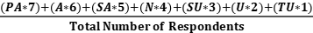

The standard deviation formula used as the statistical treatment of the gathered data is:

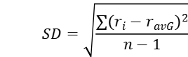

Where: SD = Standard Deviation

n = Population Size

ri = Each value from Population

r avg = Mean

The standard deviation measures the spreading of the dataset relative to its mean and is calculated as the square root of the variance. According to Delmase and Liu (2005) on his article entitle “Exploring Students’ Conceptions of the Standard Deviation”, if the data points are further from the mean, there is a higher deviation within the data set; thus, the more spread out the data, the higher the standard deviation.

PA (Perfectly Acceptable or 7), A (Acceptable or 6), SA (Slightly Acceptable or 5), N (Neutral or 4), SU (Slightly Unacceptable or 3), U (Unacceptable or 2), TU (Totally Unacceptable or 1)

For the interpretation of the computed weighted mean, the researchers set the following scale.

**Table 3.** Likert Scale that shows the rates and the verbal interpretation

|  |  |  |
| --- | --- | --- |
| **Rating** | **SCALE** | **VERBAL INTERPRETATION** |
| 7 | 6.20 – 7 | Perfectly Acceptable |
| 6 | 5.10 – 6.19 | Acceptable |
| 5 | 4.2 – 5 | Slightly Acceptable |
| 4 | 3.4 – 4.19 | Neutral |
| 3 | 2.6 – 3.39 | Slightly Unacceptable |
| 2 | 1. 8 – 2.59 | Unacceptable |
| 1 | 1 – 1.79 | Totally Unacceptable |

**Project Design**

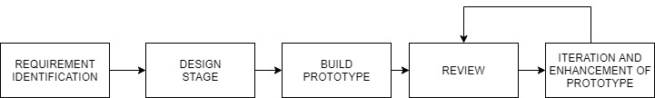To make this project completely functional, the researcher has applied the System Development Life Cycle (SDLC) Prototyping Model, generally the seven steps are (1) Requirement Identification (2) Design Stage (3) Build Prototype (4) Review of the Prototype (5) Iteration and Enhancement of Prototype



**Figure 2.** Prototyping Model illustrates the process and flow of the model to follow in order to build a system

Requirement Identification: Here identification of product requirements is cleared in details. It is done through interview some product's future users and other members of the departments where the researcher has interviewed with the Secretaries of the Mayor for what is the difficulties of the process of how to get an appointment with the Mayor.

Design Stage: A first-round design is created in this stage for the new system. In this phase the researcher has made a rough draft of what to put in the system and at how it looks while minding the color palettes of the System because the Secretaries of Mayor Egay has mentioned that a specific color is banned from using in the City Hall.

Build the Initial Prototype: An initial prototype the target software is built from the original design. Working off all the product components may not be perfect or accurate. The first sample model of the system is built by the researcher tailored to the needs of the Mayor, Secretaries and Clients of the City Hall.

Review of the Prototype: After the product completes all the iterations of the update, it is presented to the staff or secretary of the Mayors’ office. The response is accumulated in an organized way so that they can be used for further system enhancements.

Iteration and Enhancement of Prototype: Once the review of the product is done, it is set for further enhancement based on factors like - time, suggestions and time. Also, the technical feasibility of actual implementation is checked.

**Testing and Evaluation Procedure**

This section discusses the test and evaluation procedures used by the researchers to further evaluate the study. The researcher believes the method used will be a big help for the developed study.

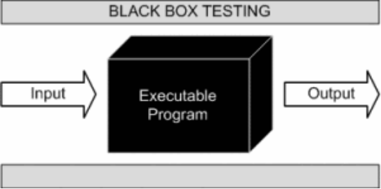

**Figure 3.** Blackbox Testing that shows the flow of testing using black box. The method is used by the researchers to further test the functionalities in terms of its performance.

Black box testing also known as behavioral testing is a software testing tool that is used to measure the internal structure or design of the item that is being tested. The advantage of using black box testing is that user can easily point out what is missing or lacking on the object that is being tested without requiring them to have a knowledge of which programming language was used or how the system was created as a whole. Black box testing is a type of testing which ignores internal specifications of a system or a software, it is used when the code itself is not seen by the users rather focuses on the outputs relatively to the actions given (Bhasin, Khanna and Sudha 2014)

**Table 4.** Test case scenario for Admin User Accepting/Rejecting Pending Appointment Requests through Mobile Phone.

|  |  |  |  |  |  |
| --- | --- | --- | --- | --- | --- |
|  | INDICATOR | DESCRIPTION | | EXPECTED RESULTS | |
| 1 | Open Mobile Application | Displays Login Interface | | PASS | |
| 2 | Enter Credentials | Credentials can be entered | | PASS | |
| 3 | Click Submit | Admin User is logged in | | PASS | |
| 4 | Access the User Admin Account | Displays the dashboard which displays the active admin accounts, messages received, and logs. The left side of displays the Home Button which contains the dashboard, the Users button in which contains a subsection of Add, List and Archive, a Calendar, Schedules, System Logs, and Account Settings | | PASS | |
| 5 | Tap **“Schedule Button”** | Displays different options of “Write Message”, **“Appointment Inbox” , “Appointment Archive, and “Rejected Appointment Archive”** | | PASS | |
| 6 | Tap **“Appointment Inbox”** | Displays the Appointment Requests | | PASS | |
| 7 | Tap **“Blue Flag”** | Clicking the **“Blue Double Arrow”** besides a pending schedule will let the admin user accept and move it to the **“Priority Schedules”** which the system will send a SMS Response to the client user that the Appointment Request is accepted. | | PASS | |
| 8 | Click the **“Red Thumbs Down Button”** | Clicking the **“Red Exclamation Mark”** besides a pending schedule will let the admin user reject the request inwhich the system will send a SMS Response to the client user that the Appointment Request is rejected. | | PASS | |
| 9 | Click the **“Red Flag”** | Clicking the **“Red Flag”**besides a pending schedule will let the admin user accept and move it to the **“Non-Priority Schedules”** which the system will send a SMS Response to the client user that the Appointment Request is accepted. | | PASS | |
| 10 | Click the “**Red Exclamation Mark Button”** | Clicking the **“Red Exclamation Mark Button”** will display the info inputted by the Client User. | | PASS | |
| 11 | Click the “**Red Arrow**” | Clicking the **“Red Arrow”** will notify an Accepted Appointment that their reservation is moved via SMS | | PASS | |
|  |  | |  | |  | |

Table 4 shows the testing evaluation tool that is intended for the E-Mayor Mobile application. It shows the step-by-step process of opening the mobile application, logging in with an Admin Account, navigating the mobile application to the Schedules tab, then navigating it to the Appointment Inbox tab, accepting an appointment request, rejecting a request and the viewing of the client users’ detail. The measuring statement identifiers above were the actual statement used during the conducted test.

**Table 5.** Test case scenario for Client User requesting appointment through the system.

|  |  |  |  |
| --- | --- | --- | --- |
|  | INDICATOR | DESCRIPTION | EXPECTED RESULTS |
| 1 | Navigate to website | Site should open | PASS |
| 2 | Fill Up Registration Form | Fill up registration form which consists of First Name, Contact Number, Last Name, Address then press add. | PASS |
| 3 | Receiving the OTP | After filling up the form you should receive an OTP. | PASS |
| 4 | Tap Left Menu | Displays Left Menu Options which consists of Home, Calendar. | PASS |
| 5 | Tap **“Calendar”** | Displays a Calendar that when clicked on your desired date will display if it is booked or not on a desired time. | PASS |
| 6 | Booking for an Appointment | Clicking your desired time on a desired date, a modal will appear which will Display a registration form which the user must fill it consists of the One Time Password, Event Title, Event Time, Event Date | PASS |
| 7 | Confirmation | The appointment is confirmed | PASS |
| 8 | Rejected | The appointment is rejected | PASS |
| 9 | SMS Confirmation | Based on the decision of the secretary the system will send an SMS Response to the Client User | PASS |

Table 5 shows the testing evaluation tool that is intended for the E-Mayor Website. It shows the step-by-step process of how the client users can navigate through the website, registering for an OTP, picking a desired date and time, making a request and waiting the decision of the Secretary if it’s Accepted or Rejected. The measuring statement identifiers above were the actual statement used during the conducted test.

**Table 6.** This table shows the test case scenario for Admin User Accepting/Rejecting Pending Appointment Requests through the Website.

|  |  |  |  |
| --- | --- | --- | --- |
|  | INDICATOR | DESCRIPTION | EXPECTED RESULTS |
| 1 | Navigate to website | Site should open |  |
| 2 | Click the **“Login button”** | Displays a LOGIN interface with the login requirements Username and Password | PASS |
| 3 | Enter Credentials | Credentials can be entered | PASS |
| 4 | Click Submit | User Admin is logged in | PASS |
| 5 | Accesses the User Admin Page | Displays the dashboard which displays the active admin accounts, messages received, and logs. The left side of displays the Home Button which contains the dashboard, the Users button in which contains a subsection of Add, List and Archive, a Calendar, Schedules, System Logs, and Account Settings | PASS |
| 6 | Click **“Schedule Button”** | Displays different options of “Write Message”, **“Appointment Inbox” , “Appointment Archive, and “Rejected Appointment Archive”** | PASS |
|  | Click **“Appointment Inbox”** | Displays Appointments Requests | PASS |
|  | Click the **“Blue Flag”** | Clicking the **“Blue Double Arrow”** besides a pending schedule will let the admin user accept and move it to the **“Priority Schedules”** which the system will send a SMS Response to the client user that the Appointment Request is accepted. | PASS |
|  | Click the **“Red Thumbs Down Button”** | Clicking the **“Red Exclamation Mark”** besides a pending schedule will let the admin user reject the request inwhich the system will send a SMS Response to the client user that the Appointment Request is rejected. | PASS |
|  | Click the **“Red Flag”** | Clicking the **“Red Flag”**besides a pending schedule will let the admin user accept and move it to the **“Non-Priority Schedules”** which the system will send a SMS Response to the client user that the Appointment Request is accepted. | PASS |

Table 6 shows the testing evaluation tool that is intended for the E-Mayor Website. It shows the step-by-step process of how the Admin Users Accepts/Rejects Appointment Requests by accessing the website, logging in with a Admin Account, navigating to the Schedules section then clicking appointment inbox, and Accepting/ Rejecting the Requests of the Client Users. The measuring statement identifiers above were the actual statement used during the conducted test.

**Table 7.** This table shows a test case scenario for the Admin User manually inputting schedules in the system.

|  |  |  |  |
| --- | --- | --- | --- |
|  | INDICATOR | DESCRIPTION | EXPECTED RESULTS |
| 1 | Navigate to website | Site should open | PASS |
| 2 | Click the **“Login button”** | Displays a LOGIN interface with the login requirements Username and Password | PASS |
| 3 | Enter Credentials | Credentials can be entered | PASS |
| 4 | Click Submit | Admin User is Logged in | PASS |
| 5 | Access Admin User Page | Displays the dashboard which displays the active admin accounts, messages received, and logs. The left side of displays the Home Button which contains the dashboard, the Users button in which contains a subsection of Add, List and Archive, a Calendar, Schedules, System Logs, and Account Settings | PASS |
| 6 | Navigate to **“Calendar”** | Displays a Calendar | PASS |
| 7 | Click desired date in the **“Calendar”** | Clicking a Date in the “Calendar” a modal will display an Appointment form | PASS |
| 8 | Clicking desired time in “**Calendar”** | Clicking a desired Time in a Date a modal will appear with an Appointment Form | PASS |
| 9 | Fill Up Requirements | The Appointment Form which consists of Name, Contact #, Address, Email Address, Subject Title, Time and Date must be filled. | PASS |
| 10 | Click “Confirm” | Clicking the Confirm button the User Admin will receive the request in the Pending Schedules. | PASS |

Table 7 shows the testing evaluation tool that is intended for the E-Mayor Website. It shows the step by step process on how the Admin user can manually input schedules using the E-Mayor Website by navigating to the website, logging in with an Admin Account, clicking the Calendar tab, clicking a desired date and time, then filling up the schedule details. The measuring statement identifiers above were the actual statement used during the conducted test.

**Validation of Questionnaire**

Researchers constructed two self-made questionnaires for each user group to obtain user feedback and acceptance towards the developed mobile platform. The questionnaires are constructed based on the Technology Acceptance Model factors in terms of Quality, Perceive Ease of Use, Perceived Usefulness, Experience, Attitude towards Using and the Behavioral Intention to Use, combined with the ISO/IEC 9126 software quality metrics. According to Bhatti and Kepler (2005), application of software metrics is proven to be an effective technique for assessing, estimating software quality and productivity. The researchers incorporate the ISO/IEC 9126 software quality metrics to the Technology Acceptance Model in order give more accurate and relevant assessment. The questionnaires are validated by Dr. Villarica, Mia, the research study adviser for further rectification before the dissemination

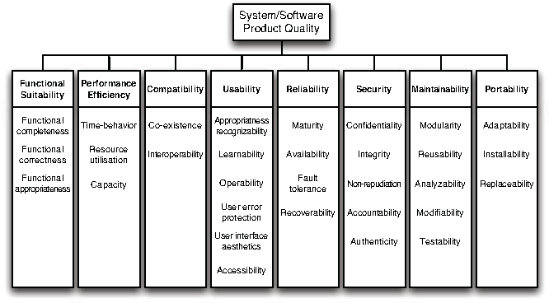

**Figure 4**.ISO/IEC 201510 Software Quality Metrics. This figure shows the different types of quality metrics that determine which quality characteristics will be taken into account when evaluating the properties of the software.

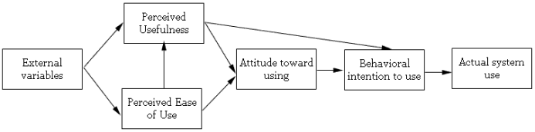

|  |
| --- |
|  |
|  |  |

**Figure 5.** Technology Acceptance Model (TAM). This figure shows the flow of TAM that determines user acceptance based on Quality Factors, Perceived Usefulness, Perceived Ease of Use, Attitude towards Using, Behavioral Intention to Use, And Actual System Use/Experience which the researchers utilized.

The Technology Acceptance Model (TAM) was defined by Ma and Liu in their study “The Technology Acceptance Model” (2017) as prediction of the acceptance of information technology by the use of perceived ease of use and perceived usefulness. The technology acceptance model was tested into different application and has been proven to become the most widely applied model of user acceptance and usage.

**Perceived Usefulness –** is the degree which a person believes that using a particular system would enhance their job performance. (Davis et al., 1989)

**Perceived Ease of Use –** is the degree which an individual believes that using a particular information technology system would be free of effort. An application perceived to be easier to use than another is more likely to be accepted by user. (Davis et al., 1989)

**Attitude Towards Using –** explains the base of compatibility which includes for instance the preference for itself – service, technology and lifestyle. (Davis et al., 1989)

**Behavioral Intention to Use –** explains the measure of the strength of one’s intention to perform a specified behavior. It could be determined by considering both the attitude that a person has towards the actual behavior, and subjective norm associated with the behavior in question. (Davis et al., 1989)

**Actual System Use –** is the end-point where we want everyone to be able to do with technology, so we have to form Behavioral Intention, which is a factor that leads people to use the technology

**CHAPTER IV**

**RESULTS AND DISCUSSION**

This chapter presents whether the objective of the study achieved the needs of Mayors Office of the Sta.Cruz Laguna. It also presents the detailed result of the evaluation obtain from surveys done in testing and implementation.

Generally the capstone project aims to develop, test, and assess the user acceptability of the system entitled “E-Mayor Scheduling System w/ Mobile Application” that evaluate the E-Mayor appointment management system of the Sta. Cruz Laguna Municipality that supports the Mayors Office in monitoring particularly the needs of the people of Sta. Cruz Laguna. Sought to achieve three specific objectives. This chapter presents result of the research methodology the researchers pursued to attain the specified objectives.

* 1. **To design and develop a system that supports E-Mayor appointment management**

The researchers used descriptive research method to further understand the problems within the process of handling of Appointments with the Mayors’ Office. The Researcher has used research instruments such as Interview Questioner, Technology Acceptance Model with ISO standard, Test-case scenario. Due to the short time to develop to make a system the researcher has used Prototyping Model to make a system because the logic behind it is the prototyping methodology allows you to design a working "prototype" or early sample of what's to come. The prototyping model According to a study by Mohamad, Jiga, Rahmat, Azlan, Rahman, Saptari, 2019 entitled “Online Booking Systems for Managing Queues at The Road Transport Department “The prototyping model is considered as one of the systems development method (SDM) that allows a prototype to be built, verified, and then revised as necessary until it achieves an acceptable prototype that can be used to develop the complete product or system. The Prototyping Model, generally the 5 steps are (1) Requirement Identification, here identification of product requirements is cleared in details. It is done through interview some product's future users and other members of the departments where the researcher has interviewed with the Secretaries of the Mayor for what is the difficulties of the process of how to get an appointment with the Mayor. (2) Design Stage, A first-round design is created in this stage for the new system. In this phase the researcher has made a rough draft of what to put in the system and at how it looks while minding the color palettes of the System because the Secretaries of Mayor Egay has mentioned that a specific color is banned from using in the City Hall. (3) Build Prototype, An initial prototype the target software is built from the original design. Working off all the product components may not be perfect or accurate. The first sample model of the system is built by the researcher tailored to the needs of the Mayor, Secretaries and Clients of the City Hall. (4) Review of the Prototype, after the product completes all the iterations of the update, it is presented to the staff or secretary of the Mayors office. The response is accumulated in an organized way so that they can be used for further system enhancements (5) Iteration and Enhancement of Prototype. once the review of the product is done, it is set for further enhancement based on factors like - time, suggestions and time. Also, the technical feasibility of actual implementation is checked.

During the interview with a secretary of the Mayors Offiice the researcher were able to identify the problems in the process of handling in the appointment management system that supports the Mayors’ Office where in 1.) The Appointments is made in paper. 2.) The traffic flow of people going in for an appointment 3.) Mayor constantly changing schedule 4.) Storage Problem 5.) Appointments getting misplaced and 6.) Archived Appointments getting misplaced. These made the researcher to provide a solution that will enhance the current process of Traffic Management Office that would complement the transferring, recording, retrieving of data and viewing of reports that would work well with the developed system.

To enhance the process of the Mayors’ Office of Sta. Cruz Laguna the Researcher have identified certain features that the system would provide to further improve the process of appointment management between the Secretary, Mayor and his Constituents. The researcher have identified that having a website for the Mayors’ Office would remove the need for the Mayors Constituents in doing a traditional way of making an appointment with Mayor where they need to physically go to the Mayor Secretary just to make a 30 minute or 1 hour meeting with the Mayor, in which the constituent will waste his not just his money and time if his appointment is rejected. The website will give the constituent the power to request an appointment with the Mayor at the comforts of home. The website will also give the secretary the power to handle the appointment requests of the Mayor efficiently without being hassled with the need of physically doing the Mayors Schedule on a piece of paper that can be easily be misplaced, a fire hazard, and a hassle to store, with the website the secretary can see Pending Requests she can accept or deny on behalf of the mayor and based on those decisions the constituent will receive an SMS Notification regarding the requested schedule. The researcher has provided with a mobile app that the Mayor or his Secretary to use that has the same functionalities with the website mainly 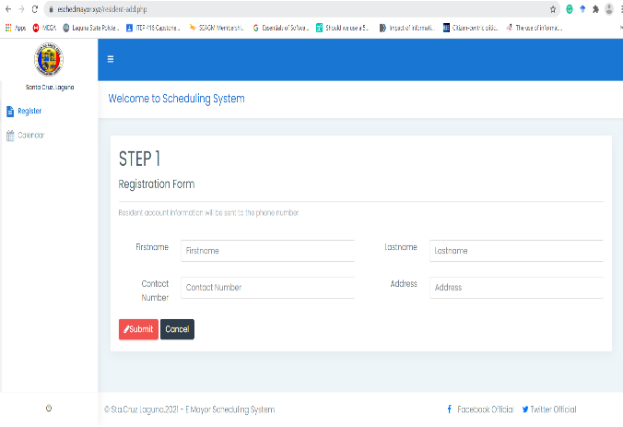seeing the pending Appointments and, either accept or reject the request.

**Figure 6.** Register Form. Form for End Users register to receive an OTP.

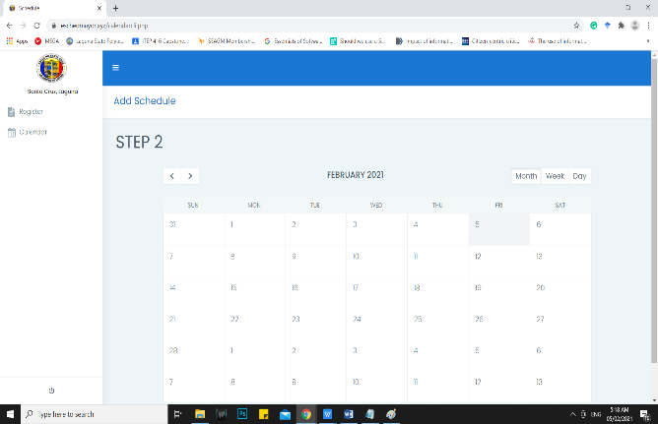

**Figure 7.** A calendar to see the registered schedule dates.

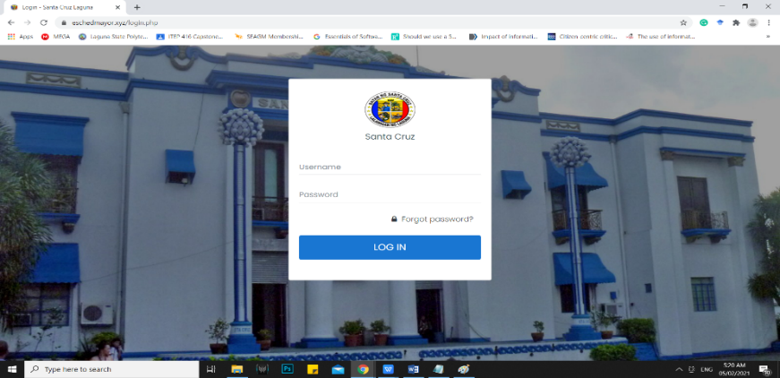

**Figure 8.** The figure above shows the Login Interface for the User Admins.

* 1. **to test the functionalities of the developed system based on the behavior of the system during the test case focusing on its major features:**

**a. Online Inquiry**

**b. Scheduling Portability**

**c. SMS response**

**d. User Management**

The researchers used the descriptive developmental to analyze and describe, the product-developmental, descriptive developmental is also defined as the systematic of designing, developing and evaluating that must meet the criteria of effectiveness of the final product. According to Miller (2017) in descriptive developmental, to start the testing of the developed system participants with testing skill is important and needed to be recruited, testing skills is the ability needed in actual working with research participant, whether face-to-face interaction or in observing and measuring behavior.

The researcher used black box testing which is based on the requirement and functionality through the use of test case which will help to test if the developed system functions and features is perfectly functioning according to its used to support the researcher choice in using black box testing in the literature review Bhasin, Khanna and Sudha 2014). Black box testing is a type of testing which ignores internal specifications of a system or a software, it is used when the code itself is not seen by the users rather focuses on the outputs relatively to the actions given. The questionnaire consist of the functionality of the developed system in which the tester are not allowed to see the code of the developed system. The researcher followed the method discussed in Srinivas discussion in which to prepare a set of question that reflects the function and features of the developed system. The Researchers presented their system in front of the IT professionals using Zoom testing to test the functionality and features of the developed system if the functions needed by the E-Mayor Scheduling System is functioning

**Table 8.** Feedback of IT Experts for the Black Box testing.

|  |  |  |
| --- | --- | --- |
| **System Evaluators** | **Name** | **Feedback** |
| System Evaluator 1 | Meyrick Villarica | The Developed system and that all functions is working his suggestions to improve the system were is in terms of Data Privacy in which the developed system displays the previous inputted information at the register function. |
| System Evaluator 2 | John Rosh Birador | The Developed system and that all functions is working and it has passed the initial Black Box Testing of the developed system. |
| System Evaluator 3 | Juliemar Anonuevo | The Developed system and that all functions is working and it has passed the initial Black Box Testing of the developed system |
| System Evaluator 4 | Reinald De Luna | The Developed system and that all functions is working and it has passed the initial Black Box Testing of the developed system |
| System Evaluator 5 | Eugene Sumague | The Developed system and that all functions is working and it has passed the initial Black Box Testing of the developed system. Mr. Sumague also suggested for Data Privacy to put in some policies in using the developed system. |

In addition, the tables below specifically shows the results of the black box testing in different functions needed in the study.

**Table 9.**Test case table for Admin User in Accepting/Reject Pending Request through Mobile Phone

|  |  |  |  |  |
| --- | --- | --- | --- | --- |
| **Indicator** | **No. of Testers** | **Passed (Frequency)** | **Failed (Frequency)** | **Percentage** |
| 1. Open Mobile Application (Displays Login Interface) | 5 | 5 | 0 | 100% |
| 2. Enter Credentials (Credentials can be entered) | 5 | 5 | 0 | 100% |
| 3. Tap Submit (Admin User is logged in) | 5 | 5 | 0 | 100% |
| 4. Access the User Admin Account (Displays the dashboard which displays the active admin accounts, messages received, and Logs.) | 5 | 5 | 0 | 100% |
| 5. Tap “Schedule Button” (Displays Write Message, Appointment Inbox, Appointment Archive and Rejected Archive” | 5 | 5 | 0 | 100% |
| 6. Tap “Appointment Inbox” (Displays the Appointment requests) | 5 | 5 | 0 | 100% |
| 7. Tap “Blue Flag” (Accepts requested appointment in to Priority and sends an SMS Notification) | 5 | 5 | 0 | 100% |
| 8. Tap the “Red Thumbs Down Button” (Rejects the Appointment Request and sends an SMS Notification) | 5 | 5 | 0 | 100% |
| 9. Tap “Red Flag” (Accepts requested appointment in to Non-Priority) | 5 | 5 | 0 | 100% |
| 10. Tap “Red Exclamation Mark Button” (Displays Client User Information) | 5 | 5 | 0 | 100% |
| 11. Tap “Red Arrow” (Notify appointment has been moved via SMS) | 5 | 5 | 0 | 100% |

The table above represents the performance of the first Website and Mobile platform under test. The input-output design logic of the first Website and Mobile application was divided into four processes. The first process – Open Mobile Application has a perfect 5 out of 5 “Passed” Frequency an equivalent of a 100 % passed rate. The Second process also has a 100% passed rate functionality of its process - Enter Credentials. The Third process Tap Submit has a perfect 5 of 5 "Passed Frequency an equivalent of 100% passed rated so is the fourth, fifth, sixth, seventh, eighth, ninth, tenth, and eleventh processes- which is Access the User Admin Account, Tap “Schedule Button”, Tap “Appointment Inbox”, Tap “Blue Flag”, Tap the “Red Thumbs Down Button”, Tap “Red Flag”, Tap “Red Exclamation Mark Button” , and Tap “Red Arrow” respectively also has garnered a 5 out of 5 passed frequency. The above data concludes that the E-Mayor Website and Mobile Application is 100% working and functional with no error occurred and meet the expected response versus the actual test response, thus justifies the first Website and Mobile application meets the desired requirement specification.

**Table 10.** Test case scenario for End User on how to request for an Appointment

|  |  |  |  |  |
| --- | --- | --- | --- | --- |
| **Indicator** | **No. of Testers** | **Passed (Frequency)** | **Failed (Frequency)** | **Percentage** |
| 1. Navigate to Website ( Site should Open) | 5 | 5 | 0 | 100% |
| 2. Fill Up Registration Form (Information required Entered) | 5 | 5 | 0 | 100% |
| 3. Receiving the OTP ( Should receive an OTP after submitting the form) | 5 | 5 | 0 | 100% |
| 4. Click Left Menu (Displays the Left Menu Options which consists of Register, Calendar.) | 5 | 5 | 0 | 100% |
| 5. Click “Calendar” (Displays a Calendar when clicked on a desired date, will display if it is booked or not on a desired time) | 5 | 5 | 0 | 100% |
| 6. Booking for an Appointment “(Clicking your desired time on a desred date, a modal will appear which displays a registration form in which the user must fill.) | 5 | 5 | 0 | 100% |
| 7. Confirmation (The appointment is confirmed) | 5 | 5 | 0 | 100% |
| 8. Rejected ( The appointment is rejected) | 5 | 5 | 0 | 100% |

The table above shows the summation of results of the 5 actual tests on the developed Website and Mobile Application. It represents the performance of the first Website and Mobile platform under test. The input-output design logic of the first Website and Mobile application was divided into four processes. The first process – Navigate to Website has a perfect 5 out of 5 “Passed” Frequency an equivalent of a 100 % passed rate. The Second process - Fill up Registration Form also has a 100% passed rate functionality of its process. The Third process Tap Submit has a perfect 5 of 5 "Passed Frequency an equivalent of 100% passed rated so is the fourth, fifth, sixth, seventh, eighth, ninth processes- which is Receiving the OTP, Click Left Menu, Click “Calendar”, Booking for an Appointment, Rejected, SMS Confirmation respectively also has garnered a 5 out of 5 passed frequency. The above data concludes that the E-Mayor Website and Mobile Application is 100% working and functional with no error occurred and meet the expected response versus the actual test response, thus justifies the first Website and Mobile application meets the desired requirement specification.

**Table 11. Test case scenario for Admin User**

|  |  |  |  |  |
| --- | --- | --- | --- | --- |
| **Indicator** | **No. of Testers** | **Passed (Frequency)** | **Failed (Frequency)** | **Percentage** |
| 1. Navigate to website (Site should open) | 5 | 5 | 0 | 100% |
| 2. Click the “Login Button (Displays Login Interface) | 5 | 5 | 0 | 100% |
| 3. Enter Credentials (Credentials can be entered) | 5 | 5 | 0 | 100% |
| 4. Click Submit (Admin User is logged in) | 5 | 5 | 0 | 100% |
| 5. Access the User Admin Account (Displays the dashboard which displays the active admin accounts, messages received, and Logs.) | 5 | 5 | 0 | 100% |
| 6. Click “Schedule Button” (Displays Write Message, Appointment Inbox, Appointment Archive and Rejected Archive” | 5 | 5 | 0 | 100% |
| 7. Click “Appointment Inbox” (Displays the Appointment requests) | 5 | 5 | 0 | 100% |
| 8. Click “Blue Flag” (Accepts requested appointment in to Priority and sends an SMS Notification) | 5 | 5 | 0 | 100% |
| 9. Click “Red Thumbs Down Button” (Rejects the Appointment Request and sends an SMS Notification) | 5 | 5 | 0 | 100% |
| 10. Click “Red Flag” (Accepts requested appointment in to Non-Priority) | 5 | 5 | 0 | 100% |

The table above shows the summation of results of the 5 actual tests on the developed Website and Mobile Application. It represents the performance of the first Website and Mobile platform under test. The input-output design logic of the first Website and Mobile application was divided into four processes. The first process – Navigate to Website has a perfect 5 out of 5 “Passed” Frequency an equivalent of a 100 % passed rate. The Second process - Click the “Login Button also has a 100% passed rate functionality of its process. The Third process - Enter Credentials has a perfect 5 of 5 "Passed Frequency an equivalent of 100% passed rated so is the fourth, fifth, sixth, seventh, eighth, ninth, tenth processes- which is Click Submit, Access the User Admin Account, Click “Schedule Button”, Click “Appointment Inbox”, Click “Blue Flag”, Click “Red Thumbs Down Button”, and Click “Red Flag” respectively also has garnered a 5 out of 5 passed frequency. The above data concludes that the E-Mayor Website and Mobile Application is 100% working and functional with no error occurred and meet the expected response versus the actual test response, thus justifies the first Website and Mobile application meets the desired requirement specification.

**Table 12. Test case scenario for Admin User**

|  |  |  |  |  |
| --- | --- | --- | --- | --- |
| **Indicator** | **No. of Testers** | **Passed (Frequency)** | **Failed (Frequency)** | **Percentage** |
| 1. Navigate to website (Site should open) | 5 | 5 | 0 | 100% |
| 2. Click the “Login Button (Displays Login Interface) | 5 | 5 | 0 | 100% |
| 3. Enter Credentials (Credentials can be entered) | 5 | 5 | 0 | 100% |
| 4. Click Submit (Admin User is logged in) | 5 | 5 | 0 | 100% |
| 5. Access the User Admin Account (Displays the dashboard which displays the active admin accounts, messages received, and Logs.) | 5 | 5 | 0 | 100% |
| 6. Navigate to Calendar (Displays a Calendar | 5 | 5 | 0 | 100% |
| 7. Click desired date on Calendar (Displays time) | 5 | 5 | 0 | 100% |
| 8. Clicking desired time in Calendar (Displays a modal with an Appointment Form) | 5 | 5 | 0 | 100% |
| 9. Fill Up Requirement (Appointment form which consists of Contact #, Address, Email, Address, Subject Title.) | 5 | 5 | 0 | 100% |
| 10. Click “Confirm” (Sends appointment in Appointment Inbox) | 5 | 5 | 0 | 100% |

The table above shows the summation of results of the 5 actual tests on the developed Website and Mobile Application. It represents the performance of the first Website and Mobile platform under test. The input-output design logic of the first Website and Mobile application was divided into four processes. The first process – Navigate to Website has a perfect 5 out of 5 “Passed” Frequency an equivalent of a 100 % passed rate. The Second process - Click the “Login Button also has a 100% passed rate functionality of its process. The Third process - Enter Credentials has a perfect 5 of 5 "Passed Frequency an equivalent of 100% passed rated so is the fourth, fifth, sixth, seventh, eighth, ninth, tenth- which is Click Submit, Access the User Admin Account, Navigate to Calendar, Click desired date on Calendar, Clicking desired time in Calendar, Fill Up Requirement, and Click “Confirm” respectively also has garnered a 5 out of 5 passed frequency. The above data concludes that the E-Mayor Website and Mobile Application is 100% working and functional with no error occurred and meet the expected response versus the actual test response, thus justifies the first Website and Mobile application meets the desired requirement specification.

**3. To assess the developed system with regards to user acceptance and behavioral intention to use the system using technology acceptance model (TAM) criteria in terms of:**

**Quality Factors**

* 1. **Perceive Ease of Use**
  2. **Experience**
  3. **Perceived Usefulness**
  4. **Attitude Towards Using**
  5. **Behavioral Intention to Use**

The researchers conducted a test to the E-Mayor of Sta. Cruz Laguna using the Technology Acceptance Model, which includes Quality Factor, Perceived Ease of Use, Perceived Usefulness, Attitude towards Using, Behavioural Intention to Use and Experience.

The researchers presented their developed system for the respondents to test and get their respondents comment and suggestion toward the use of the developed system to determine the effectiveness and efficiency. The developed system is sufficient in term of user friendly interface with operations that provide ease in their current process. These are the visual representation of the data gathered by the researchers in their test in. The weighted mean result is from the gathered questionnaire given to the respondents under the quality characteristic of the Technology Acceptance Model with ISO standard.

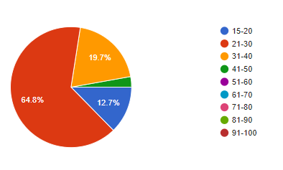

**Figure 9**. Demographics of E-Mayor Age Bracket. The figure above shows the visual representation of the various ages of the respondents.

Figure 9 shows the divisions of the 65 End user respondents during the evaluation. The demographic was based on the age bracket set by the researchers on the evaluation tool. The graph shows 12.7 % of the user were 15-20 years of age. 64.8% of the respondents were at the age of 21 - 30 years old which covers most of the graph, 19.7% of the respondents were at the age of 31-40 and the rest of respondents which consists of 2.8% at the age of 41-50.

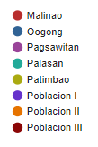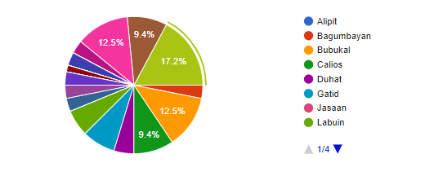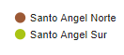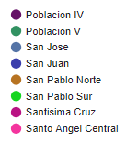

**Figure 10.** Demographics of E-Mayor Address Bracket. The figure above shows the visual representation of how many respondents is in each barangay of Sta. Cruz Laguna.

Figure 10 shows the divisions of the 65 End User respondents during the evaluation. The demographic was based on what address bracket set by the researchers on the evaluation tool. The graph shows 12.5 % of the users were from Santo Angel Central. 9.4% of the respondents were from Santo Angel Norte. 17.2% of the respondents were from Santo Angel Sur. 3.1% of of the respondents were from Bagumbayan. 12.5% of the respondents were from Bubukal. 9.4% of the respondents were from Calios. 4.7% of the respondents were from Duhat. 7.8% of the respondents were from Gatid. 6.3% of the respondents were from Labuin. 3.1% of the respondents were from Oogong. 3.1% of the respondents were from Pagsawitan. 3.1% of the respondents were from Poblacion I. 1.6% of the respondents were from Poblacion III. 3.1% of the respondents were from San Juan and another 3.1% of the respondents were from Santisima Cruz.

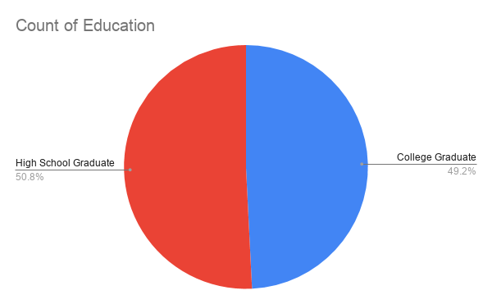

**Figure 11.** Demographics of E-Mayor Educational Attainment Bracket. The figure above shows the visual representation of the Educational Accomplishment of the respondents.

Figure 11 shows the divisions of the 65 End User respondents during the evaluation. The demographic was based on what educational attainment did the respondents achieve set by the researchers on the evaluation tool. The graph shows 50.8% of the respondents has an educational attainment of being a High School Graduate and a 49.2% of the respondents has an educational attainment of being a College Graduate.

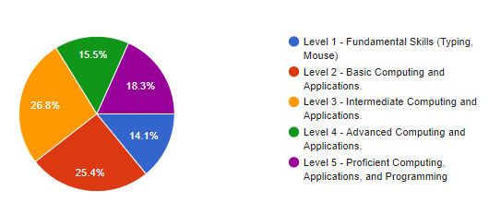

**Figure 12.** Demographics of E-Mayor Computer Literacy Bracket. The figure above shows the visual representation of the computer literacy of the respondents.

Figure 12 shows the divisions of the 65 End User respondents during the evaluation. The demographic was based on what level of computer literacy does the respondents have, set by the researchers on the evaluation tool. The graph shows that 14.1% of the respondents has a computer literacy of Level 1. 25.4% of the respondents has a computer Literacy of Level 2. 26.8% of the respondents has a computer Literacy of Level 3. 15.5% of the respondents has a computer Literacy of Level 4. 18.3% of the respondents has a computer Literacy of Level 5.

**Table 13.** Results for Quality Factors.Technology Acceptance Model table in terms of Quality Factor.

|  |  |  |  |
| --- | --- | --- | --- |
| **Indicator** | **Mean** | **Standard Deviation** | **Verbal Interpretation** |
| 1. **Correctness:** The developed system provides correct and accurate results in providing an up-to-date information about the availability of the Municipality Mayor for public viewing. | *6.47* | *0.71* | Perfectly Acceptable |
| 2. **Reliability:** The developed system has all the necessary functions and features that would help and assist with Municipal Mayor Secretary duties and responsibilities in handling Municipal Mayor’s schedule management. | 6.44 | 0.68 | Perfectly Acceptable |
| 3. **Efficiency:** The developed system covers complete and relevant features specific tasks for different user roles and using the developed system the users and achieve their specific job roles. | 6.32 | 0.76 | Perfectly Acceptable |
| 4. **Integrity:** The developed system provides comprehensive user role management and provide users with password security and SMS Notifications to the end user Municipal Mayor Secretary and Municipal Mayor. | 6.29 | 0.82 | Perfectly Acceptable |

Table 13 shows the perception of the respondents towards the quality factors of the scheduling system namely, the E-Mayor. The E-Mayors functions’ Correctness has a mean of 6.47 which has a verbal interpretation of “Perfectly Acceptable”. The reliability got a 6.44 mean which has a verbal interpretation of “Perfectly Acceptable”. The efficiency and integrity got 6.32 and 6.29 respectively which has a verbal interpretation of “Perfectly Acceptable” Thus making an overall 6.38 mean of the E-Mayor in terms of Quality Factors – Perfectly Acceptable. This means the E-Mayor intended for the constituents of Sta. Cruz and the staff of the Mayor have passed the quality standards of the respondents based on the video experience and actual usage.

**Table 14**.Result of Perceived Ease of Use.Technology Acceptance Model table in term of Perceived Ease of Use

|  |  |  |  |
| --- | --- | --- | --- |
| **Indicator** | **Mean** | **Standard Deviation** | **Verbal Interpretation** |
| 1. **Learnability:**  The developed system does not require much effort in terms of understanding the flow of the system. | 6.32 | 1.13 | Acceptable |
| 2. **Understandability:**  My interaction with the developed system is be clear and understandable. | 6.4 | 0.78 | Perfectly Acceptable |
| 3. **Operability:** The functions of the system help lessen the effort of secretary in their task of transferring, retrieving, recording of schedule data. | 6.42 | 0.71 | Perfectly Acceptable |
| 4. **User Interaction Aesthetics:** I find the software user interface pleasing and satisfying interaction. | 6.4 | 0.73 | Perfectly Acceptable |

Table 14 shows the perception of the respondents towards the quality factors of the scheduling system namely, the E-Mayor. The E-Mayors functions’ Learnability has a mean of 6.32 which has a verbal interpretation of “Perfectly Acceptable”. The Understandability got a 6.40 mean which has a verbal interpretation of “Perfectly Acceptable”. The Operability and User Interaction Aesthetics’ got 6.42 and 6.40 respectively which has a verbal interpretation of “Perfectly Acceptable” Thus making an overall 6.39 mean of the E-Mayor in terms of Perceived Ease of Use – Perfectly Acceptable. This means the E-Mayor intended for the constituents of Sta. Cruz and the staff of the Mayor have passed the quality standards of the respondents based on the video experience and actual usage.

**Table 15.** Result of Perceived Usefulness.Technology Acceptance Model table in terms of Perceived Usefulness

|  |  |  |  |
| --- | --- | --- | --- |
| **Indicator** | **Mean** | **Standard Deviation** | **Verbal Interpretation** |
| 1. **Operability:** The developed system has exceptional features that make it easy to operate and control | *6.39* | *0.73* | Perfectly Acceptable |
| 2. **Usability:** Using this software product in my job would enable me to accomplish my tasks more quickly and improve my job performance. | *6.35* | *0.72* | Perfectly Acceptable |
| 3. **Efficiency:** The developed system generates automatically stores appointment requests and responses to Accepted/Rejected requests efficiently. | 6.58 | 0.71 | Perfectly Acceptable |
| 4. **Functional Completeness:** The developed system has useful and sufficient features that would generate information clearly and effortlessly. | 6.44 | 0.73 | Perfectly Acceptable |

Table 15 shows the perception of the respondents towards the quality factors of the scheduling system namely, the E-Mayor. The E-Mayors functions’ Operability has a mean of 6.39 which has a verbal interpretation of “Perfectly Acceptable”. The Usability got a 6.35 mean which has a verbal interpretation of “Perfectly Acceptable”. The Efficiency and Functional Completeness got 6.58 and 6.44 respectively which has a verbal interpretation of “Perfectly Acceptable” Thus making an overall 6.44 mean of the E-Mayor in terms of Perceived Ease of Usefulness – Perfectly Acceptable. This means the E-Mayor intended for the constituents of Sta. Cruz and the staff of the Mayor have passed the quality standards of the respondents based on the video experience and actual usage.

**Table 16**. **Result of Attitude towards.** Using Technology Acceptance Model table in terms of Attitude towards Using.

|  |  |  |  |
| --- | --- | --- | --- |
| **Indicator** | **Mean** | **Standard Deviation** | **Verbal Interpretation** |
| 1. **Suitability:** The developed system will help me to save time and effort in terms of making an appointment with the mayor. | 6.56 | 0.71 | Perfectly Acceptable |
| 2. **Usability:** The developed system will be helpful to the Mayors Office Personnel who is in charge in safekeeping, recording of data and for the viewing of schedules of the Mayor. | 6.54 | 0.68 | Perfectly Acceptable |
| 3. **Efficiency:** The developed system is reliable in terms of getting the Data provided by the user. | 6.44 | 0.68 | Perfectly Acceptable |
| 4. **Operability:** The developed system is reliable in giving an automatic SMS Response. | 6.47 | 0.76 | Perfectly Acceptable |
| **Total Average:** | **6.50** |  | **Perfectly Acceptable** |

Table 16 shows the perception of the respondents towards the quality factors of the scheduling system namely, the E-Mayor. The E-Mayors functions’ Suitability has a mean of 6.56 which has a verbal interpretation of “Perfectly Acceptable”. The Usability got a 6.54 mean which has a verbal interpretation of “Perfectly Acceptable”. The Efficiency and Operability got 6.44 and 6.47 respectively which has a verbal interpretation of “Perfectly Acceptable” Thus making an overall 6.50 mean of the E-Mayor in terms of Attitude towards – Perfectly Acceptable. This means the E-Mayor intended for the constituents of Sta. Cruz and the staff of the Mayor have passed the quality standards of the respondents based on the video experience and actual usage.

**Table 17. Result of Behavioral Intention to Use.** Technology Acceptance Model table in terms of Behavioral Intention to Use

|  |  |  |  |
| --- | --- | --- | --- |
| **Indicator** | **Mean** | **Standard Deviation** | **Verbal Interpretation** |
| 1 **Suitability:**  I am willing to use this software product in my job. | 6.50 | 0.76 | Perfectly Acceptable |
| 2.  **Learnability:** I am willing to learn and adopt this developed system. | 6.44 | 0.76 | Perfectly Acceptable |
| 3.  **Attractiveness:** I am satisfied in terms of the over-all flow of the system | 6.37 | 0.82 | Perfectly Acceptable |
| 4. **Functional Correctness:** I am willing to participate in the usage and enhancement of the developed system. | 6.37 | 0.82 | Perfectly Acceptable |
| **Total Average:** | **6.42** |  | **Perfectly Acceptable** |

Table 17 shows the perception of the respondents towards the quality factors of the scheduling system namely, the E-Mayor. The E-Mayors functions’ Suitability has a mean of 6.56 which has a verbal interpretation of “Perfectly Acceptable”. The Learnability got a 6.54 mean which has a verbal interpretation of “Perfectly Acceptable”. The Attractiveness and Functional Correctness got 6.37 and 6.37 respectively which has a verbal interpretation of “Perfectly Acceptable” Thus making an overall 6.42 mean of the E-Mayor in terms of Behavioral Intention to Use – Perfectly Acceptable. This means the E-Mayor intended for the constituents of Sta. Cruz and the staff of the Mayor have passed the quality standards of the respondents based on the video experience and actual usage.

**Table 18. Result of Experience.** Technology Acceptance Model table in terms of Experience

|  |  |  |  |
| --- | --- | --- | --- |
| **Indicator** | **Mean** | **Standard Deviation** | **Verbal Interpretation** |
| 1**. Operability:** I can easily navigate and utilize the developed system in variety of process like making an appointment, retrieving archived schedules, recording schedules, and viewing of schedules. | 6.39 | 0.82 | Perfectly Acceptable |
| 2. **Stability:** I never experience errors or system failure on making an appointment, retrieving archived schedules, recording schedules, and viewing of schedules. | 6.35 | 0.83 | Perfectly Acceptable |
| 3. **Efficiency:** Using this developed system, I can handle more transactions than the current process we have. | 6.42 | 0.86 | Perfectly Acceptable |
| 4.**Usability:** The system will bring convenience and smooth operations to the Sta. Cruz LagunaMunicipality | 6.49 | 0.73 | Perfectly Acceptable |
| **Total Average:** | **6.41** |  | **Perfectly Acceptable** |

Table 18 shows the perception of the respondents towards the quality factors of the scheduling system namely, the E-Mayor. The E-Mayors functions’ Operability has a mean of 6.39 which has a verbal interpretation of “Perfectly Acceptable”. The Stability got a 6.35 mean which has a verbal interpretation of “Perfectly Acceptable”. The Efficiency and Usability got 6.42 and 6.49 respectively which has a verbal interpretation of “Perfectly Acceptable” Thus making an overall 6.41 mean of the E-Mayor in terms of Experience – Perfectly Acceptable. This means the E-Mayor intended for the constituents of Sta. Cruz and the staff of the Mayor have passed the quality standards of the respondents based on the video experience and actual usage.

The following table will show the overall evaluation result of the E-Mayor. With the Quality Factors, Perceive Ease of Use, Perceived Usefulness, Attitude towards Using, Behavioral Intention to use and Experience which was perfectly acceptable by the respondent

Table 19. **Overall Mean Result**

|  |  |  |
| --- | --- | --- |
| **Questions** | **Mean** | **Verbal Interpretation** |
| Quality Factors | 6.38 | Perfectly Acceptable |
| Perceive Ease of Use | 6.39 | Perfectly Acceptable |
| Perceived Usefulness | 6.44 | Perfectly Acceptable |
| Attitude towards Using | 6.50 | Perfectly Acceptable |
| Behavioral Intention to Use | 6.42 | Perfectly Acceptable |
| Experience | 6.41 | Perfectly Acceptable |

Table 19 shows the overall mean results of the TAM Questionnaire which specifies the Quality Factors that has a 6.38 mean result with a verbal interpretation of “Perfectly Acceptable”. Perceived Ease of Use that has a 6.39 mean result with a verbal interpretation of “Perfectly Acceptable”. Perceived Usefulness that has a 6.44 mean result with a verbal interpretation of “Perfectly Acceptable”. Attitude towards Using that has a 6.50 mean result with a verbal interpretation of “Perfectly Acceptable”. Behavioral Intention to Use that has a 6.42 mean result with a verbal interpretation of “Perfectly Acceptable”. Experience that has a 6.41 mean result with a verbal interpretation of “Perfectly Acceptable”.

**CHAPTER V**

**SUMMARY, CONCLUSION AND RECOMMENDATION**

In this chapter the result of the study is discussed based on the series of conducted procedure; this includes the summary of research methodology used by the developed system, the conclusion about the research and the recommendation for the future enhancement of the developed system

**Summary**

The environment of technology today has a faster alteration that the present industry needs to keep aware for the fast upgrading of computer and mobile technologies to make us more productive. Indeed, inside the nature of industry, modernization of every operation and transaction are now often used to make us more productive. As it reached the quality of satisfaction of every possible beneficiary even in small organizations like governments, many other end-users are now convinced to have their own. Having an appointment with the mayor to discuss various topics, business, and concerns is one of the core components of the Mayors’ Office of Sta. Cruz Laguna Municipality. The appointment is requested by a constituent to the secretary to have a meeting with the mayor. In these meeting with his Constituents the Mayor better understands the needs and concerns that will shape his whole and in part the whole Municipality in helping the land of Sta. Cruz and its People.

The E-Mayor Scheduling system was developed to bring convenience for the Mayor’s Office of Sta. Cruz Laguna and to the people wishing to have a meeting with the Mayor. The researcher developed a cross platform application of Website and Mobile Application to help secretaries who manage and creates the schedule of the Mayor. To further test the system’s functionalities, the researchers utilizes a survey questionnaire specifically black box testing and TAM Questionnaires which is intended to test the functions of the developed system on the other hand, the technology acceptance model was used to evaluate the user acceptance towards the developed system.

The questionnaires were given to the respondents which includes the secretaries of the Sta. Cruz Laguna Municipality and IT Experts. The data was gathered upon distributing the survey questionnaire after the demonstration and testing of the system and was analyzed and interpreted to acquire the results needed to know if the system met the expectation and satisfied the intended users. The survey results have shown that the system was highly accepted by the intended users.

**Conclusions**

The feedback shared by the respondents after the demonstration and the result acquired by the researchers with the used of survey questionnaires, it shows that the developed system is more likely to use by the office of the Mayor when it will be implemented. The system has made the process of creating a mediator between the Constituents of Sta. Cruz Laguna and the Mayor. Based on the results of the Technology Acceptance Model questionnaire and Test case from the respondents and IT professional that evaluated the developed system. As a result to the main goal of the study, the following specific objectives were met:

In order to determine the current process of the handling of Appointments with the Mayors, the researcher used the fact finding techniques specifically; observation, internet and library research as well as in depth interview. It helped the researchers deeply understand the organization and the current process of ticketing with the help of fact findings techniques and data collection method the researchers were able to gain valuable information uncovering the needs to improve in the traffic management office process of ticketing, this also help the research to analyze and specify the needed software requirement and its function and features of the system, using this method, the researcher has identified the best solution that will enhance the process of the handling the Schedule of the Mayor. To develop the E-Mayor Scheduling System, the researcher used bootstrap and HTML 5 and the website Hostinger for its hosting and domain. For the development, the researchers used PHP and java script as the programming language. PHP or (recursive acronym for PHP: Hypertext Preprocessor) is a widely – used open source general-purpose scripting language that is especially suited for web development and can be embedded into HTML. On the other hand, JavaScript is a dynamic computer programming language that is lightweight and most commonly used as a part of web pages, whose implementations allow client-side script to interact with the user and make dynamic pages. For the database, the researcher used MyphpAdmin.

**Recommendations**

The following recommendations were identified for the future improvement of the developed study

1. Further test the functionalities of the system by using a large number of respondents
2. Integrate a responsive table in the Mobile Application
3. Develop a deployment plan for the possible implementation of the developed system.
4. For more improvement future researcher may add and adjust all the features and functions of the developed system

**BIBLIOGRAPHY**

Aashis, S., & Kim, Y. S. (2016). Information Communication Technology Development in Nepal. Institute for Poverty Alleviation and International Development, 25(1), 101–141. <https://doi.org/10.18350/ipaid.2016.25.1.101>

Alenezi, H., Tarhini, A., & Sharma, S. K. (2015). Development of quantitative model to investigate the strategic relationship between information quality and e-government benefits. Transforming Government: People, Process and Policy.

Alshehri, M., & Drew, S. J. (2015). E-government principles: implementation, advantages and challenges. International Journal of Electronic Business, 9(3), 255. https://doi.org/10.1504/ijeb.2011.042545

Ansell, D., Crispo, J. A. G., Simard, B., & Bjerre, L. M. (2017). Interventions to reduce wait times for primary care appointments: a systematic review. BMC Health Services Research, 17(1), 1–4. https://doi.org/10.1186/s12913-017-2219-y

Anthopoulos, L., Reddick, C. G., Giannakidou, I., & Mavridis, N. (2016). Why e-government projects fail? An analysis of the Healthcare.gov website. Government Information Quarterly, 33(1), 161–173. https://doi.org/10.1016/j.giq.2015.07.003

Bakunzibake, P., Klein, G. O., & Islam, S. M. (2019). E‐government implementation and monitoring: The case of Rwanda's ‘one‐stop’E‐government. The Electronic Journal of Information Systems in Developing Countries, 85(5), e12086.

Batitis, C. A. B. (2019). SMS NOTIFICATION IMPLEMENTING INTERNET OF THINGSFOR BARANGAY LABAS, CITY OF SANTA ROSA, LAGUNA. International Journal of Advanced Research in Computer Science, 10(1), 21–25. https://doi.org/10.26483/ijarcs.v10i1.6356

Berlilana, B., Hariguna, T., & Lai, M. T. (2018). Effects of Relationship Quality on Citizen Intention Use of E-government Services: An Empirical Study of E-government System. International Journal of Electrical and Computer Engineering (IJECE), 8(6), 5127. https://doi.org/10.11591/ijece.v8i6.pp5127-5133

Bhatti, Zubair K.; Zall Kusek, Jody; Verheijen, Tony. (2015). Logged On : Smart Government Solutions from South Asia. Washington, DC: World Bank. © World Bank. https://openknowledge.worldbank.org/handle/10986/20487 License: CC BY 3.0 IGO.

Castro, M. D. B., & Custodio, E. B. (2016). Managing Customer Reservations of BulSU Hostel through the Development of Online Information and Reservation System. Journal of Advances in Information Technology,

Cheok, M. L., & Wong, S. L. (2015). Predictors of e-learning satisfaction in teaching and learning for school teachers: A literature review. International Journal of Instruction, 8(1), 75-90.

Delmar, R. (2015). Record Keeping System. Http://Www.Delmarlearning.Com/Companions/Content/142831928X/Summaries/Chapter13.Pdf.

Dhjaku, V., Xoxa, N., & Berberi, K. (2016). Interoperability of E-government Services. In RTA-CSIT (pp. 111-115).

Dusheiko, M., & Gravelle, H. (2018). Choosing and booking—and attending? Impact of an electronic booking system on outpatient referrals and non‐attendances. Health economics, 27(2), 357-371.

Ellis, P. (2015). System and method for providing web-based management solutions. Google. <https://patents.google.com/patent/US8370186B2/en>

Eludire, A. (2011). The Design and Implementation of Student Academic Record Management System.

Esmeria, G., Seva, R. (2017, June 20-22). DLSU Research Congress. Web Usability: A Literature Review, 1-7. Retrieved from https://scholar.google.com.ph/citations?user=lCIfTGoAAAAJ&hl=en#d=gs_md_cita-d&u=%2Fcitations%3Fview_op%3Dview_citation%26hl%3Den%26user%3DlCIfTGoAAAAJ%26citation_for_view%3DlCIfTGoAAAAJ%3Ad1gkVwhDpl0C%26tzom%3D-480

Fakhoury, R., & Aubert, B. (2015). Citizenship, trust, and behavioural intentions to use public e-services: The case of Lebanon. International Journal of Information Management, 35(3), 346–351. https://doi.org/10.1016/j.ijinfomgt.2015.02.002

Fakhoury, R., & Aubert, B. (2017). The impact of initial learning experience on digital services usage diffusion: A field study of e-services in Lebanon. International Journal of Information Management, 37(4), 284–296. https://doi.org/10.1016/j.ijinfomgt.2017.03.004

Forman, S. G. (2015). Implementation of mental health programs in schools: A change agent's guide. American Psychological Association.

Gil-Garcia, J. R., Dawes, S. S., & Pardo, T. A. (2018). Digital government and public management research: finding the crossroads.

Gil-Garcia, J. R., Pardo, T. A., & Nam, T. (2015). What makes a city smart? Identifying core components and proposing an integrative and comprehensive conceptualization. Information Polity, 20(1), 61–87. https://doi.org/10.3233/ip-150354

Giri, M. S., & Shrestha, M. R. (2018). Reform of civil service of Nepal with e-government practice. Journal of Personnel Training Academy. ISSN, 2091, 2382.

Grace, DB, & Arino, LC (2015). Rebuilding public trust in government administrations through e-government actions. Spanish Journal of Marketing Research ESIC , 19 (1), 1-11.

Gracia, D. B., & Casaló Ariño, L. V. (2015). Rebuilding public trust in government administrations through e-government actions. Revista Española de Investigación de Marketing ESIC, 19(1), 1–11. https://doi.org/10.1016/j.reimke.2014.07.001

Guidang, E. P. (2016). A Responsive Website: Development and Traffic Analysis. JPAIR Multidisciplinary Research, 26(1), 1. https://doi.org/10.7719/jpair.v26i1.416

Gutman et. al. (2015) "Sending a Notifications as a Service" from [https://patents.google.com/patent/US10375188B2/en?q=Mobile+application+sms+notification&oq=Mobile+application+with+sms+notification&page=27](https://patents.google.com/patent/US10375188B2/en?q=Mobile%20application%20sms%20notification&oq=Mobile%20application%20with%20sms%20notification&page=27&fbclid=IwAR2o3a83UDDzOqCSQ8uGw3Q4UUq3AqyVkyBk9mUjEbYKhQApTBJ44tQLARA)

Guzman, M. M. F., Manaloto, J. A. B., Senina, A. D. D. R., & Portus, A. J. A. (2017). F6-2 Usability Testing of Online Movie Ticket Reservation in the Philippines. The Japanese Journal of Ergonomics, 53(Supplement2), S592–S595. https://doi.org/10.5100/jje.53.s592

Hariguna, T., Lai, M. T., Hung, C. W., & Chen, S. C. (2017). Understanding information system quality on public e-government service intention: an empirical study. International Journal of Innovation and Sustainable Development, 11(2-3), 271-290.

Hariguna, T., Lai, M. T., Hung, C. W., & Chen, S. C. (2017). Understanding information system quality on public e-government service intention: an empirical study. International Journal of Innovation and Sustainable Development, 11(2-3), 271-290.

Hatsu, S., Ngassam, E. K. (2016). A framework for the monitoring and evaluation of e‐governance projects in developing countries. 2016 IST‐Africa Week Conference, Durban, 11–13 May 2016

Huang, I. (2015). Online appointment booking system. Google. https://patents.google.com/patent/US20110313806A1/en

Ismail, N. S., Kasim, S., Jusoh, Y. Y., Hassan, R., & Alyani, A. (2017). Medical appointment application. Acta Electronica Malaysia, 1(2), 5-9.

Iuliia, P., Aleksei, M., & Mikhail, B. (2015). Trust in digital government as a result of overcoming knowledge access inequality and dissemination of belief in e-democracy. Proceedings of the 16th Annual International Conference on Digital Government Research, 1–4. https://doi.org/10.1145/2757401.2757449

Jain, N., (2014, November). Journal of Global Research in Computer Science. Review of Different Responsive CSS Front-End Frameworks, 5, 11, 5-10. Retrieved from https://pdfs.semanticscholar.org/d9b2/d41c7b9b7433a33344bad41f4ddab883cf8b.pdf.

Jassen et al (2017) “Record Management System (RMS)” Retrieved from issue https://www.techopedia.com/definition/30667/records-management-system-rms.

Jeng, C. R. (2019). The Role of Trust in Explaining Tourists’ Behavioral Intention to Use E-booking Services in Taiwan. Journal of China Tourism Research, 15(4), 478-489.

Johnston. (2020) What are the Advantages and Disadvantages of an Online Booking and Online Scheduling System? https://www.bookinglive.com/blog/advantages-disadvantages-online-booking-system

Joshi, P. R., & Islam, S. (2018). E-Government Maturity Model for Sustainable E-Government Services from the Perspective of Developing Countries. Sustainability, 10(6), 1882.

Kaushik, A. K., Agrawal, A. K., & Rahman, Z. (2015). Tourist behaviour towards self-service hotel technology adoption: Trust and subjective norm as key antecedents. Tourism Management Perspectives, 16, 278-289.

Keesstra, S. D., Bouma, J., Wallinga, J., Tittonell, P., Smith, P., Cerdà, A., ... & Bardgett, R. D. (2016). The significance of soils and soil science towards realization of the United Nations Sustainable Development Goals. Soil.

Lewis, J. R. (1993). Multipoint scales: Mean and median differences and observed significance levels. International Journal of Human-Computer Interaction, 5(4), 383–392. https://doi.org/10.1080/10447319309526075

Luta, E., Padasas, S., & Herana, C. (2018, August 14). BYAHE: A WEB AND MOBILE-BASED COMMUTING APP. Lm.Uc.Edu.Ph. https://lm.uc.edu.ph/wp-content/uploads/2019/08/CCS-Journal-Vol-1-No-2.pdf

Mcevoy, D. (2015). Booking system and method (20050114167). United States Patent Application. https://www.freepatentsonline.com/y2005/0114167.html

Meijer, A., & Bekkers, V. (2015). A metatheory of e-government: Creating some order in a fragmented research field. Government Information Quarterly, 32(3), 237-245.

Meijer, A., & Bolívar, M. P. R. (2015). Governing the smart city: a review of the literature on smart urban governance. International Review of Administrative Sciences, 82(2), 392–408. https://doi.org/10.1177/0020852314564308

Melin, U., & Wihlborg, E. (2018). Balanced and integrated e-government implementation–exploring the crossroad of public policy-making and information systems project management processes. Transforming Government: People, Process and Policy.

Mendoza, S., Padpad, R. C., Vael, A. J., Alcazar, C., & Pula, R. (2019). A Web-Based “InstaSked” Appointment Scheduling System at Perpetual Help Medical Center Outpatient Department. World Congress on Engineering and Technology; Innovation and Its Sustainability 2018, 3–14. <https://doi.org/10.1007/978-3-030-20904-9_1>

Mohamad, E., Jiga, I. A., Rahmat, R., Azlan, A., Abd Rahman, M. S., & Saptari, A. (2019). Online Booking Systems for Managing Queues at The Road Transport Department. Journal of Industrial Engineering, 4(1), 21-32.

Mohamd Y.A. (2015). e-Government: A proposed Legal and Regulatory Framework, pdf, accessed on November 2016.

Mostaghimi, A., O’Brien, J., Bajracharya, A., Safran, C., Landon, B. E., & Crotty, B. H. (2015). Prevalence and Risk Profile Of Unread Messages To Patients In A Patient Web Portal. Applied Clinical Informatics, 06(02), 375–382. https://doi.org/10.4338/aci-2015-01-cr-0006

Mtshali, Z. (2015). A review of the monitoring and evaluation system to monitor the implementation of early childhood development within Gauteng Department of Health (Doctoral dissertation, Stellenbosch: Stellenbosch University).

Navimipour, N. J., Rahmani, A. M., Navin, A. H., & Hosseinzadeh, M. (2015). Expert Cloud: A Cloud-based framework to share the knowledge and skills of human resources. Computers in Human Behavior, 46, 57-74.

Nulhusna, R., Sandhyaduhita, P. I., Hidayanto, A. N., & Phusavat, K. (2017). The relation of e-government quality on public trust and its impact on public participation. Transforming Government: People, Process and Policy, 11(3), 393–418. https://doi.org/10.1108/tg-01-2017-0004

Ølnes, S., & Jansen, A. (2015). What Is This Thing Called e-Service? Interoperability Challenges in e-Service Modelling. In International Conference on Electronic Government (pp. 197-208). Springer, Cham.

Ordiyasa, I. W., Nugroho, L. E., Santosa, P. I., Ferdiana, R., & Kumorotomo, W. (2015). Interoperability model of e-Government services. In 2015 2nd International Conference on Information Technology, Computer, and Electrical Engineering (ICITACEE) (pp. 177-182). IEEE.

Oseni, K., Dingley, K., & Hart, P. (2015, ). Barriers facing e-Service Technology in developing countries: A structured literature review with Nigeria as a case study - IEEE Conference Publication. IEEE Xplore. https://ieeexplore.ieee.org/document/7366867

Ostasius, E., & Laukaitis, A. (2015). Reference model for e‐government monitoring, evaluation and benchmarking. Engineering Economics, 26(3), 255–263.

Otieno, I., & Omwenga, E. (2015). Citizen-centric critical success factors for the implementation of e-government: A case study of Kenya Huduma Centres. In 2015 IST-Africa Conference (pp. 1-9). IEEE.

Oyekunle (2016) entitled “An Overview of E-Government Technological Divide in Developing Countries” from <https://www.igi-global.com/chapter/an-overview-of-e-government-technological-divide-in-developing-countries/147846>

Pandey, Prasad(2017), Challenges of the Grievance handling in Public Service Delivery and the Use of Information Technology, PTA Journal. Year (5), Vol. 1, No. 5. Pp. 124-136

Paredes, R., Hernandez A., (2018, January 25). 2017IEEE 9th International Conference on Humanoid, Nanotechnology, Information Technology, Communication and Control, Environment and Management (HNICEM). Measuring the quality of user experience on web services: A case of university in the Philippines. Retrieved from <https://ieeexplore.ieee.org/document/8269446/authors#authors.>

Przeybilovicz, E., Cunha, M. A., & Meirelles, F. D. S. (2018) The use of information and communication technology to characterize municipalities: who they are and what they need to develop e-government and smart city actions.Public Administration Magazine, 52(4), 630-649.

Purohit, A. (2015) Method and system for scheduling activities. Google. https://patents.google.com/patent/US8781873B2/en

Reyes Jr, R., & Tangkeko, M. S. (2017, July). Interoperability Framework for Government E-Services of the Philippines. In PACIS (p. 33).

Robert, Amanda, (2019, July-August). ABA Journal. How to make a Website Accessible, 105 Issue 6, 1. Retrieved from http://eds.a.ebscohost.com/eds/detail/detail?vid=0&sid=273feabb-fc0c-477f-a5be-920152725679%40sessionmgr4007&bdata=JnNpdGU9ZWRzLWxpdmU%3d#AN=137250612&db=a9h

Rose, J., Persson, J. S., Heeager, L. T., & Irani, Z. (2015). Managing e‐Government: value positions and relationships. Information Systems Journal, 25(5), 531-571.

S Giri, S Shakya & R Pande(2018), E-Governance Implementation: Challenges of Effective Service Delivery in Civil Service of Nepal, Singhaniya University Global Journal of Computer Science and Technology: G Interdisciplinary Volume 18 Issue 3 Version 1.0 Year 2018 Type: Double Blind Peer Reviewed International Research Journal Publisher: Global Journals Online ISSN: 0975-4172 & Print ISSN: 0975-4350

Salonen, J. (2017, August 21). Booking method and system. Google. https://patents.google.com/patent/US7406429B2/en

Samorani, M., & LaGanga, L. R. (2015). Outpatient appointment scheduling given individual day-dependent no-show predictions. European Journal of Operational Research, 240(1), 245–257. https://doi.org/10.1016/j.ejor.2014.06.034

Sengol Mary J, Usha S, 2015, Web Based Document Management System in Life Science Organization. Green Engineering and Technologies (IC-GET), 2015 Online International Conference on, IEEE Journal, DOI: 10.1109/GET.2015.7453826, http://ieeexplore.ieee.org/document/7453826/

Sivakumar, S., Venkataraman, S., & Gombiro, C. (2015). A user-intelligent adaptive learning model for learning management system using data mining and artificial intelligence.

Sullivan, K., Irminger, R., & Cheikh, S. (2015). Reservation system and method (US9324043B2). Nordco Inc. https://patents.google.com/patent/US9324043B2/en

Susanto, T.D., Goodwin, R.(2015): Factors influencing citizen adoption of SMS-based e-government services. Electron. J. e-Gov. 8(1), 55–71

Tan, F. B., & Sutherland, P. (2015). Online Consumer Trust. Journal of Electronic Commerce in Organizations, 2(3), 40–58. https://doi.org/10.4018/jeco.2004070103

Taqwa Hariguna & Min-Tsai Lai & Chung-Wen Hung & Shih-Chih Chen, (2017). "Understanding information system quality on public e-government service intention: an empirical study," International Journal of Innovation and Sustainable Development, Inderscience Enterprises Ltd, vol. 11(2/3), pages 271-290.

Teryima, S. J., & Sunday, A. (2015). The role of information communication technology (ICT) in enhancing productivity in local government administration in Benue State, Nigeria. International Journal of Business and Economic Development (IJBED), 3(1).

United Nations Publications. (2017). United Nations E-Government Survey 2016: E-Government in Support of Sustainable Development. United Nations.

United Nations Publications. (2018). United Nations E-Government Survey 2017: E-Government in Support of Sustainable Development. United Nations.

Upadhyay et. al (2016) “Does E-Readiness of Citizens Ensure Better Adoption of Government’s Digital Initiative. A Case Based Study” from <https://www.emerald.com/insight/content/doi/10.1108/JEIM-01-2016-0001/full/html>

Urbina, A. U., & Abe, N. (2017). Citizen-centric Perspective on the Adoption of E-Government in the Philippines. Electronic Journal of e-Government, 15(2), 63.

Violante, M. G., & Vezzetti, E. (2015). Virtual interactive e‐learning application: An evaluation of the student satisfaction. Computer Applications in Engineering Education, 23(1), 72-91.

Waller, L., & Genius, A. (2015). Barriers to transforming government in Jamaica. Transforming Government: People, Process and Policy, 9(4), 480–497. https://doi.org/10.1108/tg-12-2014-0067

Wamoto, F. O. (2015). E-government Implementation in Kenya, an evaluation of Factors hindering or promoting e-government successful implementation. International Journal of Computer Applications Technology and Research, 4(12), 906-915.

Williams, M.D., Rana, N.P. and Dwivedi, Y.K. (2015), "The unified theory of acceptance and use of technology (UTAUT): a literature review", Journal of Enterprise Information Management, Vol. 28 No. 3, pp. 443-488

Ziemba, E., Papaj, T., Zelazny, R., & Jadamus-Hacura, M. (2015). Building and evaluating classification framework of critical success factors for e-government adoption. In European Conference on e-Government (p. 341). Academic Conferences International Limited.

**APPENDICES**

**APPENDIX A**

**Process Flow Chart**

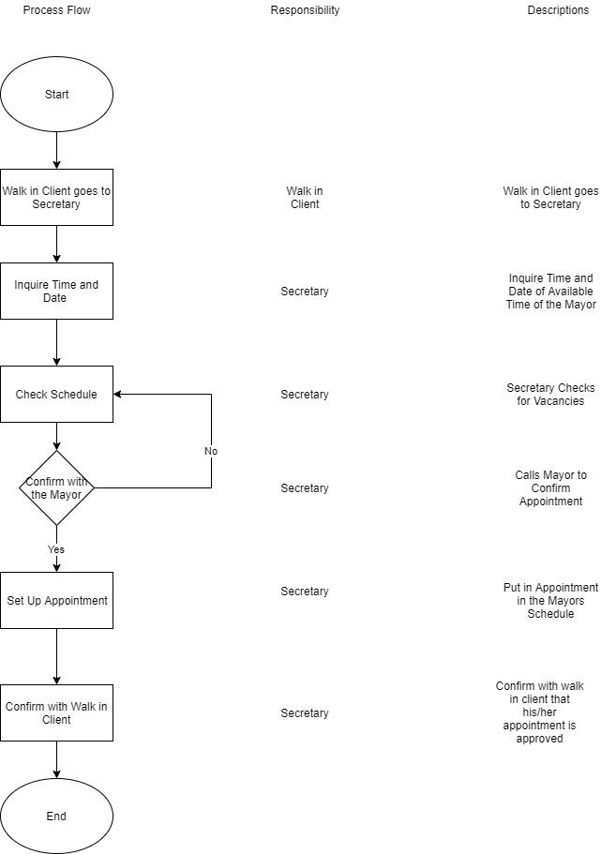

**Process Flow Current Process.** The figure above shows the current process of how to have an appointment with the Mayor

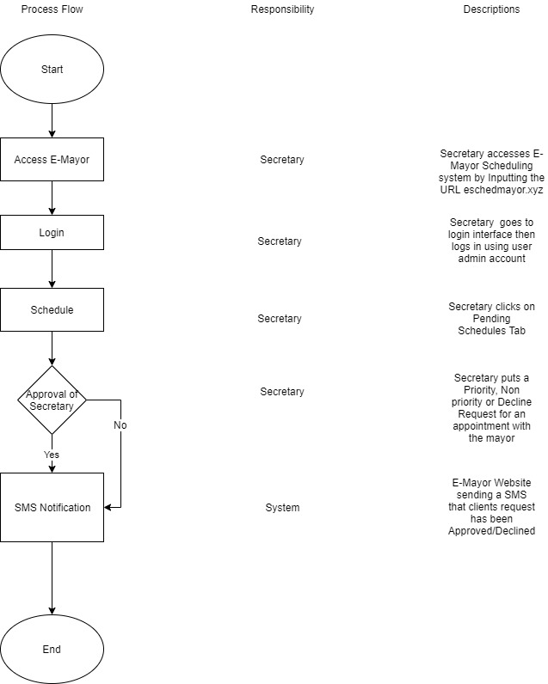

**Process Flow Proposed Process.** The figure above shows the proposed process of how to have an appointment with the Mayor using the E-Mayor Scheduling System

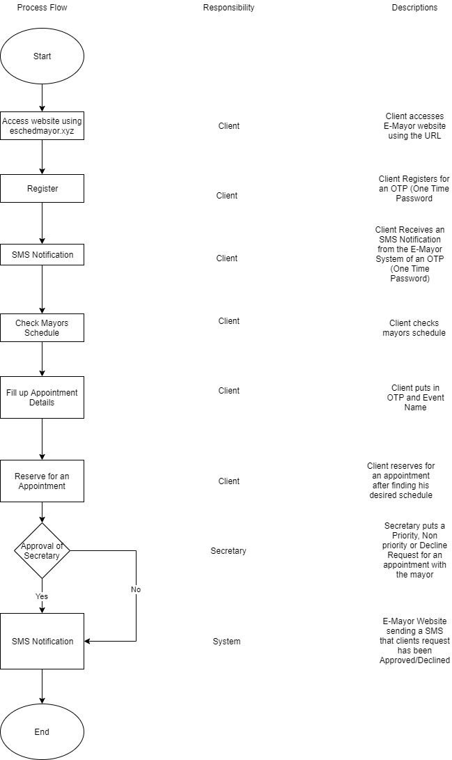

**Process Flow Website Accepting.** The figure above shows the flow of the secretary Accepting or Rejecting an appointment then sends an SMS Notification.

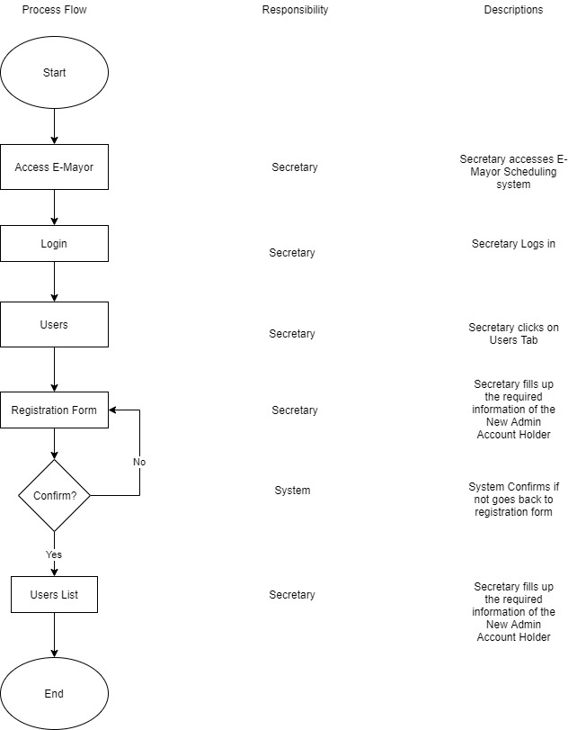

**Process Flow Adding User.** The figure above shows the flow of the secretary adding another Admin Account.

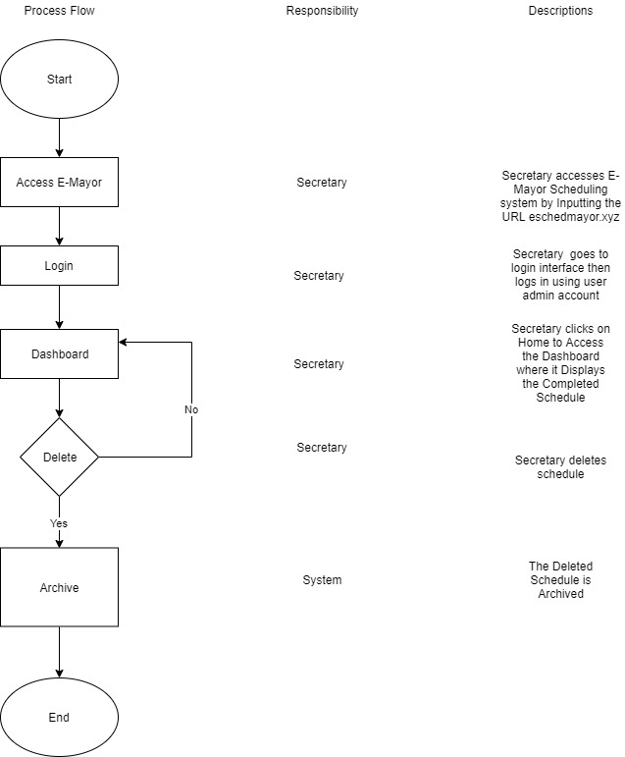

**Process Flow Deleting Completed Schedule.** The figure above shows the flow of the secretary deleting a completed Schedule.

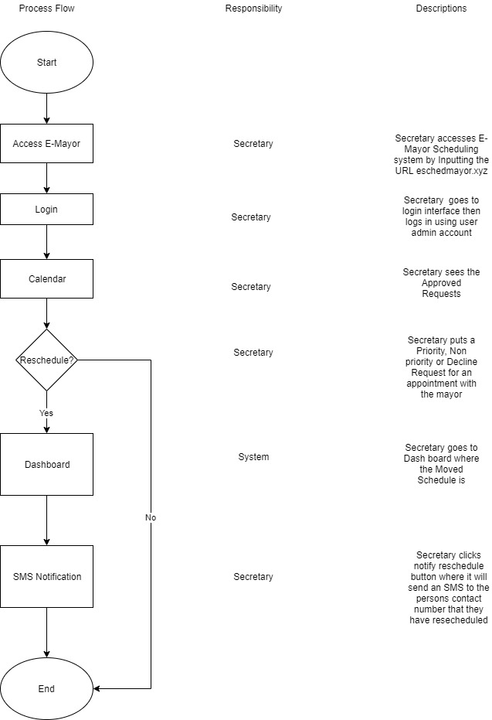

**Process Flow Moving Schedules.** The figure above shows the flow of the secretary moving a schedule and notifying the End User,

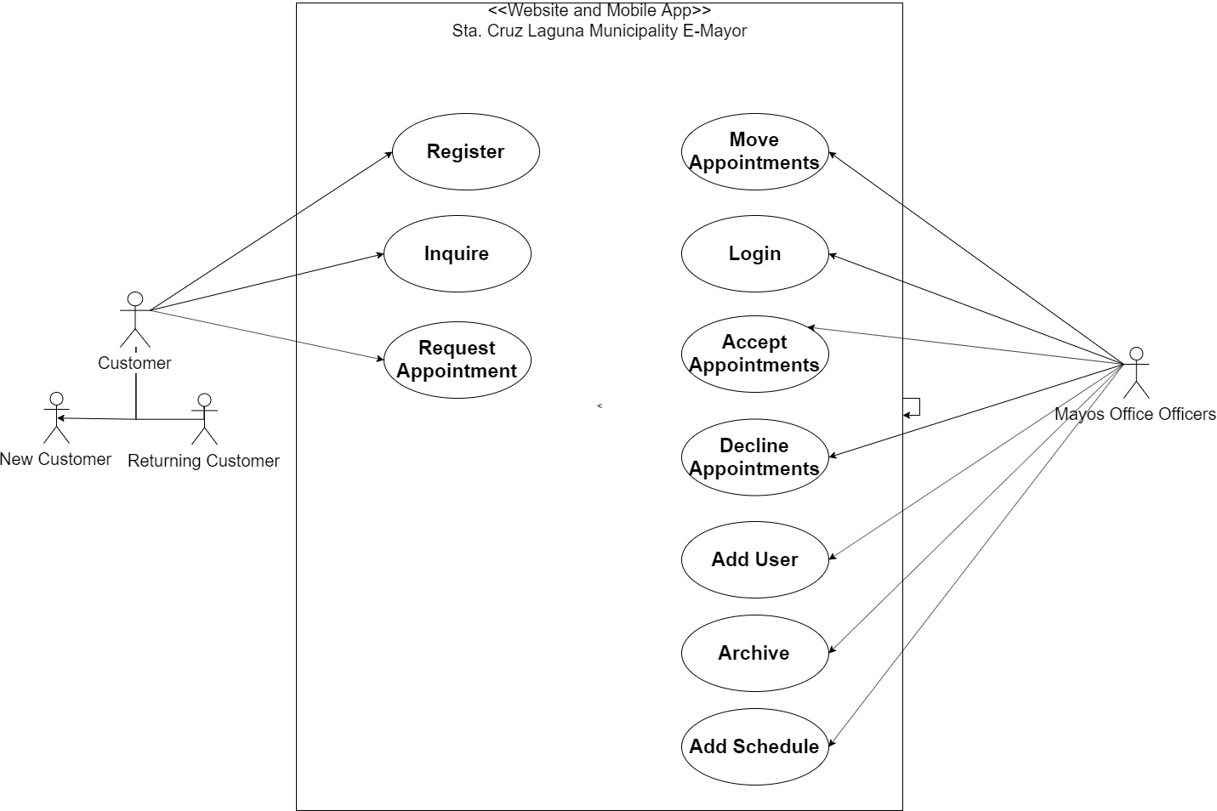

**Use Case Diagram.** The figure above shows the use diagram of the Website and Mobile Application.

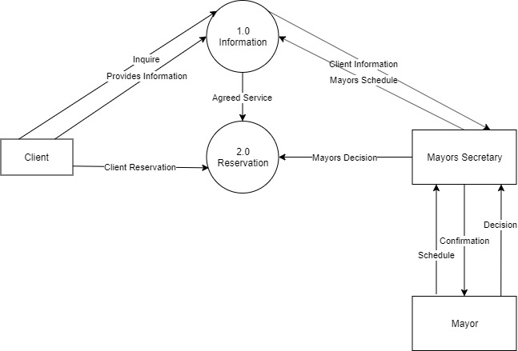**SYSTEM CONTEXT DIAGRAM**

**System Context Diagram.** The figure above shows the use system context diagram

**DATA FLOW DIAGRAM**

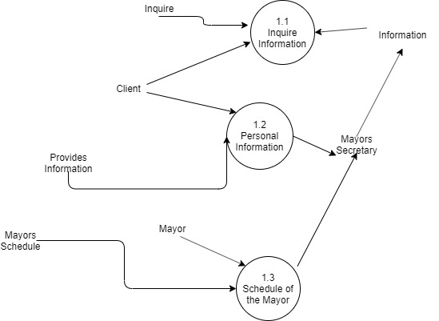

**Data Flow Diagram.** The figure above shows the use data flow diagram

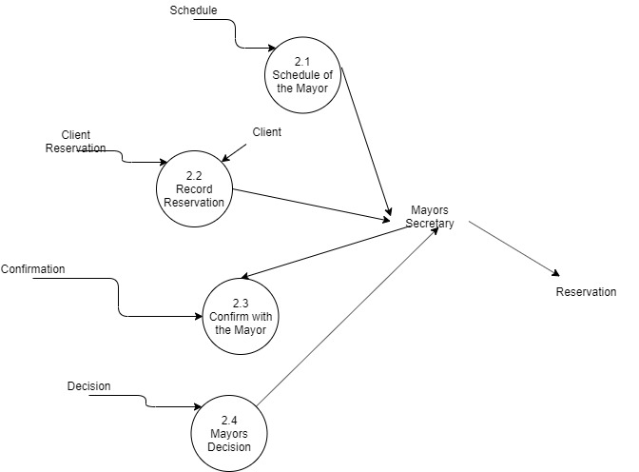

**Data Flow Diagram.** The figure above shows the use data flow diagram

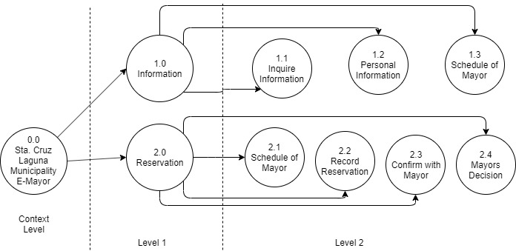

**Data Flow Diagram.** The figure above shows the decomposition data flow diagram

**DATA DICTIONARY**

|  |  |  |  |
| --- | --- | --- | --- |
| Column | Type | Null | Description |
| id (Primary) | int(255) | No | Primary Key |
| userid | varchar(255) | No | User ID |
| notif | int(11) | No | Notification |
| seen | int(11) | No | Seen |
| confirmed | int(11) | No | Confirmed |
| status | varchar(255) | No | Status |
| fname | varchar(255) | No | First Name |
| lname | varchar(255) | No | Last Name |
| cnumber | varchar(11) | No | Contact Number |
| address | varchar(255) | No | Address |
| otp | varchar(10) | No | OTP |
| title | varchar(255) | No | Title |
| etype | text | No | Event type |
| color | varchar(10) | Yes | Event Color |
| start | datetime | No | Event Start Time |
| time | time | Yes | NULL |
| end | datetime | No | Even End Time |

Table 19. **getevent.** Table above shows shows the database design for the End Users which contains their Information

|  |  |  |  |
| --- | --- | --- | --- |
| Column | Type | Null | Description |
| id (Primary) | int(255) | No | Primary Key |
| userid | varchar(255) | No | User ID |
| notif | int(11) | No | Notification |
| seen | int(11) | No | Seen |
| confirmed | int(11) | No | Confirmed |
| status | varchar(255) | No | Status |
| fname | varchar(255) | No | First Name |
| lname | varchar(255) | No | Last Name |
| cnumber | varchar(11) | No | Contact Number |
| address | varchar(255) | No | Address |
| otp | varchar(10) | No | OTP |
| title | varchar(255) | No | Title |
| etype | text | No | Event type |
| color | varchar(10) | Yes | Event Color |
| start | datetime | No | Event Start Time |
| time | time | Yes | Event Time |
| end | datetime | No | Even End Time |

## Table 20. **geteventarchive.** Table above shows shows the database design for the schedules that has been archived

|  |  |  |  |
| --- | --- | --- | --- |
| Column | Type | Null | Description |
| log_id (Primary) | int(11) | No | Log ID |
| username | varchar(55) | No | Username |
| action | varchar(55) | No | User Action |
| time | varchar(55) | No | Time |
| remarks | varchar(55) | No | System Remarks |

Table 21. **Logs.** The table above shows the database design for the System Logs.

|  |  |  |  |
| --- | --- | --- | --- |
| Column | Type | Null | Description |
| user_id | int(11) | No | ID |
| username (Primary) | varchar(55) | No | Username |
| password | varchar(55) | No | Password |
| usertype | varchar(55) | No | User type |
| firstname | varchar(55) | No | First Name |
| lastname | varchar(55) | No | Last Name |
| status | varchar(55) | No | Status |
| contactno | varchar(11) | No | Contact No. |
| date_created | varchar(55) | No | Date Created |
| date_updated | varchar(55) | No | Date Updated |
| date_del | varchar(55) | No | Date Deleted |

Table 22. **new_usearchive** The table above shows the database design for archiving Completed Schedules

|  |  |  |  |
| --- | --- | --- | --- |
| **Column** | **Type** | **Null** | **Description** |
| id (Primary) | int(255) | No | Sched ID |
| userid | varchar(255) | No | User ID |
| notif | int(11) | No | Notification |
| seen | int(11) | No | Seen |
| confirmed | int(11) | No | Confirmed |
| status | varchar(255) | No | Rejected |
| fname | varchar(255) | No | First Name |
| lname | varchar(255) | No | Last Name |
| cnumber | varchar(11) | No | Contact Number |
| address | varchar(255) | No | Address |
| otp | varchar(10) | No | One Time Password |
| title | varchar(255) | No | Event Title |
| etype | text | No | Event Type |
| color | varchar(10) | Yes | *NULL* |
| start | datetime | No | Time Start |
| time | time | Yes | *NULL* |
| end | datetime | No | Time End |

## Table 23. **rejectedsched** The table above shows the database design for archiving Rejected Schedules

|  |  |  |  |
| --- | --- | --- | --- |
| Column | Type | Null | Description |
| user_id (Primary) | int(11) | No | Admin ID |
| username | varchar(255) | No | Username |
| password | varchar(255) | No | Password |
| usertype | varchar(255) | No | User Type |
| firstname | varchar(255) | No | First Name |
| lastname | varchar(255) | No | Last Name |
| status | varchar(255) | No | Status |
| contactno | varchar(55) | No | Contact No. |
| secret | varchar(45) | No | Secret Question |
| ans | varchar(45) | No | Answer |
| date_created | varchar(55) | No | Date Created |
| date_updated | varchar(55) | No | Date Updated |

## Table 24. **user** The table above shows the database design for the list of Admin Account Holders and their Information

## **HIERARCHICHAL INPUT OUPUT PROCESS MODEL**

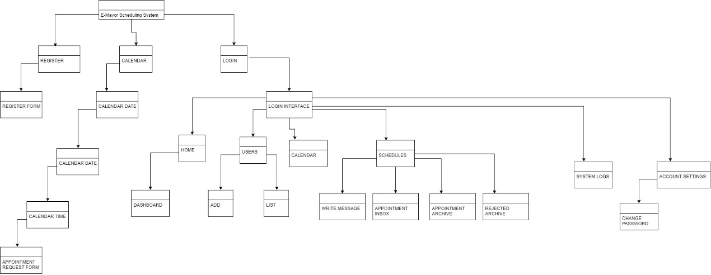

Figure 25. **HIPO.** The figure above shows the Hierarchical Input Output Process Model

In an article by Durugbo, C., Tiwari, A., & Alcock, J. R. (2010). entitled “A review of information flow diagrammatic models for product–service systems. The International Journal of Advanced Manufacturing Technology” A product–service system (PSS) is a combination of products and services to create value for both customers and manufacturers. Modelling a PSS based on function orientation offers a useful way to distinguish system inputs and outputs with regards to how data are consumed and information is used, i.e. information flow. This article presents a review of diagrammatic information flow tools, which are designed to describe a system through its functions.

**Software Project Schedule**

This illustrates the schedule of activities performed or to be performed by the researchers for the development of the study by the use of Gantt chart.

|  |  |  |  |  |  |  |  |  |  |  |  |  |  |  |  |  |  |  |  |
| --- | --- | --- | --- | --- | --- | --- | --- | --- | --- | --- | --- | --- | --- | --- | --- | --- | --- | --- | --- |
| **ACTIVITIES** | **OCT** | | | **NOV** | | | | **DEC** | | | | **JAN** | | | | **FEB** | | | |
| 2 | 3 | 4 | 1 | 2 | 3 | 4 | 1 | 2 | 3 | 4 | 1 | 2 | 3 | 4 | 3 | 4 | 5 | 6 |
| **PRESENTATION OF SYSTEM ANALYSIS** |  |  |  |  |  |  |  |  |  |  |  |  |  |  |  |  |  |  |  |
| Flowchart Designing |  |  |  |  |  |  |  |  |  |  |  |  |  |  |  |  |  |  |  |
| Studying all the Features and Requirements of the System |  |  |  |  |  |  |  |  |  |  |  |  |  |  |  |  |  |  |  |
|  |  |  |  |  |  |  |  |  |  |  |  |  |  |  |  |  |  |  |
| Client consultation |  |  |  |  |  |  |  |  |  |  |  |  |  |  |  |  |  |  |  |
| **Model Designing** |  |  |  |  |  |  |  |  |  |  |  |  |  |  |  |  |  |  |  |
| Information Gathering |  |  |  |  |  |  |  |  |  |  |  |  |  |  |  |  |  |  |  |
| Database Designing |  |  |  |  |  |  |  |  |  |  |  |  |  |  |  |  |  |  |  |
| System Development |  |  |  |  |  |  |  |  |  |  |  |  |  |  |  |  |  |  |  |
| Coding |  |  |  |  |  |  |  |  |  |  |  |  |  |  |  |  |  |  |  |
| Client Consultation |  |  |  |  |  |  |  |  |  |  |  |  |  |  |  |  |  |  |  |
| System Adjustment |  |  |  |  |  |  |  |  |  |  |  |  |  |  |  |  |  |  |  |
| **Testing** |  |  |  |  |  |  |  |  |  |  |  |  |  |  |  |  |  |  |  |
| System Adjustment |  |  |  |  |  |  |  |  |  |  |  |  |  |  |  |  |  |  |  |
| System Testing |  |  |  |  |  |  |  |  |  |  |  |  |  |  |  |  |  |  |  |
| System Adjustment |  |  |  |  |  |  |  |  |  |  |  |  |  |  |  |  |  |  |  |
| Client Consultation |  |  |  |  |  |  |  |  |  |  |  |  |  |  |  |  |  |  |  |
| **Implementation** |  |  |  |  |  |  |  |  |  |  |  |  |  |  |  |  |  |  |  |
| Final Adjustments |  |  |  |  |  |  |  |  |  |  |  |  |  |  |  |  |  |  |  |
| System Implementation |  |  |  |  |  |  |  |  |  |  |  |  |  |  |  |  |  |  |  |
| **Documentation** |  |  |  |  |  |  |  |  |  |  |  |  |  |  |  |  |  |  |  |

**Table 25.** Software Project Schedule. The figure above shows the summary of the activities performed or to be performed by the researchers for the development of the study.

**E-Mayor**

**Users Manual**

**TABLE OF CONTENTS**

**Page**

1.0 GENERAL INFORATION124

1.1 System Overview124

1.2 Authorized Use Permission124

2.0 SYSTEM CONCEPTS124

2.1 Available Actions 124

2.2 System Specification125

3.0 GETTING STARTED125

3.1 System Requirement and Installation125

4.0 How to Request an Appointment (Client User) 126

5.0 Functions of the E-Mayor Website for Admin Users128

5.1 Logging in128

5.2 Dashboard128

5.3 Adding Admin Users129

5.4 Manually Putting in Schedules130

5.5 Moving the Time and Date of Schedules131

5.6 Custom Message132

5.7 Archives132

5.8 Changing Password133

5.9 Accepting/Rejecting Appointment Requests134

5.10 Retrieving Schedules from Archive136

6.0 MOBILE APPLICATION137

6.1 Dashboard137

6.2 Adding Admin Users138

6.3 Manually Inputting Schedules139

6.4 Writing Custom Messages140

6.5 Archive140

6.6 User Logs141

6.7 Changing Password142

6.8 Messages142

# **GENERAL INFORMATION**

## ***System Overview***

E-Mayor Website and Mobile application is designed to provide equal opportunities to the constituents of Sta, Cruz Laguna and citizens outside to request an appointment with the Mayor remotely while helping the Secretary in sorting out the requests and archive the schedules.

## ***Authorized Use Permission***

This document and the corresponding mobile application are part of the CAPSTONE project by the students of College of Computer Studies. Access to the mobile application and website is restricted and consent should be looked for prior to making duplicates. Kindly contact the relevant department for more information.

# **SYSTEM CONCEPTS**

This section provides a step-by-step process on how the application operates with the listed actions available for the website users and mobile users. A complete usage tutorial with examples can be found in the next chapter of this document.

### ***Available actions***

E-Mayor Website and Mobile application (Admin Users)

1. Account Login
2. Add User Admins
3. Manual Inputting Schedules
4. Moving schedules
5. Approving/Rejecting appointment requests
6. Archiving Rejected and Completed Schedules
7. Change Password
8. User Logs

E-Mayor Website (Client Users)

1. Request Appointment

### ***System specification***

Technologies used to construct E-Mayor Website and Mobile application:

* Java with Android SDK
* PHP
* Hostinger
* Sempahore

# **GETTING STARTED**

## ***System requirements and installation***

The mobile application available on the Android platform is compatible with the Android system version 4.0 and higher while the mobile application available while the website is available to any PC

The mobile devices running other platforms are not able to operate the E-Mayor mobile application.

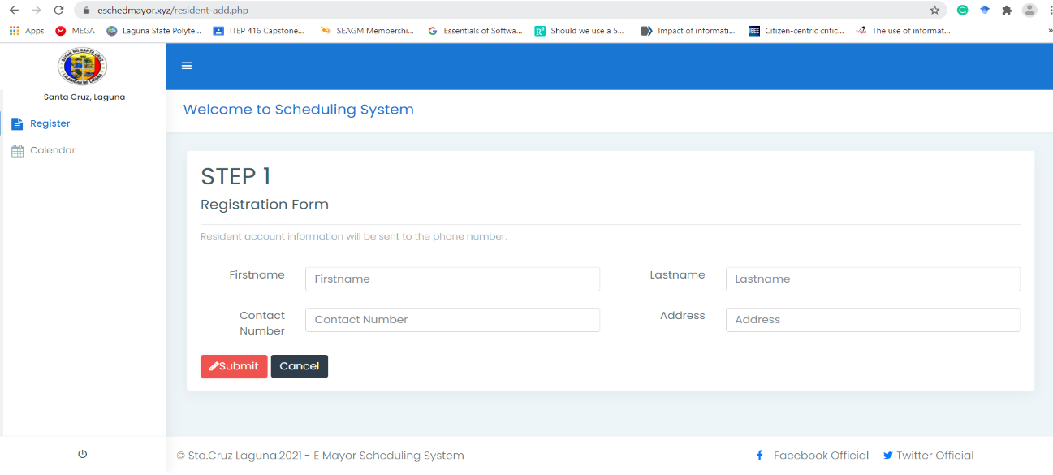**4.0. How to Request an Appointment (Client User)**

Figure 26. **Client Register form/Client User.** The figure above shows the registration form of the E-Mayor

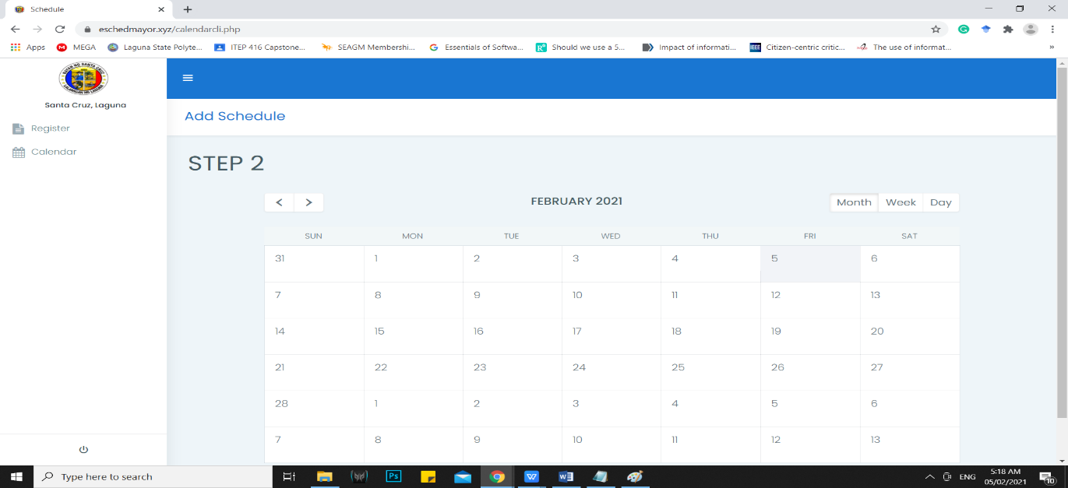In order to use the E-Mayor website, the client must fill in the required information such as Firstname, Lastname, Contact number, and Address. After filling up the required information and pressing submit, the contact number the client provided will receive an OTP number to be used in the next step.

Figure 27. **Calendar/Client User** The figure above shows Calendar for Scheduled Dates

After receiving the OTP, press the calendar button where you will be redirected to a calendar

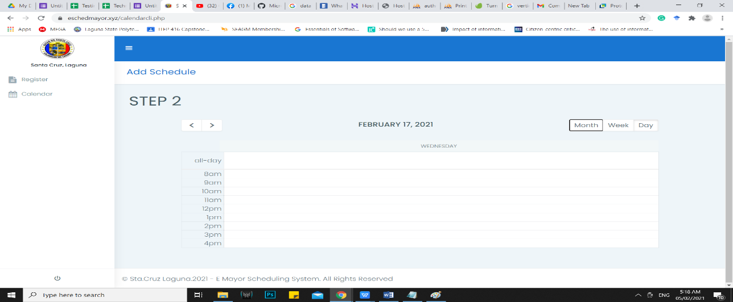

Figure 28. **Time Table/Client User.** The figure above shows a time table to show the vacancies in the mayors’ schedule

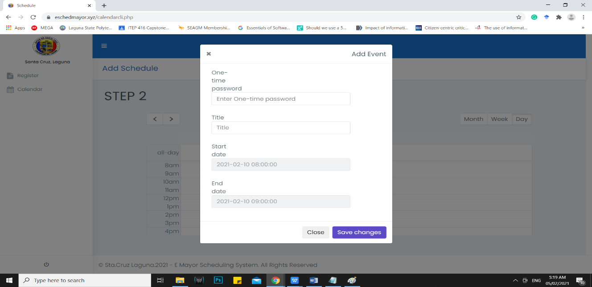Then select a desired date where you will be redirected to different time tables that is either been reserved or not.

Figure 29. **Request Form/Client User.** The figure above shows the appointment request form.

Pick a desired time that is not reserved, after picking it an information box will appear that says to put in the OTP you received and the topic that you want to discuss with the Mayor then press save changes where it will be reviewed by the secretary.

**5.0 FUNCTIONS OF THE E-MAYOR FOR ADMIN USERS**

***5.1 LOGGING IN***

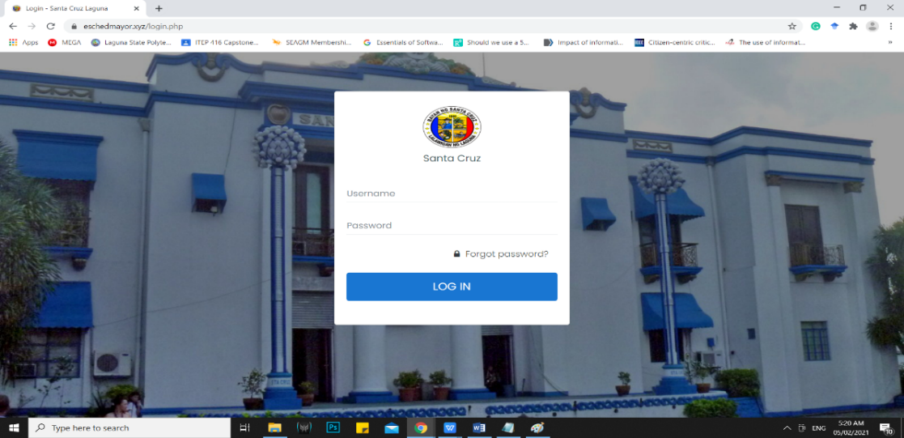

Figure 30. **Login Interface/Admin Users.** The figure above shows the Login Interface for Admin Users in the Website.

In order to use the E-Mayor Website on the Admin Users side, you must first go to the Login Interface and Login with an existing Admin User Account.

***5.2 DASHBOARD***

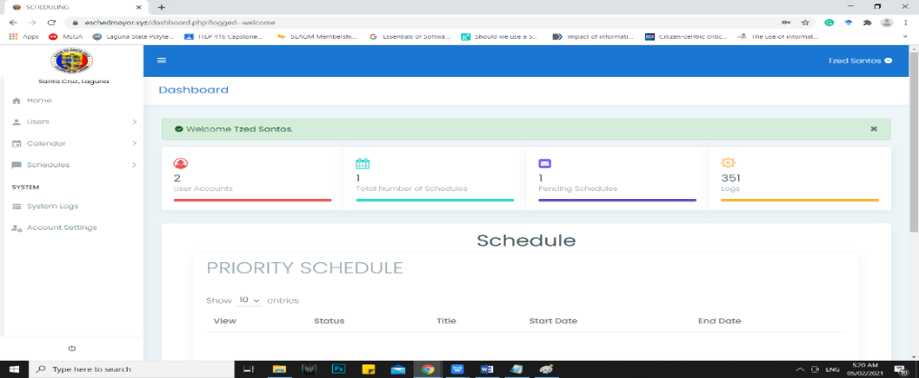

Figure 31. **Dashboard.** The figure above shows the dashboard when opened by an account holder.

The dashboard lets the admin user gets an overall view of the data inside like, how many User Admin Accounts Listed, Total Number of Schedules, Pending Schedules, User Logs, and a table for Prioritized and Non Prioritized Schedules.

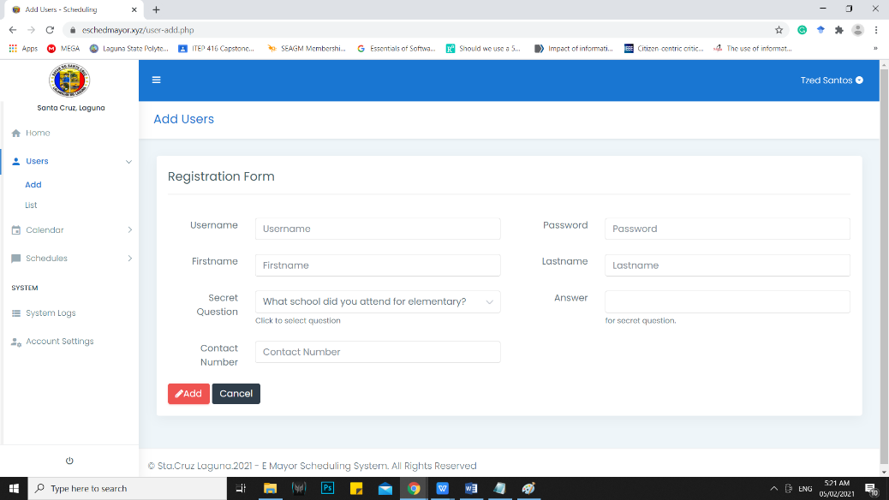**5.3 ADDING ADMIN USERS**

Figure 32. **Add Users.** The figure above shows the registration form for adding new Admin Users

To add new users you must first fill in the required Username, Firstname, Lastname, Password, Secret Question, Answer, and Contact number of the new Admin user account the click add.

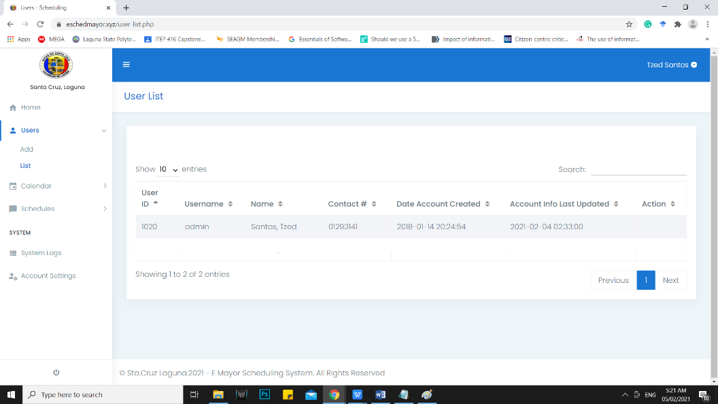

Figure 33**. List**. The figure above shows the list of Admin User Accounts.

After clicking add you will see the new Admin User account in User List.

***5.4 MANUALLY PUTTING IN SCHEDULES***

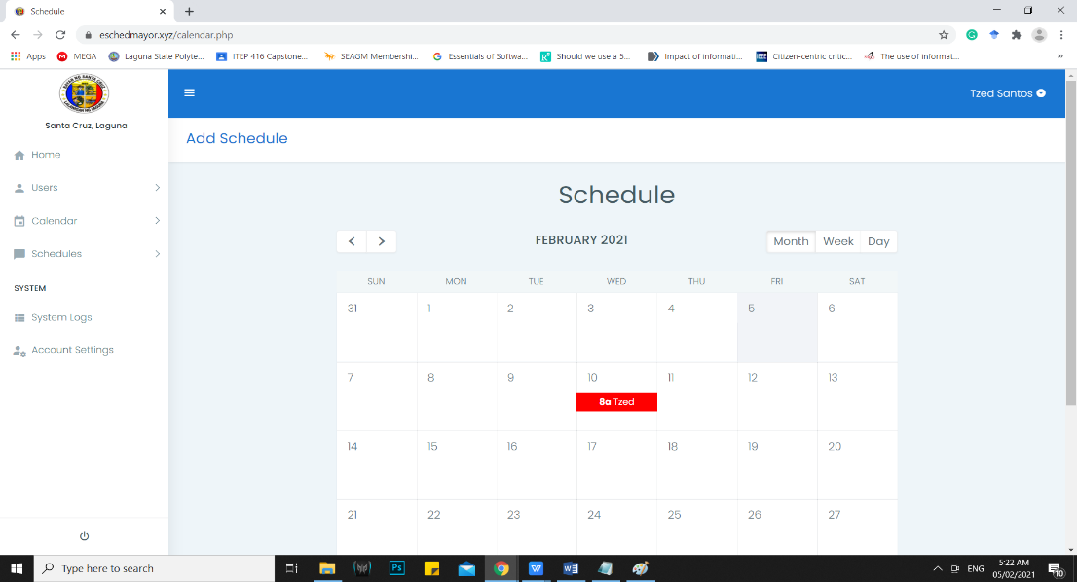

Figure 34. **Calendar.** The figure above shows the calendar

To manually put in schedules you must go to the calendar tab where you will be redirected to a Calendar then press a desired date and time.

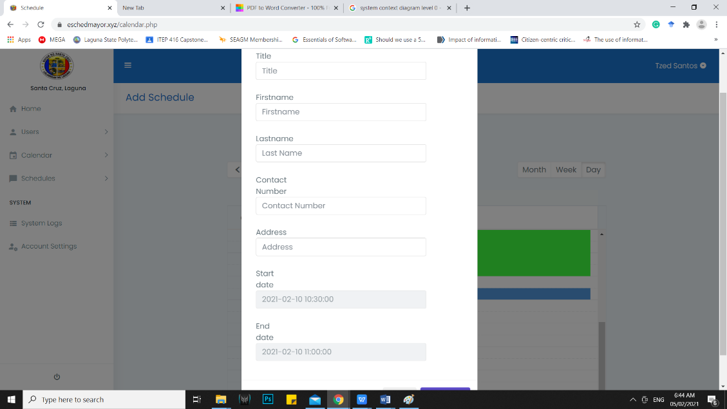

Figure 35**. Manual Scheduling.** The figure above shows how the secretary can manually put in schedules.

After picking a desired time a registration form will appear where you will need to fill up the required Title, First name, last name, Contact Number, and Address then press add.

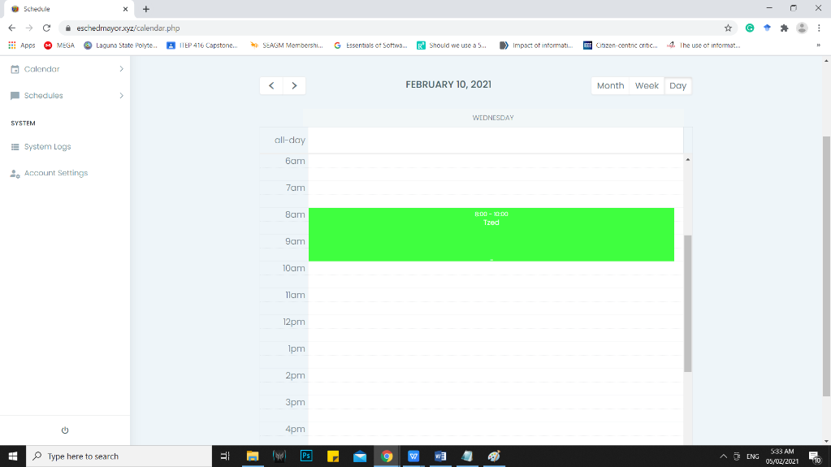***5.5 MOVING THE TIME AND DATE OF SCHEDULES***

Figure 36. **Reserved time and date.** The figure above shows the reserved request.

To extend the time of a requested appointment you must drag the the bottom part of the time and drag it to your desired time.

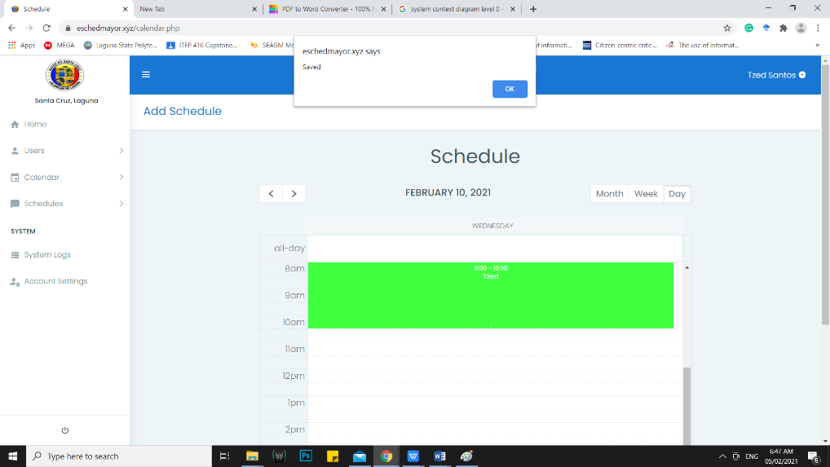

Figure 37. **Extending Time.** The figure above shows how the secretary extending a schedules time by dragging the tip of the schedule to another time.

After dragging it, it will automatically save the moved time.

***5.6 CUSTOM MESSAGE***

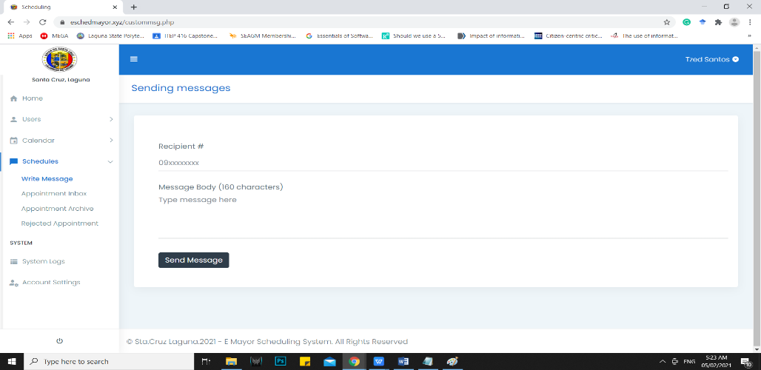

Figure 38. **Custom Message.** The figure above shows the write message.

To construct a custom message you must first go to schedules tab then press the write message section. You will be redirected to a platform that lets you write custom messages.

***5.7 ARCHIVES***

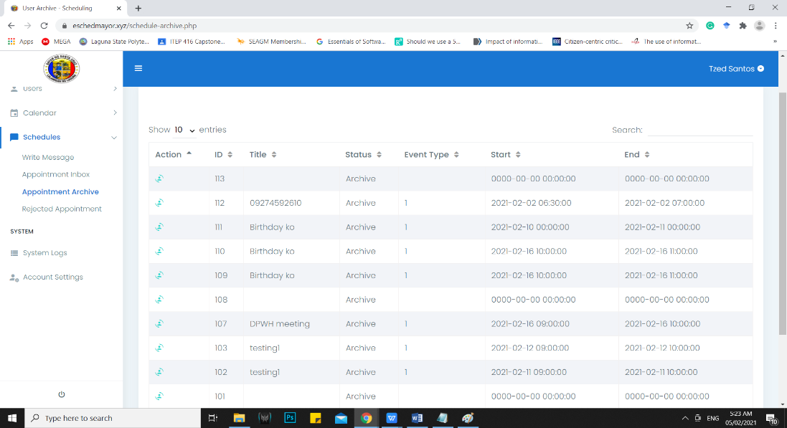

Figure 39. **Appointment Archive.** The figure above shows the appointment archive.

In order to use the appointment archive the admin user must first delete a completed schedules where it goes to the appointment archive for recording and retrieving.

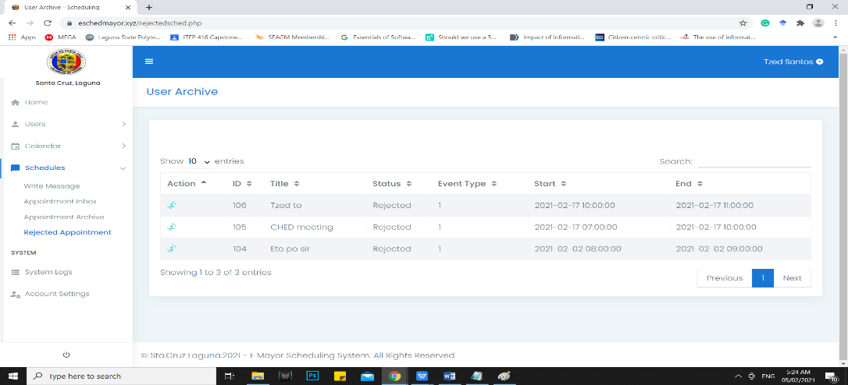

Figure 40. **Rejected Appointment Archive.** The figure above shows the rejected appointment archive.

In order to use the reject appointment archive the admin user must first reject a pending schedule where it will automatically store the schedule in the Rejected Appointment Archive for recording and retrieving.

***5.8 CHANGING PASSWORD***

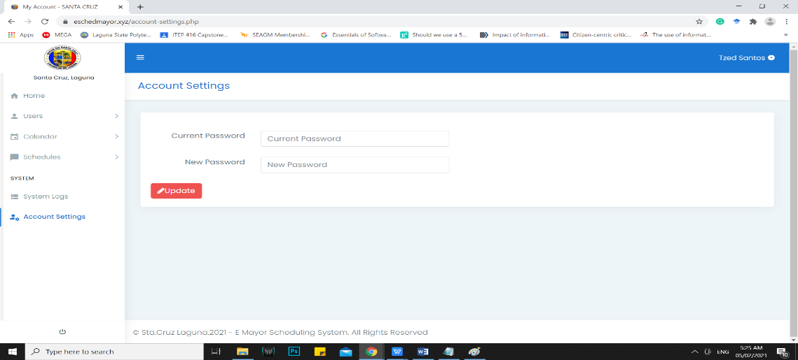

Figure 41. **Account Settings.** The figure above shows the accounts settings.

To use the account setting the admin user must input the current password for the account and put in the new password.

***5.9 ACCEPTING/ REJECTING APPOINTMENT REQUESTS.***

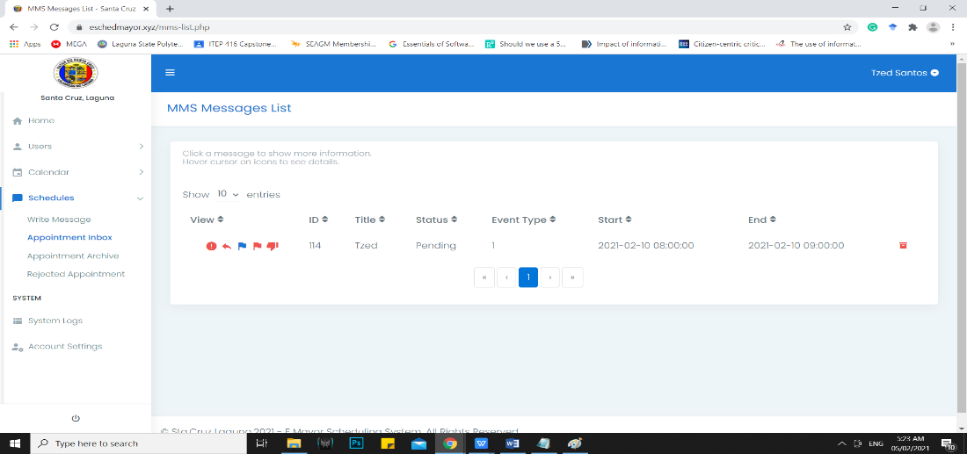

Figure 42. **Appointment Inbox.** The figure above shows the appointment inbox.

To accept/reject a pending schedule the admin user must first go to the Schedules tab and go to the appointment inbox section where it will shows the schedules.

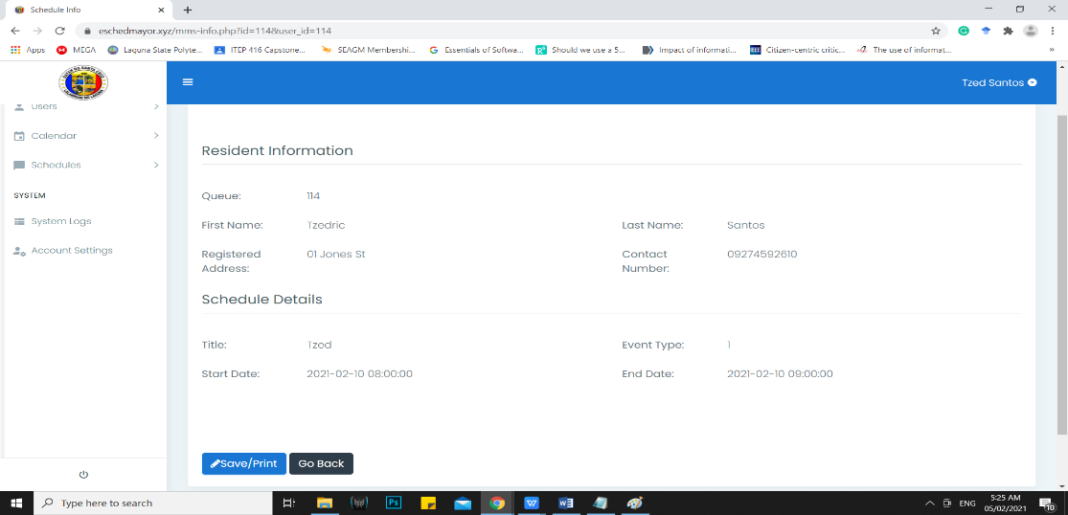

Figure 43. **Resident Information.** The figure above shows the resident information

After that the Admin User will review the Schedule by pressing the Red Exclamation mark where it will show the details inputted by the client user.

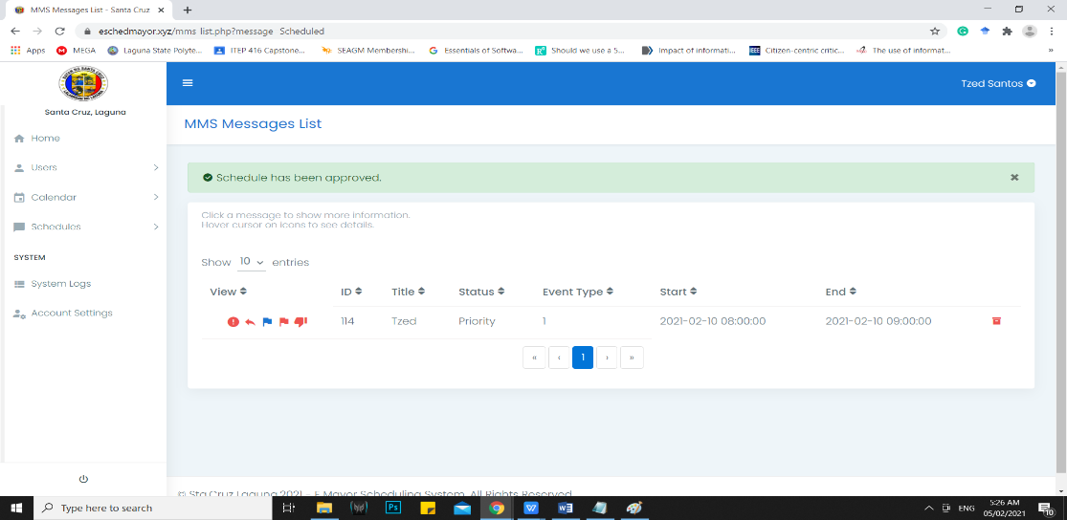

Figure 44. **Approved.** The figure above shows that your request has been approve

Then if the admin user press the blue flag which is priority schedule which lets the admin user approve a schedule it will shows that the schedule has been approved and it will send a SMS to client user that it is approved.

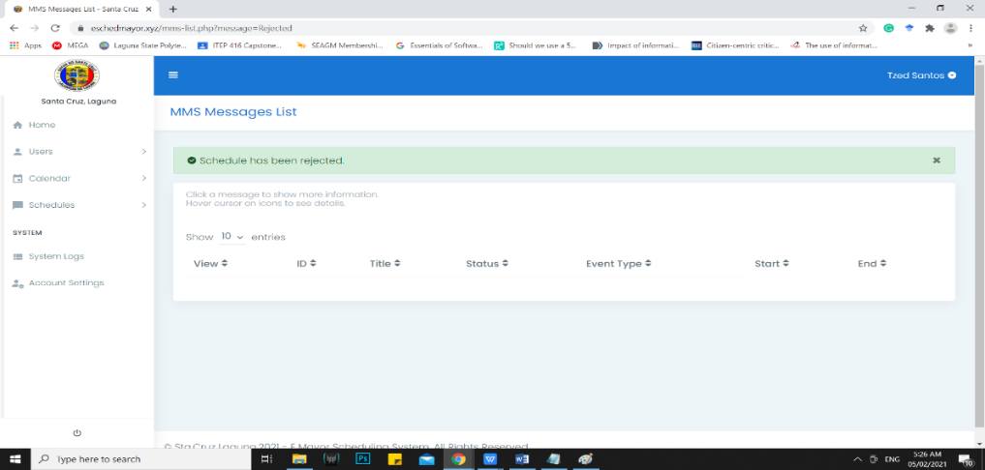

Figure 45. **Rejected.** The figure above shows that your request has been rejected

Then if the admin user press the Red Thumbs Down which is Reject schedule which lets the admin user Reject a schedule it will shows that the schedule has been rejected and it will send a SMS to client user that it is rejected.

***5.10 RETRIEVING SCHEDULES FROM ARCHIVE***

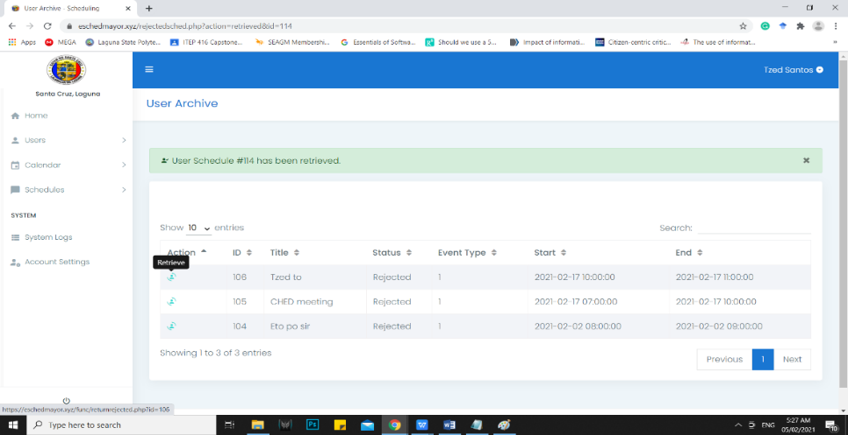

Figure 46. **Retrieve Schedule.** The figure above shows the schedule being retrieved from the Appointment Archive.

To retrieve schedules from the appointment archive the admin user must first go to the appointment archive section then click the blue button besides the archived schedule.

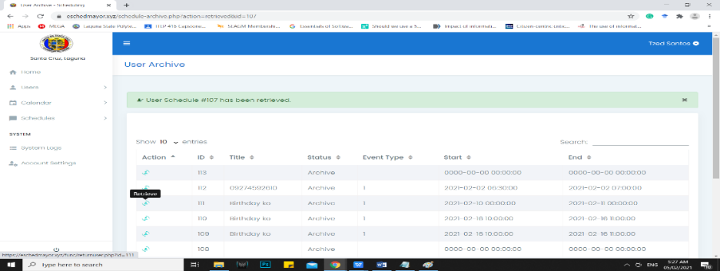

Figure 47**. Retrieve Schedule**. The figure above shows the schedule being retrieved from the Rejected Appointment Archive.

To retrieve schedules from the rejected appointment archive the admin user must first go to rejected appointment archive section then click the blue button besides the archived schedule.

***6.0 MOBILE APPLICATION***

***6.1 LOGGING IN***

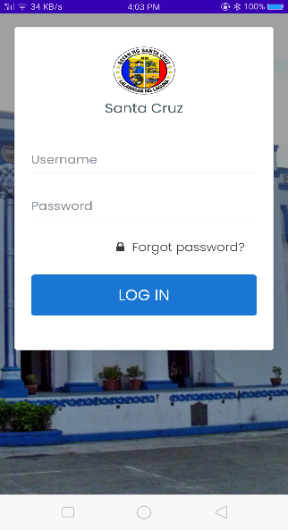

Figure 48**. Login.** The figure above shows the mobile Login Interface.

To use the mobile application the admin user must first log in using the login interface of the E-Mayor Mobile Application.

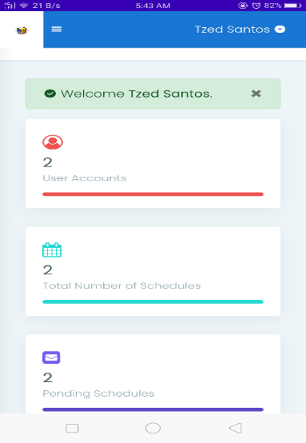***6.1 DASHBOARD***

Figure 49. **Dashboard.** The figure above shows the dashboard when opened in the Mobile Application.

The dashboard lets the admin user gets an overall view of the data inside like, how many User Admin Accounts Listed, Total Number of Schedules, Pending Schedules, User Logs, and a table for Prioritized and Non Prioritized Schedules.

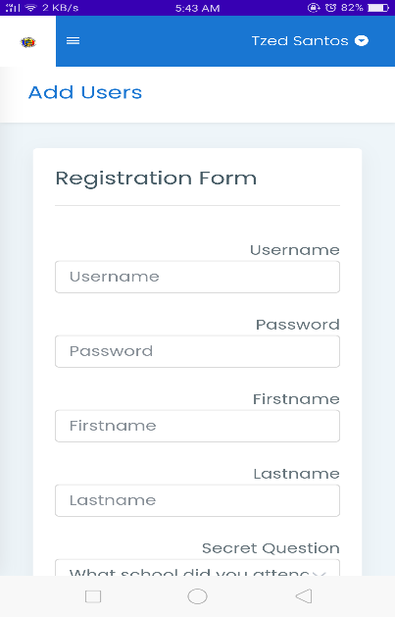***6.2 ADDING ADMIN USERS***

Figure 50. **Add Users.** The figure above shows the registration form for adding new Admin Users through Mobile Application.

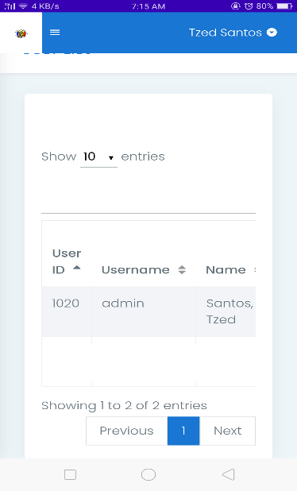To add new users you must first fill in the required Username, Firstname, Lastname, Password, Secret Question, Answer, and Contact number of the new Admin user account the click add.

Figure 51. **List.** The figure above shows the list of Admin User Accounts with the use of Mobile Application.

After clicking add you will see the new Admin User account in User List.

***6.3 MANUALLY INPUTTING SCHEDULES***

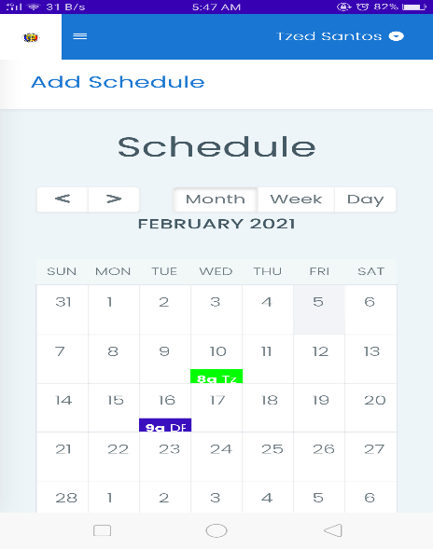

Figure 52. **Calendar.** The figure above shows the calendar that can be used to manually add schedules through mobile application.

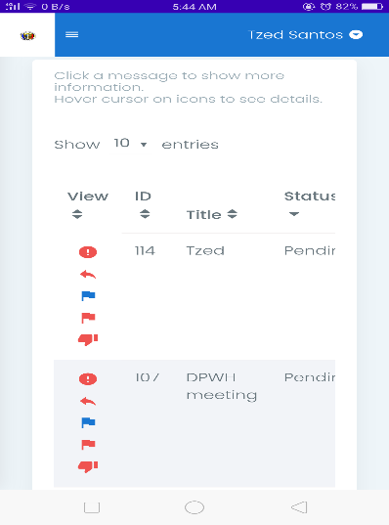To manually put in schedules you must go to the calendar tab where you will be redirected to a Calendar then press a desired date and time. After picking a desired time a registration form will appear where you will need to fill up

Figure 54**. Appointment Inbox.** The figure above shows the appointment inbox through the mobile application.

To accept/reject a pending schedule the admin user must first go to the Schedules tab and go to the appointment inbox section where it will shows the schedules. After that the Admin User will review the Schedule by pressing the Red Exclamation mark where it will show the details inputted by the client user. Then if the admin user press the blue flag which is priority schedule which lets the admin user approve a schedule it will shows that the schedule has been approved and it will send a SMS to client user that it is approved. Then if the admin user press the Red Thumbs Down which is Reject schedule which lets the admin user Reject a schedule it will shows that the schedule has been rejected and it will send a SMS to client user that it is rejected.

***6.4 WRITING CUSTOM MESSAGES***

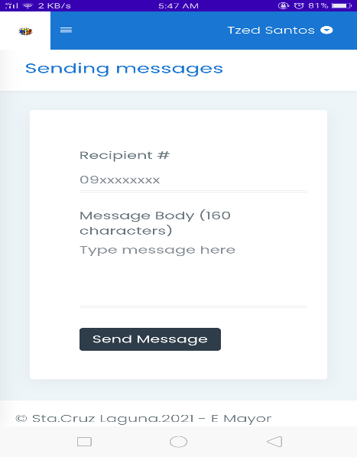

Figure 53. **Write Message.** The figure above shows the write message in the mobile application.

To construct a custom message you must first go to schedules tab then press the write message section. You will be redirected to a platform that lets you write custom messages.

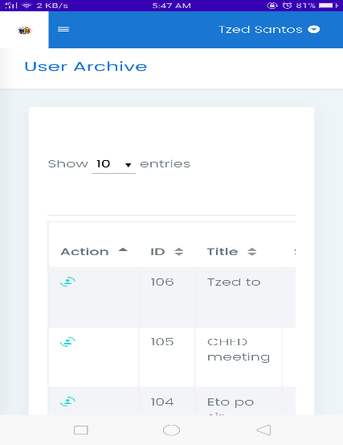***6.5 ARCHIVE***

Figure 55. **Appointment Archive.** The figure above shows the appointment archive through the mobile application.

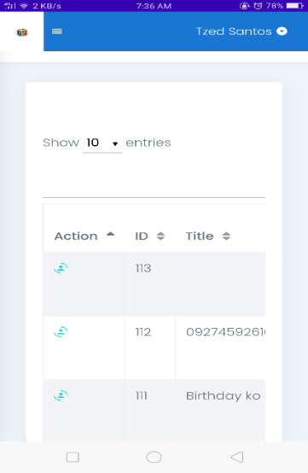In order to use the appointment archive the admin user must first delete a completed schedules where it goes to the appointment archive for recording and retrieving.

Figure 57. **Rejected Appointment Archive.** The figure above shows the rejected appointment archive through the mobile application.

In order to use the reject appointment archive the admin user must first reject a pending schedule where it will automatically store the schedule in the Rejected Appointment Archive for recording and retrieving

**6.6 USER LOGS**

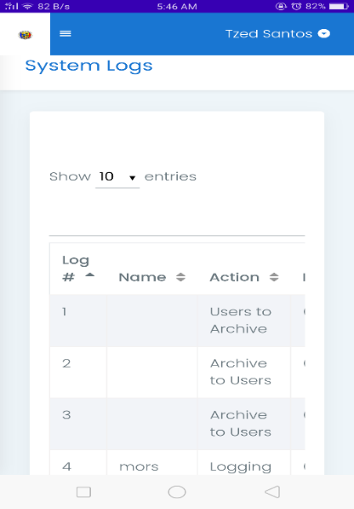

Figure 56. **System Logs.** The figure above shows the system logs through the mobile application

To use the system logs the admin user must first login then press the System Logs button which will display what did the user of an account do and what time they did it.

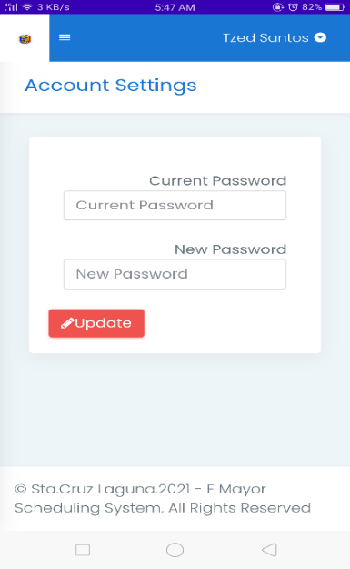***6.7 CHANGING PASSWORD***

Figure 58. **Account Settings.** The figure above shows the account settings.

To change a password for an account the admin user must first login then go to the Account Setting which will display what is needed to change the password specifically the Current Password, then the New Password. After putting in the required information press Update.

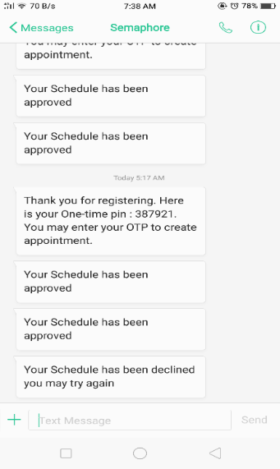***6.8 MESSAGES***

Figure 59. **Messages.** The figure above shows the SMS Notifications of being Registered, Approved and Rejected.

This displays what the user of the E-Mayor will receive when they receive an OTP, being approved or being rejected.

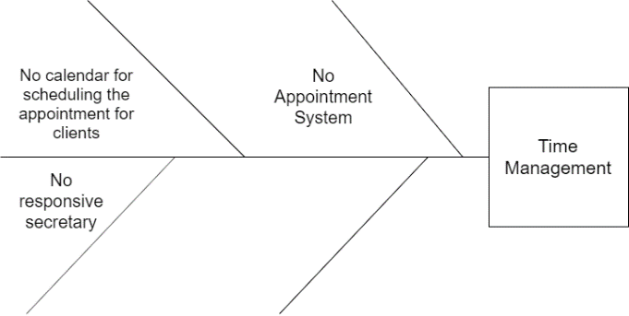**ISHIKAWA DIAGRAM**

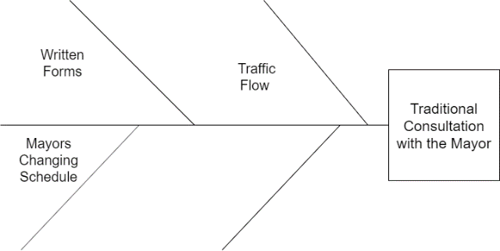Figure 60. Ishikawa Diagram. The figure above shows the various problems in the current process of the scheduling of the Mayor

Figure 61. Ishikawa Diagram. The figure above shows the various problems in the current process of the scheduling of the Mayor.

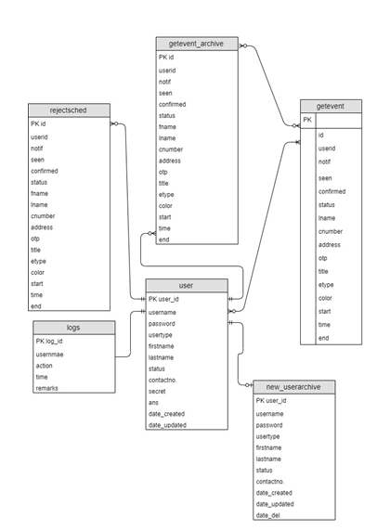**ENTITY RELATIONSHIP DIAGRAM**

Figure 61. ERD. The figure above show the Entity Relation Diagram of the Developed E-Mayor.

**TESTING AND EVALUATION INSTRUCTION**

**Testing Instruction**

|  |  |  |  |  |  |  |  |  |  |  |
| --- | --- | --- | --- | --- | --- | --- | --- | --- | --- | --- |
| Test Case ID | | 1 | Test Case Description | | Test the use of accepting/rejecting requests using mobile app | | | | | |
| Created By | |  | **Reviewed By** | |  | | **Version** | |  | |
|  |  |  |  |  |  |  |  |  |  |  |
| QA Tester’s Log | |  |  |  |  |  |  |  |  |  |
|  |  |  |  |  |  |  |  |  |  |  |
| Tester's Name | |  | **Date Tested** | |  | | **Test Case (Pass/Fail/Not Executed)** | |  | |
|  |  |  |  |  |  |  |  |  |  |  |
| S # | **Prerequisites:** | | |  | **S #** | Test Data | | | | |
| 1 | Mobile Application | | |  | 1 |  | | | | |
| 2 | Internet Connection | | |  | 2 |  | | | | |
| 3 |  | | |  | 3 |  | | | | |
| 4 |  | | |  | 4 |  | | | | |
|  |  |  |  |  |  |  |  |  |  |  |
|  |  |  |  |  |  |  |  |  |  |  |
| Test Scenario | Admin  User | MOBILE APPLICATION ACCEPTING/REJECTING REQUESTS |  |  |  |  |  |  |  |  |
|  |  |  |  |  |  |  |  |  |  |  |
| Step # | **Step Details** | | **Expected Results** | | **Actual Results** | | | **Passed** | **Failed** |  |
|  |
| 1 | Open Mobile Application | | Displays Login Interface | |  | | |  |  |  |
| 3 | Enter Credentials | | Credentials can be entered | |  | | |  |  |  |
| 4 | Click Submit | | Admin User is logged in | |  | | |  |  |  |
| 5 | Access the User Admin Account | | Displays the dashboard which displays the active admin accounts, messages received, and logs. The left side of displays the Home Button which contains the dashboard, the Users button in which contains a subsection of Add, List and Archive, a Calendar, Schedules, System Logs, and Account Settings | |  | | |  |  |  |
| 6 | Tap **“Schedule Button”** | | Displays different options of “Write Message”, **“Appointment Inbox” , “Appointment Archive, and “Rejected Appointment Archive”** | |  | | |  |  |  |
|  | Tap **“Appointment Inbox”** | | Displays the Appointment Requests | |  | | |  |  |  |
| 7 | Tap **“Blue Flag”** | | Clicking the **“Blue Double Arrow”** besides a pending schedule will let the admin user accept and move it to the **“Priority Schedules”** which the system will send a SMS Response to the client user that the Appointment Request is accepted. | |  | | |  |  |  |
| 8 | Click the **“Red Thumbs Down Button”** | | Clicking the **“Red Exclamation Mark”** besides a pending schedule will let the admin user reject the request inwhich the system will send a SMS Response to the client user that the Appointment Request is rejected. | |  | | |  |  |  |
| 9 | Click the **“Red Flag”** | | Clicking the **“Red Flag”** besides a pending schedule will let the admin user accept and move it to the **“Non-Priority Schedules”** which the system will send a SMS Response to the client user that the Appointment Request is accepted. | |  | | |  |  |  |
| 10 | Click the “**Red Exclamation Mark Button”** | | Clicking the **“Red Exclamation Mark Button”** will display the info inputted by the Client User. | |  | | |  |  |  |
|  | Click the “Red Arrow” | | Clicking the “Red Arrow” will notify an Accepted Appointment that their reservation is moved via SMS | |  | | |  |  |  |

|  |  |  |  |  |  |  |  |  |  |  |
| --- | --- | --- | --- | --- | --- | --- | --- | --- | --- | --- |
| Test Case ID | | 2 | Test Case Description | | Test the use of appointment reservation using website. | | | | | |
| Created By | |  | **Reviewed By** | |  | | **Version** | |  | |
|  |  |  |  |  |  |  |  |  |  |  | |
| QA Tester’s Log | |  |  |  |  |  |  |  |  |  | |
|  |  |  |  |  |  |  |  |  |  |  | |
| Tester's Name | |  | **Date Tested** | |  | | **Test Case (Pass/Fail/Not Executed)** | |  | |
|  |  |  |  |  |  |  |  |  |  |  | |
| S # | **Prerequisites:** | | |  | **S #** | **Test Data** | | | | | |
| 1 | Web Browser | | |  | 1 |  | | | | | |
| 2 | Internet Connection | | |  | 2 |  | | | | | |
| 3 |  | | |  | 3 |  | | | | | |
| 4 |  | | |  | 4 |  | | | | | |
|  |  |  |  |  |  |  |  |  |  |  | |
|  |  |  |  |  |  |  |  |  |  |  | |
| Test Scenario | End User | WEBSITE APPOINTMENT RESERVATION |  |  |  |  |  |  |  |  | |
|  |  |  |  |  |  |  |  |  |  |  | |
| Step # | **Step Details** | | **Expected Results** | | **Actual Results** | | | **Passed** | **Failed** |  | |
|  |  |  |  |  |  |  |  |  | |
| 1 | Navigate to website | | Site should open | |  | | |  |  |  | |
| 2 | Fill Up Registration Form | | Fill up registration form which consists of First Name, Contact Number, Last Name, Address then press add. | |  | | |  |  |  | |
| 3 | Receiving the OTP | | After filling up the form you should receive an OTP. | |  | | |  |  |  | |
| 4 | Tap Left Menu | | Displays Left Menu Options which consists of Home, Calendar. | |  | | |  |  |  | |
| 5 | Tap **“Calendar”** | | Displays a Calendar that when clicked on your desired date will display if it is booked or not on a desired time. | |  | | |  |  |  | |
| 6 | Booking for an Appointment | | Clicking your desired time on a desired date, a modal will appear which will Display a registration form which the user must fill it consists of the One Time Password, Event Title, Event Time, Event Date | |  | | |  |  |  | |
| 7 | Confirmation | | The appointment is confirmed | |  | | |  |  |  | |
| 8 | Rejected | | The appointment is rejected | |  | | |  |  |  | |
| 9 | SMS Confirmation | | Based on the decision of the secretary the system will send an SMS Response to the Client User | |  | | |  |  |  | |

|  |  |  |  |  |  |  |  |  |  |  |  |  |  |  |  |  |  |  |  |
| --- | --- | --- | --- | --- | --- | --- | --- | --- | --- | --- | --- | --- | --- | --- | --- | --- | --- | --- | --- |
| Test Case ID | | 3 | | Test Case Description | | | | Testing the function of the website accepting appointment requests. | | | | | | | | | | | |
| Created By | |  | | **Reviewed By** | | | |  | | | | **Version** | | | |  | | | |
|  |  | |  | |  | |  | |  | |  | |  | |  | |
| QA Tester’s Log | |  | |  | |  | |  | |  | |  | |  | |  | | |  |
|  |  | |  | |  | |  | |  | |  | |  | |  | |  |
| Tester's Name | |  | | **Date Tested** | | | |  | | | | **Test Case (Pass/Fail/Not Executed)** | | | |  | | | |
|  |  | |  | |  | |  | |  | |  | |  | |  | |  |
| S # | **Prerequisites:** | | | | | |  | | **S #** | | **Test Data** | | | | | | | | |
| 1 | Web Browser | | | | | |  | | 1 | | Admin User ID- admin Password- admin123 | | | | | | | | |
| 2 | Internet Connection | | | | | |  | | 2 | |  | | | | | | | | |
| 3 |  | | | | | |  | | 3 | |  | | | | | | | | |
| 4 |  | | | | | |  | | 4 | |  | | | | | | | | |
|  |  | |  | |  | |  | |  | |  | |  | |  | |  | | | |  |
| Test Scenario | Admin User | | ACCEPTS, AND REJECTS REQUEST MADE | |  | |  | |  | |  | |  | |  | |  | | | |  |
| Step # | **Step Details** | | | | **Expected Results** | | | | **Actual Results** | | | | | | **Passed** | | **Failed** | | | |  |
|  |  | |  | |  | |  | |  | |  | |  | |  |
| 1 | Navigate to website | | | | Site should open | | | |  | | | | | |  | |  | | | |  |
| 2 | Click the **“Login button”** | | | | Displays a LOGIN interface with the login requirements Username and Password | | | |  | | | | | |  | |  | | | |  |
| 3 | Enter Credentials | | | | Credentials can be entered | | | |  | | | | | |  | |  | | | |  |
| 4 | Click Submit | | | | User Admin is logged in | | | |  | | | | | |  | |  | | | |  |
| 5 | Accesses the User Admin Page | | | | Displays the dashboard which displays the active admin accounts, messages received, and logs. The left side of displays the Home Button which contains the dashboard, the Users button in which contains a subsection of Add, List and Archive, a Calendar, Schedules, System Logs, and Account Settings | | | |  | | | | | |  | |  | | | |  |
| 6 | Click **“Schedule Button”** | | | | Displays different options of “Write Message”, **“Appointment Inbox” , “Appointment Archive, and “Rejected Appointment Archive”** | | | |  | | | | | |  | |  | | | |  |
| 7 | Click **“Appointment Inbox”** | | | | Displays Appointments Requests | | | |  | | | | | |  | |  | | | |  |
| 8 | Click the **“Blue Flag”** | | | | Clicking the **“Blue Double Arrow”** besides a pending schedule will let the admin user accept and move it to the **“Priority Schedules”** which the system will send a SMS Response to the client user that the Appointment Request is accepted. | | | |  | | | | | |  | |  | | | |  |
| 9 | Click the **“Red Thumbs Down Button”** | | | | Clicking the **“Red Exclamation Mark”** besides a pending schedule will let the admin user reject the request inwhich the system will send a SMS Response to the client user that the Appointment Request is rejected. | | | |  | | | | | |  | |  | | | |  |
| 10 | Click the **“Red Flag”** | | | | Clicking the **“Red Flag”** besides a pending schedule will let the admin user accept and move it to the **“Non-Priority Schedules”** which the system will send a SMS Response to the client user that the Appointment Request is accepted. | | | |  | | | | | |  | |  | | | |  |

|  |  |  |  |  |  |  |  |  |  |  |
| --- | --- | --- | --- | --- | --- | --- | --- | --- | --- | --- |
| Test Case ID | | 4 | Test Case Description | | Test the manual inputting of Schedules | | | | | |
| Created By | |  | **Reviewed By** | |  | | **Version** | |  | |
|  |  |  |  |  |  |  |  |  |  |  |
| QA Tester’s Log | |  |  |  |  |  |  |  |  |  |
|  |  |  |  |  |  |  |  |  |  |  |
| Tester's Name | |  | **Date Tested** | |  | | **Test Case (Pass/Fail/Not Executed)** | |  | |
|  |  |  |  |  |  |  |  |  |  |  |
| S # | **Prerequisites:** | | |  | **S #** | **Test Data** | | | | |
| 1 | Web Browser | | |  | 1 | Super User = Username: zero Password: 123 | | | | |
| 2 | Internet Connection | | |  | 2 |  | | | | |
| 3 |  | | |  | 3 |  | | | | |
| 4 |  | | |  | 4 |  | | | | |
|  |  |  |  |  |  |  |  |  |  |  |
| Test Scenario | Super User |  |  |  |  |  |  |  |  |  |
|  |  |  |  |  |  |  |  |  |  |  |
| Step # | **Step Details** |  | **Expected Results** | | **Actual Results** | | | **Passed** | **Failed** |  |
|  |  |  |  |  |  |  |  |  |
| 1 | Navigate to website | | Site should open | |  | | |  |  |  |
| 2 | Click the **“Login button”** | | Displays a LOGIN interface with the login requirements Username and Password | |  | | |  |  |  |
| 3 | Enter Credentials | | Credentials can be entered | |  | | |  |  |  |
| 4 | Click Submit | | Admin User is Logged in | |  | | |  |  |  |
| 5 | Access Admin User Page | | Displays the dashboard which displays the active admin accounts, messages received, and logs. The left side of displays the Home Button which contains the dashboard, the Users button in which contains a subsection of Add, List and Archive, a Calendar, Schedules, System Logs, and Account Settings | |  | | |  |  |  |
|  |  | |  | |  | | |  |  |  |
|  | Navigate to **“Calendar”** | | Displays a Calendar | |  | | |  |  |  |
|  | Click desired date in the **“Calendar”** | | Clicking a Date in the “Calendar” a modal will display an Appointment form | |  | | |  |  |  |
|  | Clicking desired time in “**Calendar”** | | Clicking a desired Time in a Date a modal will appear with an Appointment Form | |  | | |  |  |  |
|  | Fill Up Requirements | | The Appointment Form which consists of Name, Contact #, Address, Email Address, Subject Title,  Time and Date must be filled. | |  | | |  |  |  |
|  | Click “Confirm” | | Clicking the Confirm button the User Admin will receive the request in the Pending Schedules. | |  | | |  |  |  |

|  |
| --- |
| **Technology Acceptance Questionnaire**  Dear Respondents,  Greetings in the name of the Lords!  The purpose of the questionnaire to assess the user acceptance and behavioural intention of using the developed system “**e-Mayor**”. This study is conducted to enhance the current scheduling management system of the Mayor’s Office specifically a mobile application that handles online inquiry, scheduling portability, SMS integration for schedule confirmation and user management to assist and support he Mayor’s Office in handling appointment, events and schedule Municipal Mayor of Sta.Cruz, Laguna.  The first part is the respondent’s data, and the second part is the assessment of the user acceptance and behavioural intention of using the developed web and mobile application.  I am seeking for your assistance and support as a respondent to this study. Rest assured that your data and responses would be protected and treated with utmost confidentiality.  Thank you so much for your help and God bless  Sincerely,  **Tzedric Kristiann V. Santos** |

**Part 1: Respondents Data**

**Directions:** Please fill in the following information

**Name of the Respondents (*optional*):** _____**Position**:__________________

**Directions**: Kindly **shade** the box on the corresponding information needed

Age:

* 15-20
* 21-30
* 31-40
* 41-50
* 51-60
* 61-70
* 71-80
* 81-90
* 91-100

Education:High school Graduate

* College Graduate

**Level Proficiency**

* Level 1 - Fundamental Skills (Typing, Mouse)
* Level 2 - Basic Computing and Applications.
* Level 3 - Intermediate Computing and Applications.
* Level 4 - Advanced Computing and Applications.
* Level 5 - Proficient Computing, Applications, and Programming

**Part 2: Technology Acceptance Questionnaire**

**Directions:** Kindly put CHECK ( ) on the corresponding scale to indicate your level of acceptance relative to each question. Indicate your acceptability with the following statement using the following scale:

**1** – Totally unacceptable, **2** – Unacceptable, **3** – Slightly unacceptable, **4** – Neutral, **5** – Slightly acceptable, **6** – Acceptable, **7** – Perfectly Acceptable)

You may also indicate your comment and suggestions at the last part of the questionnaire.

|  |  |  |  |  |  |  |  |
| --- | --- | --- | --- | --- | --- | --- | --- |
| **QUALITY FACTORS** | **1** | **2** | **3** | **4** | **5** | **6** | **7** |
| 1. **Correctness:**  The developed system provides correct and accurate results in providing an up-to-date information about the availability of the Municipality Mayor for public viewing. |  |  |  |  |  |  |  |
| 1. **Reliability:** The developed system has all the necessary functions and features that would help and assist with Municipal Mayor Secretary duties and responsibilities in handling Municipal Mayor’s schedule management. |  |  |  |  |  |  |  |
| 1. **Efficiency:** The developed system covers complete and relevant features specific tasks for different user roles and using the developed system the users and achieve their specific job roles. |  |  |  |  |  |  |  |
| 1. **Integrity:** The developed system provides comprehensive user role management and provide users with password security and SMS Notifications to the end user Municipal Mayor Secretary and Municipal Mayor . |  |  |  |  |  |  |  |
| **PERCEIVE EASE OF USE** | 1 | 2 | 3 | 4 | 5 | 6 | 7 |
| 1. **Learnability:** The developed system does not require much effort in terms of understanding the flow of the system. |  |  |  |  |  |  |  |
| 1. **Understandability:** My interaction with the developed system is be clear and understandable. |  |  |  |  |  |  |  |
| 1. **Operability:** The functions of the system help lessen the effort of secretary in their task of transferring, retrieving, recording of schedule data. |  |  |  |  |  |  |  |
| 1. **Attractiveness:** I find the software user interface pleasing and satisfying interaction. |  |  |  |  |  |  |  |
| **PERCEIVED USEFULNESS** | 1 | 2 | 3 | 4 | 5 | 6 | 7 |
| 1. **Operability:** The developed system has exceptional features that make it easy to operate and control |  |  |  |  |  |  |  |
| 1. **Usability:** Using this software product in my jobwould enable me to accomplish my tasks more quickly and improve my job performance. |  |  |  |  |  |  |  |
| 1. **Efficiency:** The developed system generates automatically stores appointment requests and responses to Accepted/Rejected requests efficiently. |  |  |  |  |  |  |  |
| 1. **Functional Completeness:** The developed system has useful and sufficient features that would generate information clearly and effortlessly. |  |  |  |  |  |  |  |
|  |  |  |  |  |  |  |  |
| **ATTITUDE TOWARDS USING** | 1 | 2 | 3 | 4 | 5 | 6 | 7 |
| 1. The developed system will help me to save time and effort in terms of making an appointment with the mayor. |  |  |  |  |  |  |  |
| 1. The developed system will be helpful to the Mayors Office Personnel who is in charge in safekeeping, recording of data and for the viewing of schedules of the Mayor. |  |  |  |  |  |  |  |
| 1. The developed system is reliable in terms of getting the Data provided by the user. |  |  |  |  |  |  |  |
| 1. The developed system is reliable in giving an automatic SMS Response. |  |  |  |  |  |  |  |
| **BEHAVIORAL INTENTION TO USE** | 1 | 2 | 3 | 4 | 5 | 6 | 7 |
| 1. I am willing to use this software product in my job. |  |  |  |  |  |  |  |
| 1. I am willing to learn and adopt this developed system. |  |  |  |  |  |  |  |
| 1. I am satisfied in terms of the over-all flow of the system |  |  |  |  |  |  |  |
| 1. I am willing to participate in the usage and enhancement of the developed system. |  |  |  |  |  |  |  |
| **EXPERIENCE** | 1 | 2 | 3 | 4 | 5 | 6 | 7 |
| 1. I can easily navigate and utilize the developed system in variety of process like making an appointment, retrieving archived schedules, recording schedules, and viewing of schedules. |  |  |  |  |  |  |  |
| 1. I never experience errors or system failure on making an appointment, retrieving archived schedules, recording schedules, and viewing of schedules. |  |  |  |  |  |  |  |
| 1. Using this developed system, I can handle more transactions than the current process we have. |  |  |  |  |  |  |  |
| 1. The system will bring convenience and smooth operations to the Sta. Cruz Laguna Municipality |  |  |  |  |  |  |  |

**Feel free to write a comment if you have any suggestion or recommendations. Please state it here:**

Childers, S. (2003, September 7). Computer Literacy: Necessity or Buzzword? Https://Digitalcommons.Unl.Edu/Cgi/Viewcontent.Cgi?Article=1096&context=libraryscience. https://digitalcommons.unl.edu/cgi/viewcontent.cgi?article=1096&context=libraryscienc

**Evaluated By:**

|  |
| --- |
|  |
| Respondents |

**IMPLEMENTATION PLAN**

**Table 38.** Implementation Plan

|  |  |  |  |
| --- | --- | --- | --- |
| **DATE** |  | **IMPLEMEMTATION** | **RESPONDENTS** |
| February 6, 2020 |  | Orientation & user’s evaluation of the developed system for the Constituents and a Secretary of the Mayors office of Sta.Cruz Laguna | Contituents of Sta. Cruz Laguna |
| February 7, 2020 |  | Black Box Testing with IT Experts | Head Researcher |
| February 9, 2020 |  | Orientation & user’s evaluation for the faculty of Gatid Elementary School | Faculty Members |
|  |  |  |  |

The table above shows the implementation plan of the developed system which includes the date it was conducted, the purpose of the activity as well as the people involve on specific scenarios. It also serves as accomplishment chart of the researcher during the orientation and users evaluation of the developed system.

**SOURCE CODES**

<?php

require_once('load.php');

$sql = "SELECT id, title, etype, start, end, color FROM getevent ";

$req = $load->prepare($sql);

$req->execute();

$events = $req->fetchAll();

?>

<!DOCTYPE html>

<html lang="en">

<head>

<meta charset="utf-8">

<meta http-equiv="X-UA-Compatible" content="IE=edge">

<meta name="viewport" content="width=device-width, initial-scale=1">

<meta name="description" content="">

<meta name="author" content="">

<title>Schedule</title>

<link rel="icon" type="image/png" sizes="16x16" href="assets/images/emayor.ico">

<!-- FullCalendar -->

<link href="assets/plugins/calendar/dist/fullcalendar.css" rel="stylesheet"/>

<link href="assets/plugins/bootstrap/css/bootstrap.min.css" rel="stylesheet">

<!-- Custom CSS -->

<link href="css/style.css" rel="stylesheet">

<!-- You can change the theme colors from here -->

<link href="css/colors/blue.css" id="theme" rel="stylesheet">

<!-- Custom CSS -->

<style>

#calendar {

max-width: 800px;

}

.col-centered{

float: none;

margin: 0 auto;

}

</style>

<!-- HTML5 Shim and Respond.js IE8 support of HTML5 elements and media queries -->

<!-- WARNING: Respond.js doesn't work if you view the page via file:// -->

<!--[if lt IE 9]>

<script src="https://oss.maxcdn.com/libs/html5shiv/3.7.0/html5shiv.js"></script>

<script src="https://oss.maxcdn.com/libs/respond.js/1.4.2/respond.min.js"></script>

<![endif]--

</head>

<body class="fix-header card-no-border">

<!-- Navigation -->

<div class="preloader">

<svg class="circular" viewBox="25 25 50 50">

<circle class="path" cx="50" cy="50" r="20" fill="none" stroke-width="2" stroke-miterlimit="10" /> </svg>

</div>

<div id="main-wrapper">

<!-- ============================================================== -->

<!-- Topbar header - style you can find in pages.scss -->

<!-- ============================================================== -->

<?php include "topheader.php";?>

<!-- ============================================================== -->

<!-- End Topbar header -->

<!-- ============================================================== -->

<!-- ============================================================== -->

<!-- Left Sidebar - style you can find in sidebar.scss -->

<!-- ============================================================== -->

<?php include "leftsidebar.php";?>

<!-- ============================================================== -->

<!-- End Left Sidebar - style you can find in sidebar.scss -->

<!-- ============================================================== -->

<!-- ============================================================== -->

<!-- Page wrapper -->

<!-- ============================================================== -->

<div class="page-wrapper">

<!-- ============================================================== -->

<!-- Bread crumb and right sidebar toggle -->

<!-- ============================================================== -->

<div class="row page-titles">

<div class="col-md-5 align-self-center">

<h3 class="text-themecolor">Add Schedule</h3>

</div>

<div hidden="">

<button class="right-side-toggle waves-effect waves-light btn-inverse btn btn-circle btn-sm pull-right m-l-10"><i class="ti-settings text-white"></i></button>

</div>

</div>

<!-- ============================================================== -->

<!-- End Bread crumb and right sidebar toggle -->

<!-- ============================================================== -->

<!-- ============================================================== -->

<!-- Page Content -->

<div class="container-fluid">

<div class="row">

<div class="col-lg-12 text-center">

<h1>Schedule</h1>

<div id="calendar" class="col-centered">

</div>

</div>

</div>

<!-- /.row -->

<!-- Modal -->

<div class="modal fade" id="ModalAdd" tabindex="-1" role="dialog" aria-labelledby="myModalLabel">

<div class="modal-dialog" role="document">

<div class="modal-content">

<form class="form-horizontal" method="POST" action="insert_eventstaff.php">

<div class="modal-header">

<button type="button" class="close" data-dismiss="modal" aria-label="Close"><span aria-hidden="true">&times;</span></button>

<h4 class="modal-title" id="myModalLabel">Add Event</h4>

</div>

<div class="modal-body">

<div class="form-group">

<label for="title" class="col-sm-2 control-label">Title</label>

<div class="col-sm-10">

<input type="text" name="title" class="form-control" id="title" placeholder="Title" required>

</div>

</div>

<div class="form-group">

<label for="title" class="col-sm-2 control-label">Firstname</label>

<div class="col-sm-10">

<input type="text" name="fname" class="form-control" id="fname" placeholder="Firstname" required>

</div>

</div>

<div class="form-group">

<label for="title" class="col-sm-2 control-label">Lastname</label>

<div class="col-sm-10">

<input type="text" name="lname" class="form-control" id="lname" placeholder="Last Name" required>

</div>

</div>

<div class="form-group">

<label for="title" class="col-sm-2 control-label">Contact Number</label>

<div class="col-sm-10">

<input type="text" name="cnumber" class="form-control" id="cnumber" placeholder="Contact Number" required>

</div>

</div>

<div class="form-group">

<label for="title" class="col-sm-2 control-label">Address</label>

<div class="col-sm-10">

<input type="text" name="address" class="form-control" id="address" placeholder="Address" required>

</div>

</div>

<div class="form-group">

<label for="start" class="col-sm-2 control-label">Start date</label>

<div class="col-sm-10">

<input type="text" name="start" class="form-control" id="start" readonly>

</div>

</div>

<div class="form-group">

<label for="end" class="col-sm-2 control-label">End date</label>

<div class="col-sm-10">

<input type="text" name="end" class="form-control" id="end" readonly>

</div>

</div>

</div>

<div class="modal-footer">

<button type="button" class="btn btn-default" data-dismiss="modal">Close</button>

<button type="submit" class="btn btn-primary">Add Event</button>

</div>

</form>

</div>

</div>

</div>

<!-- Modal -->

<div class="modal fade" id="ModalEdit" tabindex="-1" role="dialog" aria-labelledby="myModalLabel">

<div class="modal-dialog" role="document">

<div class="modal-content">

<form class="form-horizontal" method="POST" action="editEventTitle.php">

<div class="modal-header">

<button type="button" class="close" data-dismiss="modal" aria-label="Close"><span aria-hidden="true">&times;</span></button>

<h4 class="modal-title" id="myModalLabel">Event</h4>

</div>

<div class="modal-body">

<div class="form-group">

<label for="title" class="col-sm-2 control-label">Title</label>

<div class="col-sm-10">

<input type="text" name="title" class="form-control" id="title" placeholder="Title">

</div>

</div>

<input type="hidden" name="id" class="form-control" id="id">

</div>

</form>

</div>

</div>

</div>

</div>

<!-- /.container -->

<div class="right-sidebar">

<div class="slimscrollright">

<div class="rpanel-title"> Service Panel <span><i class="ti-close right-side-toggle"></i></span> </div>

<div class="r-panel-body">

<ul id="themecolors" class="m-t-20">

<li><b>With Light sidebar</b></li>

<li><a href="javascript:void(0)" data-theme="default" class="default-theme">1</a></li>

<li><a href="javascript:void(0)" data-theme="green" class="green-theme">2</a></li>

<li><a href="javascript:void(0)" data-theme="red" class="red-theme">3</a></li>

<li><a href="javascript:void(0)" data-theme="blue" class="blue-theme working">4</a></li>

<li><a href="javascript:void(0)" data-theme="purple" class="purple-theme">5</a></li>

<li><a href="javascript:void(0)" data-theme="megna" class="megna-theme">6</a></li>

<li class="d-block m-t-30"><b>With Dark sidebar</b></li>

<li><a href="javascript:void(0)" data-theme="default-dark" class="default-dark-theme">7</a></li>

<li><a href="javascript:void(0)" data-theme="green-dark" class="green-dark-theme">8</a></li>

<li><a href="javascript:void(0)" data-theme="red-dark" class="red-dark-theme">9</a></li>

<li><a href="javascript:void(0)" data-theme="blue-dark" class="blue-dark-theme">10</a></li>

<li><a href="javascript:void(0)" data-theme="purple-dark" class="purple-dark-theme">11</a></li>

<li><a href="javascript:void(0)" data-theme="megna-dark" class="megna-dark-theme ">12</a></li>

</ul>

</div>

</div>

</div>

<!-- ============================================================== -->

<!-- End Right sidebar -->

<!-- ============================================================== -->

</div>

<!-- ============================================================== -->

<!-- End Container fluid -->

<!-- ============================================================== -->

<!-- ============================================================== -->

<!-- footer -->

<!-- ============================================================== -->

<?php include "pagefooter.php";?>

<!-- ============================================================== -->

<!-- End footer -->

<!-- ============================================================== -->

</div>

<!-- ============================================================== -->

<!-- End Page wrapper -->

<!-- ============================================================== -->

</div>

<!-- ============================================================== -->

<!-- End Wrapper -->

<!-- ============================================================== -->

<!-- ============================================================== -->

<!-- All Jquery -->

<!-- ============================================================== -->

<script src="assets/plugins/jquery/jquery.min.js"></script>

<!-- Bootstrap tether Core JavaScript -->

<script src="assets/plugins/bootstrap/js/popper.min.js"></script>

<script src="assets/plugins/bootstrap/js/bootstrap.min.js"></script>

<!-- slimscrollbar scrollbar JavaScript -->

<script src="js/jquery.slimscroll.js"></script>

<!--Wave Effects -->

<script src="js/waves.js"></script>

<!--Menu sidebar -->

<script src="js/sidebarmenu.js"></script>

<!--stickey kit -->

<script src="assets/plugins/sticky-kit-master/dist/sticky-kit.min.js"></script>

<script src="assets/plugins/sparkline/jquery.sparkline.min.js"></script>

<!--Custom JavaScript -->

<script src="js/custom.min.js"></script>

<!-- ============================================================== -->

<!-- Style switcher -->

<!-- ============================================================== -->

<script src="assets/plugins/styleswitcher/jQuery.style.switcher.js"></script>

<div id=show></div>

<script type="text/javascript">

$(document).ready(function() {

$('#show').load('notifications.php', setInterval(function () {

$('#show').load('notifications.php')

}, 15000, true));

});

</script>

<!-- jQuery Version 1.11.1 -->

<script src="assets/plugins/jquery/jquery.min.js"></script>

<!-- Bootstrap Core JavaScript -->

<script src="assets/plugins/bootstrap/js/bootstrap.min.js"></script>

<!-- FullCalendar -->

<script src='assets/plugins/moment/min/moment.min.js'></script>

<script src='assets/plugins/calendar/dist/fullcalendar.min.js'></script>

<script>

$(document).ready(function() {

$('#calendar').fullCalendar({

contentHeight: ()=>{

console.log(screen.width);

if(screen.width < 577) {

return 400

} else {

return 650

}

},

header: {

left: 'prev,next today',

center: 'title',

right: 'month,agendaWeek,agendaDay'

},

editable: true,

eventLimit: true, // allow "more" link when too many events

selectable: true,

selectHelper: true,

eventOverlap: true,

selectOverlap: true,

select: function(start, end, jsEvent, view) {

if (view.name == 'agendaDay'){

$('#ModalAdd #start').val(moment(start).format('YYYY-MM-DD HH:mm:ss'));

$('#ModalAdd #end').val(moment(end).format('YYYY-MM-DD HH:mm:ss'));

$('#ModalAdd').modal('show');

}

},

dayClick: function(date, jsEvent, view) {

if(view.name == 'month' || view.name == 'agendaWeek') {

$('#calendar').fullCalendar('changeView', 'agendaDay');

$('#calendar').fullCalendar('gotoDate', date);

}

},

eventRender: function(event, element) {

element.bind('dblclick', function() {

$('#ModalEdit #id').val(event.id);

$('#ModalEdit #title').val(event.title);

$('#ModalEdit #etype').val(event.etype);

$('#ModalEdit #color').val(event.color);

$('#ModalEdit').modal('show');

});

},

eventDrop: function(event, delta, revertFunc) { //

edit(event);

},

eventResize: function(event,dayDelta,minuteDelta,revertFunc) { //

edit(event);

},

events: [

<?php foreach($events as $event):

$start = explode(" ", $event['start']);

$end = explode(" ", $event['end']);

if($start[1] == '00:00:00'){

$start = $start[0];

}else{

$start = $event['start'];

}

if($end[1] == '00:00:00'){

$end = $end[0];

}else{

$end = $event['end'];

}

?>

{

id: '<?php echo $event['id']; ?>',

title: '<?php echo $event['title']; ?>',

etype: '<?php echo $event['etype']; ?>',

start: '<?php echo $start; ?>',

end: '<?php echo $end; ?>',

color: '<?php echo $event['color']; ?>',

},

<?php endforeach; ?>

]

});

function edit(event){

start = event.start.format('YYYY-MM-DD HH:mm:ss');

if(event.end){

end = event.end.format('YYYY-MM-DD HH:mm:ss');

}else{

end = start;

}

id = event.id;

Event = [];

Event[0] = id;

Event[1] = start;

Event[2] = end;

$.ajax({

url: 'edit_event.php',

type: "POST",

data: {Event:Event},

success: function(rep) {

if(rep == 'OK'){

alert('Saved');

}else{

alert('Could not be saved. try again.');

}

}

});

}

});

</script>

<script src="assets/plugins/jquery/jquery.min.js"></script>

<!-- Bootstrap Core JavaScript -->

<script src="assets/plugins/bootstrap/js/bootstrap.min.js"></script>

<!-- FullCalendar -->

<script src='assets/plugins/moment/min/moment.min.js'></script>

<script src='assets/plugins/calendar/dist/fullcalendar.min.js'></script>

<script>

$(document).ready(function() {

$('#calendar').fullCalendar({

header: {

left: 'prev,next today',

center: 'title',

right: 'month,agendaWeek,agendaDay'

},

editable: true,

eventLimit: true, // allow "more" link when too many events

selectable: true,

selectHelper: true,

eventOverlap: true,

selectOverlap: true,

select: function(start, end, jsEvent, view) {

if (view.name == 'agendaDay'){

$('#ModalAdd #start').val(moment(start).format('YYYY-MM-DD HH:mm:ss'));

$('#ModalAdd #end').val(moment(end).format('YYYY-MM-DD HH:mm:ss'));

$('#ModalAdd').modal('show');

}

},

dayClick: function(date, jsEvent, view) {

if(view.name == 'month' || view.name == 'agendaWeek') {

$('#calendar').fullCalendar('changeView', 'agendaDay');

$('#calendar').fullCalendar('gotoDate', date);

}

},

eventRender: function(event, element) {

element.bind('dblclick', function() {

$('#ModalEdit #id').val(event.id);

$('#ModalEdit #title').val(event.title);

$('#ModalEdit #etype').val(event.etype);

$('#ModalEdit #color').val(event.color);

$('#ModalEdit').modal('show');

});

},

eventDrop: function(event, delta, revertFunc) { //

edit(event);

},

eventResize: function(event,dayDelta,minuteDelta,revertFunc) { //

edit(event);

},

events: [

<?php foreach($events as $event):

$start = explode(" ", $event['start']);

$end = explode(" ", $event['end']);

if($start[1] == '00:00:00'){

$start = $start[0];

}else{

$start = $event['start'];

}

if($end[1] == '00:00:00'){

$end = $end[0];

}else{

$end = $event['end'];

}

?>

{

id: '<?php echo $event['id']; ?>',

title: '<?php echo $event['title']; ?>',

etype: '<?php echo $event['etype']; ?>',

start: '<?php echo $start; ?>',

end: '<?php echo $end; ?>',

color: '<?php echo $event['color']; ?>',

},

<?php endforeach; ?>

]

});

function edit(event){

start = event.start.format('YYYY-MM-DD HH:mm:ss');

if(event.end){

end = event.end.format('YYYY-MM-DD HH:mm:ss');

}else{

end = start;

}

id = event.id;

Event = [];

Event[0] = id;

Event[1] = start;

Event[2] = end;

$.ajax({

url: 'edit_event.php',

type: "POST",

data: {Event:Event},

success: function(rep) {

if(rep == 'OK'){

alert('Saved');

}else{

alert('Could not be saved. try again.');

}

}

});

}

});

</script>

</body>

</html>

<!DOCTYPE html>

<html lang="en">

<head>

<meta charset="utf-8">

<meta http-equiv="X-UA-Compatible" content="IE=edge">

<!-- Tell the browser to be responsive to screen width -->

<meta name="viewport" content="width=device-width, initial-scale=1">

<meta name="description" content="">

<meta name="author" content="">

<!-- Favicon icon -->

<link rel="icon" type="image/png" sizes="16x16" href="assets/images/emayor.ico">

<title>SCHEDULING </title>

<!-- Bootstrap Core CSS -->

<link href="assets/plugins/bootstrap/css/bootstrap.min.css" rel="stylesheet">

<!-- Custom CSS -->

<link href="css/style.css" rel="stylesheet">

<!-- You can change the theme colors from here -->

<link href="css/colors/blue.css" id="theme" rel="stylesheet">

<!-- FullCalendar -->

<link href='fullcalendar.css' rel='stylesheet' />

<!-- HTML5 Shim and Respond.js IE8 support of HTML5 elements and media queries -->

<!-- WARNING: Respond.js doesn't work if you view the page via file:// -->

<!--[if lt IE 9]>

<script src="https://oss.maxcdn.com/libs/html5shiv/3.7.0/html5shiv.js"></script>

<script src="https://oss.maxcdn.com/libs/respond.js/1.4.2/respond.min.js"></script>

<![endif]-->

<style>

#calendar {

max-width: 800px;

}

.col-centered{

float: none;

margin: 0 auto;

}

</style>

</head>

<body class="fix-header card-no-border">

<!-- ============================================================== -->

<!-- Preloader - style you can find in spinners.css -->

<!-- ============================================================== -->

<div class="preloader">

<svg class="circular" viewBox="25 25 50 50">

<circle class="path" cx="50" cy="50" r="20" fill="none" stroke-width="2" stroke-miterlimit="10" /> </svg>

</div>

<!-- ============================================================== -->

<!-- Main wrapper - style you can find in pages.scss -->

<!-- ============================================================== -->

<div id="main-wrapper">

<!-- ============================================================== -->

<!-- Topbar header - style you can find in pages.scss -->

<!-- ============================================================== -->

<?php include "topheader.php";?>

<!-- ============================================================== -->

<!-- End Topbar header -->

<!-- ============================================================== -->

<!-- ============================================================== -->

<!-- Left Sidebar - style you can find in sidebar.scss -->

<!-- ============================================================== -->

<?php include "leftsidebar.php";?>

<!-- ============================================================== -->

<!-- End Left Sidebar - style you can find in sidebar.scss -->

<!-- ============================================================== -->

<!-- ============================================================== -->

<!-- Page wrapper -->

<!-- ============================================================== -->

<div class="page-wrapper">

<!-- ============================================================== -->

<!-- Bread crumb and right sidebar toggle -->

<!-- ============================================================== -->

<div class="row page-titles">

<div class="col-md-5 align-self-center">

<h3 class="text-themecolor">Dashboard</h3>

</div>

<div hidden="">

<button class="right-side-toggle waves-effect waves-light btn-inverse btn btn-circle btn-sm pull-right m-l-10"><i class="ti-settings text-white"></i></button>

</div>

</div>

<!-- ============================================================== -->

<!-- End Bread crumb and right sidebar toggle -->

<!-- ============================================================== -->

<!-- ============================================================== -->

<!-- Container fluid -->

<!-- ============================================================== -->

<div class="container-fluid">

<!-- ============================================================== -->

<!-- Start Page Content -->

<!-- ============================================================== -->

<?php if (isset($_GET['logged']) && $_GET['logged']=='welcome' ){?>

<div class="alert alert-success"> <i class="mdi mdi-check-circle"></i> Welcome <?php echo '<b>'.$_SESSION['adminsession'].'</b>.'?>

<button type="button" class="close" data-dismiss="alert" aria-label="Close"> <span aria-hidden="true">&times;</span> </button>

</div>

<?php } ?>

<div class="card-group">

<div class="card">

<div class="card-body">

<div class="row">

<div class="col-12">

<h2 class="m-b-0"><i class="fa fa-user-circle-o text-danger"></i></h2>

<h3 class=""><?php echo $USRcount;?></h3>

<h6 class="card-subtitle">User Accounts</h6></div>

<div class="col-12">

<div class="progress">

<div class="progress-bar bg-danger" role="progressbar" style="width:100%; height: 6px;" aria-valuenow="25" aria-valuemin="0" aria-valuemax="100"></div>

</div>

</div>

</div>

</div>

</div>

<!-- Column -->

<!-- Column -->

<div class="card">

<div class="card-body">

<div class="row">

<div class="col-12">

<h2 class="m-b-0"><i class="fa fa-calendar text-success"></i></h2>

<h3 class=""><?php echo $REScount?></h3>

<h6 class="card-subtitle">Total Number of Schedules</h6></div>

<div class="col-12">

<div class="progress">

<div class="progress-bar bg-success" role="progressbar" style="width: 100%; height: 6px;" aria-valuenow="25" aria-valuemin="0" aria-valuemax="100"></div>

</div>

</div>

</div>

</div>

</div>

<!-- Column -->

<!-- Column -->

<div class="card">

<div class="card-body">

<div class="row">

<div class="col-12">

<h2 class="m-b-0"><i class="fa fa-envelope-square text-purple">

<!--

<?php if ($MSGcount>0){ ?>

<div class="notify" style="margin-top: 35%;"> <span class="heartbit"></span> <span class="point"></span> </div>

<?php }else{}?>

-->

</i></h2>

<h3 class=""><?php echo $MMScount; /*$totMSGcount*/?></h3>

<h6 class="card-subtitle">Pending Schedules</h6></div>

<div class="col-12">

<div class="progress">

<div class="progress-bar bg-primary" role="progressbar" style="width: 100%; height: 6px;" aria-valuenow="25" aria-valuemin="0" aria-valuemax="100"></div>

</div>

</div>

</div>

</div>

</div>

<!-- Column -->

<!-- Column -->

<div class="card">

<div class="card-body">

<div class="row">

<div class="col-12">

<h2 class="m-b-0"><i class="ti ti-settings text-warning"></i></h2>

<h3 class=""><?php echo $LOGcount;?></h3>

<h6 class="card-subtitle">Logs</h6></div>

<div class="col-12">

<div class="progress">

<div class="progress-bar bg-warning" role="progressbar" style="width: 100%; height: 6px;" aria-valuenow="25" aria-valuemin="0" aria-valuemax="100"></div>

</div>

</div>

</div>

</div>

</div>

</div>

<!--

<div class="row" hidden="" >

<div class="col-12">

<div class="card">

<div class="card-body">

<h4 class="card-title">Semaphore API Status</h4>

<h6 class="card-subtitle"></h6>

<?php

$ch = curl_init();

curl_setopt($ch, CURLOPT_URL, 'https://semaphore.co/api/v4/account?apikey=c28aadc630b62f2cec4387cdfe4e54ff');

$output = curl_exec( $ch );

//echo $output;

$result= json_decode($output,true);

//var_dump($result);

echo $result['account_id'];

echo $result->account_id;

curl_close ($ch);

/*

$ch = curl_init();

$parameters = array(

'apikey' => '', //Your API KEY

'number' => '09998887777',

'message' => 'I just sent my first message with Semaphore',

'sendername' => 'SEMAPHORE'

);

curl_setopt( $ch, CURLOPT_URL,'http://api.semaphore.co/api/v4/messages' );

curl_setopt( $ch, CURLOPT_POST, 1 );

//Send the parameters set above with the request

curl_setopt( $ch, CURLOPT_POSTFIELDS, http_build_query( $parameters ) );

// Receive response from server

curl_setopt( $ch, CURLOPT_RETURNTRANSFER, true );

$output = curl_exec( $ch );

curl_close ($ch);

*/

?>

</div>

</div>

</div>

</div>

-->

<div class="card-group">

<div class="card">

<div class="card-body">

<div class="row">

<div class="col-12">

<h2 class="m-b-0"><i class="ti ti-time text-success"></i></h2>

<?php

include('func/connection.php');

$mytime = date('Y-m-d H:i:s');

$query=mysqli_query($conn,"SELECT * from getevent WHERE start >= NOW() AND status ='Priority'");

while($rows=mysqli_fetch_array($query)){

$title=$rows['title'];

$start=$rows['start'];

$dt = new DateTime($start);

$date = $dt->format('d-m-Y');

$time = $dt->format('h:i:s A');

$end=$rows['end'];

$edt = new DateTime($end);

$edate = $edt->format('d-m-Y');

$etime = $edt->format('h:i:s A');

}

?>

<center><th>

<td><?php echo $title;?></td>&nbsp;&nbsp;&nbsp;

<td><?php echo $time;?> -</td>

<td><?php echo $etime;?></td>

</th></center>

<h6 class="card-subtitle">Current/Upcoming Schedules</h6></div>

<div class="col-12">

<div class="progress">

<div class="progress-bar bg-success" role="progressbar" style="width: 100%; height: 6px;" aria-valuenow="25" aria-valuemin="0" aria-valuemax="100"></div>

</div>

</div>

</div>

</div>

</div>

<div class="card">

<div class="card-body">

<div class="row">

<div class="col-12">

<h2 class="m-b-0"><i class="ti ti-time text-warning"></i></h2>

<?php

include('func/connection.php');

$mytime = date('Y-m-d H:i:s');

$query=mysqli_query($conn,"SELECT * from getevent WHERE start >= NOW() AND status ='Non-Priority'");

while($rows=mysqli_fetch_array($query)){

$title=$rows['title'];

$start=$rows['start'];

$dt = new DateTime($start);

$date = $dt->format('d-m-Y');

$time = $dt->format('h:i:s A');

$end=$rows['end'];

$edt = new DateTime($end);

$edate = $edt->format('d-m-Y');

$etime = $edt->format('h:i:s A');

}

?>

<center><th>

<td><?php echo $title;?></td>&nbsp;&nbsp;&nbsp;

<td><?php echo $time;?> -</td>

<td><?php echo $etime;?></td>

</th></center>

<h6 class="card-subtitle">Current/Upcoming Non-Priority Schedule</h6></div>

<div class="col-12">

<div class="progress">

<div class="progress-bar bg-warning" role="progressbar" style="width: 100%; height: 6px;" aria-valuenow="25" aria-valuemin="0" aria-valuemax="100"></div>

</div>

</div>

</div>

</div>

</div>

</div>

</div>

<div class="row">

<div class="col-12">

<div class="card">

<div class="card-body">

<div class="row">

<div class="col-12">

<div class="card">

<div class="card-body">

<h1 class="card-subtitle">PRIORITY SCHEDULE<br>

</h1>

<div class="table-responsive m-t-40">

<label class="form-inline">Show &nbsp;

<select id="demo-show-entries">

<option value="5">5</option>

<option value="10" selected="">10</option>

<option value="15">15</option>

<option value="20">20</option>

</select> &nbsp; entries </label>

<table id="demo-foo-pagination" class="table m-b-0 data-toggle-arrow-tiny" data-page-size="10">

<thead>

<tr><th>View</th>

<th>Status</th>

<th >Title</th>

<th>Start Date</th>

<th>End Date</th>

<!--<th>#</th>-->

</tr>

</thead>

<tbody>

<?php

include('func/connection.php');

$query=mysqli_query($conn,"SELECT * from getevent WHERE status ='Priority'");

while($rows=mysqli_fetch_array($query)){

$id=$rows['id'];

$status=$rows['status'];

$title=$rows['title'];

$start=$rows['start'];

$end=$rows['end'];

?>

<?php if ($id!=''){ ?>

<tr>

<!--<td><?php echo $id;?></td>-->

<th style="text-align: center;">

<?php if ($anoba==0){?>

<a class="hidden-xs hidden-sm" href="mms-info.php?id=<?php echo $id;?>&user_id=<?php echo $id;?>"><i class="mdi mdi-alert-circle text-danger" data-toggle="tooltip" title="Unread" style="font-size: 1.25em;"></i></a>

<?php }else{?>

<a class="hidden-xs hidden-sm" href="mms-info.php?id=<?php echo $id;?>&user_id=<?php echo $id;?>"><i class="mdi mdi-alert-circle text-success" data-toggle="tooltip" title="Read" style="font-size: 1.25em;"></i></a>

<?php } ?>

<?php

if ($replypo==0){?>

<a class="hidden-xs hidden-sm" href="groupmsgdashnonprio.php?id=<?php echo $id;?>&user_id=<?php echo $id;?>"><i class="mdi mdi-flag text-danger" data-toggle="tooltip" title="Move to Non-Priority" style="font-size: 1.25em;"></i></a>

<?php }else{ ?>

<a class="hidden-xs hidden-sm" ><i class="mdi mdi-flag text-info" data-toggle="tooltip" title="Replied" style="font-size: 1.25em;"></i></a>

<?php }?>

</th>

<td><?php echo $status;?></td>

<td><?php echo $title;?></td>

<td><?php echo $start;?></td>

<td><?php echo $end;?></td>

</tr>

<?php }else{} ?>

<?php } ?>

</tbody>

<tfoot>

<tr>

<td colspan="5">

<div class="text-right">

<ul class="pagination pagination-split m-t-30"> </ul>

</div>

</td>

</tr>

</tfoot>

</table>

</div>

</div>

</div>

</div>

</div>

<div class="row">

<div class="col-12">

<div class="card">

<div class="card-body">

<h1 class="card-subtitle">NON-PRIORITY SCHEDULE<br>

</h1>

<div class="table-responsive m-t-40">

<label class="form-inline">Show &nbsp;

<select id="demo-show-entries">

<option value="5">5</option>

<option value="10" selected="">10</option>

<option value="15">15</option>

<option value="20">20</option>

</select> &nbsp; entries </label>

<table id="demo-foo-pagination" class="table m-b-0 data-toggle-arrow-tiny" data-page-size="10">

<thead>

<tr>

<th>View</th>

<th>Status</th>

<th >Title</th>

<th>Start Date</th>

<th>End Date</th>

<!--<th>#</th>-->

</tr>

</thead>

<tbody>

<?php

include('func/connection.php');

$query=mysqli_query($conn,"SELECT * from getevent WHERE status ='Non-Priority'");

while($rows=mysqli_fetch_array($query)){

$id=$rows['id'];

$status=$rows['status'];

$title=$rows['title'];

$start=$rows['start'];

$end=$rows['end'];

?>

<?php if ($id!=''){ ?>

<tr>

<!--<td><?php echo $id;?></td>-->

<th style="text-align: center;">

<?php if ($anoba==0){?>

<a class="hidden-xs hidden-sm" href="mms-info.php?id=<?php echo $id;?>&user_id=<?php echo $id;?>"><i class="mdi mdi-alert-circle text-danger" data-toggle="tooltip" title="Unread" style="font-size: 1.25em;"></i></a>

<?php }else{?>

<a class="hidden-xs hidden-sm" href="mms-info.php?id=<?php echo $id;?>&user_id=<?php echo $id;?>"><i class="mdi mdi-alert-circle text-success" data-toggle="tooltip" title="Read" style="font-size: 1.25em;"></i></a>

<?php } ?>

<?php

if ($replypo==0){?>

<a class="hidden-xs hidden-sm" href="groupmsgdashprio.php?id=<?php echo $id;?>&user_id=<?php echo $id;?>"><i class="mdi mdi-flag text-info" data-toggle="tooltip" title="Move to Priority" style="font-size: 1.25em;"></i></a>

<?php }else{ ?>

<a class="hidden-xs hidden-sm" ><i class="mdi mdi-flag text-info" data-toggle="tooltip" title="Replied" style="font-size: 1.25em;"></i></a>

<?php }?>

</th>

<td><?php echo $status;?></td>

<td><?php echo $title;?></td>

<td><?php echo $start;?></td>

<td><?php echo $end;?></td>

</tr>

<?php }else{} ?>

<?php } ?>

</tbody>

<tfoot>

<tr>

<td colspan="5">

<div class="text-right">

<ul class="pagination pagination-split m-t-30"> </ul>

</div>

</td>

</tr>

</tfoot>

</table>

</div>

</div>

</div>

</div>

</div>

<!-- ============================================================== -->

<!-- End PAge Content -->

<!-- ============================================================== -->

<!-- ============================================================== -->

<!-- Right sidebar -->

<!-- ============================================================== -->

<!-- .right-sidebar -->

<div class="right-sidebar">

<div class="slimscrollright">

<div class="rpanel-title"> Service Panel <span><i class="ti-close right-side-toggle"></i></span> </div>

<div class="r-panel-body">

<ul id="themecolors" class="m-t-20">

<li><b>With Light sidebar</b></li>

<li><a href="javascript:void(0)" data-theme="default" class="default-theme">1</a></li>

<li><a href="javascript:void(0)" data-theme="green" class="green-theme">2</a></li>

<li><a href="javascript:void(0)" data-theme="red" class="red-theme">3</a></li>

<li><a href="javascript:void(0)" data-theme="blue" class="blue-theme working">4</a></li>

<li><a href="javascript:void(0)" data-theme="purple" class="purple-theme">5</a></li>

<li><a href="javascript:void(0)" data-theme="megna" class="megna-theme">6</a></li>

<li class="d-block m-t-30"><b>With Dark sidebar</b></li>

<li><a href="javascript:void(0)" data-theme="default-dark" class="default-dark-theme">7</a></li>

<li><a href="javascript:void(0)" data-theme="green-dark" class="green-dark-theme">8</a></li>

<li><a href="javascript:void(0)" data-theme="red-dark" class="red-dark-theme">9</a></li>

<li><a href="javascript:void(0)" data-theme="blue-dark" class="blue-dark-theme">10</a></li>

<li><a href="javascript:void(0)" data-theme="purple-dark" class="purple-dark-theme">11</a></li>

<li><a href="javascript:void(0)" data-theme="megna-dark" class="megna-dark-theme ">12</a></li>

</ul>

</div>

</div>

</div>

<!-- ============================================================== -->

<!-- End Right sidebar -->

<!-- ============================================================== -->

<!-- ============================================================== -->

<!-- End Container fluid -->

<!-- ============================================================== -->

<!-- ============================================================== -->

<!-- footer -->

<!-- ============================================================== -->

<?php include "pagefooter.php";?>

<!-- ============================================================== -->

<!-- End footer -->

<!-- ============================================================== -->

</div>

<!-- ============================================================== -->

<!-- End Page wrapper -->

<!-- ============================================================== -->

</div>

<!-- ============================================================== -->

<!-- End Wrapper -->

<!-- ============================================================== -->

<!-- ============================================================== -->

<!-- All Jquery -->

<!-- ============================================================== -->

<script src="assets/plugins/jquery/jquery.min.js"></script>

<!-- Bootstrap tether Core JavaScript -->

<script src="assets/plugins/bootstrap/js/popper.min.js"></script>

<script src="assets/plugins/bootstrap/js/bootstrap.min.js"></script>

<!-- slimscrollbar scrollbar JavaScript -->

<script src="js/jquery.slimscroll.js"></script>

<!--Wave Effects -->

<script src="js/waves.js"></script>

<!--Menu sidebar -->

<script src="js/sidebarmenu.js"></script>

<!--stickey kit -->

<script src="assets/plugins/sticky-kit-master/dist/sticky-kit.min.js"></script>

<script src="assets/plugins/sparkline/jquery.sparkline.min.js"></script>

<!--Custom JavaScript -->

<script src="js/custom.min.js"></script>

<!-- ============================================================== -->

<!-- Style switcher -->

<!-- ============================================================== -->

<script src="assets/plugins/styleswitcher/jQuery.style.switcher.js"></script>

<div id=show></div>

<script type="text/javascript">

$(document).ready(function() {

$('#show').load('notifications.php', setInterval(function () {

$('#show').load('notifications.php')

}, 3000, true));

});

</script>

</body>

</html>

**APPENDIX B**

**CLIENT LETTER**

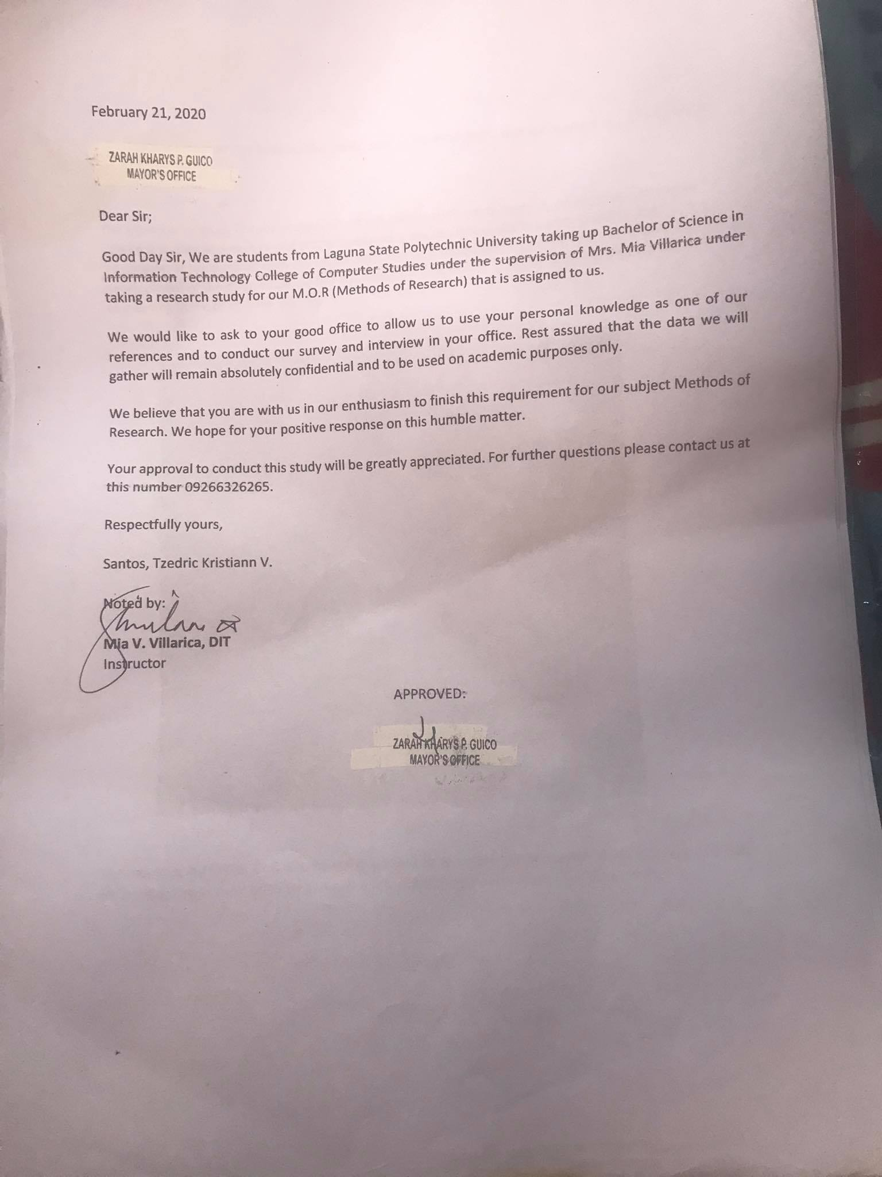

**SUMMARY OF RECOMMENDATIONS**

**Research Colloquium**

**Working Title:** E-Mayor

**Group code: D06**

**Students: Santos, Tzedric Kristiann V.**

**Section BSIT-4D**

**SCHEDULE:** Sunday **December 9**, 2020 **9:00am-9:30am**

Day Date Time

**LOCATION:** Via Gmeet

|  |  |  |
| --- | --- | --- |
| **Panel Member** | **Comments/Recommendations/Suggestions** | **Status** |
| Alliana M. Miranda | 1. Wrong Margin  2. No Page #  3. Follow the APA format  4. Improve RRL  5. No Title in RRL  6. Explain the RRL and how is it connected to the study  7. There are unnecessary info in your RRL remove if it does help your study.  8. Follow the APA format  9. Cut your Paragraphs  10. Research Design is Descriptive Developmental  11. Create a table for the Population | 1. Done 2. Done 3. Done 4. Done 5. Done 6. Done 7. Done 8. Done 9. Done 10. Done 11. Done |
| Maria Laureen B. Miranda | 1. Gawing Scrollable | 1.Done |
| Mark Bernardino | 1. Filter ni Mayor | 1.Done |
| Dr. Rina Arcigal | 1. Indepth Interview - Thematic Saturation based on data not on the population 2. Validity- Item Analysis | 1.Done  2.Done |
| Reynalen C. Justo | Emphasis on the Event Calendar | 1.Done |

Checked by

|  |  |  |
| --- | --- | --- |
| ________________________  Maria Laureen B. Miranda  Panel Member | ________________________  Alliana M. Miranda  Panel Member |  |

|  |  |
| --- | --- |
| ________________________  Dr. Mia Villarica  Panel Member | ________________________  Reynalen C. Justo, MMITM  Panel Member |

|  |  |
| --- | --- |
| ________________________  Dr. Rina Arcigal  Panel Member | ________________________  Mark Bernardino, MSCS  Panel Member |

|  |  |
| --- | --- |
|  |  |
|  |  |

Noted by:

|  |  |
| --- | --- |
| _________________________  Dr. Mia Villarica  Adviser | ______________________________  Reynalen C. Justo, MMITM  Associate Dean |

**Interview Transcript**

On January 23, 2020, the researchers went to Public Information Office located at Sta. Cruz Municipality and talked to the Local Youth Development Officer Sir Cedric Mainit. The researchers conducted the interview to understand the current process of their other front-line services which are (i) Give Assistance to Student and/or Researchers (ii) Reply to Inquires and Give General Information. Figuring out the problems the researchers are looking for enhancement in their current system.

Date of Interview: January 23, 2020

# of Interview: 2

Researcher 1: Jayech Garino

Researcher 2: Tzedric Kristiann V. Santos

Researcher 3: Mark Villanueva

Researcher 4: Ivan Cajano

Client: Public Information Office/

(Start of Interview)

|  |  |
| --- | --- |
| 1. Client | Oh ano, kami kung yan taga send ng info kami naman taga gawa, samin ang craft, saming ang concept, ang pag coconceptualize, samin lahat yun. Pag pag may event usually, ang sasabihin lang sa amin, “Oh pa event ka naman ng valentines”. Kami na ang gagawa ng idea, ng title, ng ng anong klaseng event, logisitics, physical uhhh preparations sa amin din yun. Oh pag plantsado na ang event tiyaka namin ibabato sa public information office para sila na ang mag disseminate ng information. Same goes sa mga projects, pag sinabing oh bababa ko ng barangay, mag isip agad ng title, publication, ganito, ganiyan, ganito. Pag plantsado at meron ng approval, ibaba na sa Public Information Office sila na ulit ang bahala. |
| 1. Researcher 2: | Kayo po, kapag may event, kayo po mag oorganize pagkatapos, pag na organize niyo na kanino niyo po ina announce para makalat. |
| 1. Client | Sa Public Information Office |
| 1. Researcher 2: | *Ah PIO.* |
| 1. Client | Oo, protocol, hindiii pwedeng kami na mag announce ng kami lang. |
| 1. Researcher 2: | Ng PIO? Eh akala ko ba eto ang PIO. |
| 1. Client: | Isang office lang. |
| 1. Researcher 1: | *Isang office lang* |
| 1. Researcher 3: | *Oo, iisang office lang* |
| 1. Researcher 4: | *Isang office lang.* |
| 1. Client: | *Isang office pero ibang division.* |
| 1. Researcher 2: | *Kinakalat ng PIO, ang informatiom. Ay ayun sakto may public ano,* |
| 1. Researcher 1: | *Ayun nga.* |
| 1. Client: | *Sa part din namin,meron kaming, kayo mga studyante gusto niyo magpa event, pero kailangan niyo ng tulong ng local government. Pag communication sa PIO, pero sa pag craftsmanship nung event sa amin.* |
| 1. Researcher 2: | *Ano yun yung mga loan? Ganun?* |
| 1. Client | *Hindi ehe, kung kailangan niyo ng ano, ng money for financial assistance sa event niyo, usually ang ginagawa ng mga student lalapit sa Public Information Office, tapos ang Public Information Office ang liaison, papunta sa mayors office tapos pag okay na iiwanan na kayo ng PIO sa mayors office. Pag yun ang kailangan ah.* |
| 1. Researcher 2: | *Ah liaison lang kayo?* |
| 1. Client | *Hmmhmm. Ano pa? Nangongolect ako sa sa tourism, nangongolekta kami ng data ng mga establishments, ayun ang mahirap.* |
| 1. Researcher 2: | *Ng mga bahay?* |
| 1. Client: | *No, ng mga business establishments.* |
| 1. Researcher 2: | *Ahhh resort uhh* |
| 1. Client: | *Fastfood sales, nangognolekta kami ng data ng dami ng pasok ng tao. Yung mga hotel kinukuhanan ng bilang ng tao per month, sa anong room, sa ganito, sa ganiyan. Para mabilang namin yung bilang ng arriving tourists every quarter.* |
| 1. Researcher 2: | *Ahh mga public establishments.* |
| 1. Client: | *Hmmmm, di lang yun kunwari may event anggg metro central, kunwari nag concert sila. Tapos kailangan din namin kunin ang number of arrivals ng hindi taga sta. Cruz, especially pag anilag, ngayong anilag lahat ng , lahat ngggg taong pumapasok pag hindi taga sta. Cruzzz, considered tourists kasi yun. Kinokolekta namin yung data niya. Sa tourism office din nakikipag coordinate kami sa groups, kunwari uhh religious groups, pag may fiesta, yon, coordination din ng movement* |
| 1. Researcher 4: | *Tulad nuuung parada, ati atihan mga ganun no?* |
| 1. Client: | *Kami din aaang, lumilibot din kami, chinecheck namin kung may bagong usbong na mga tourism destination na pwede naming idevelop. Kunwari may nakita kaming ilog na bago, chinecheck namin yun tapos, tinitignan namin kung pwedeng maging tourist spot. Kami din ang nangangalaga ng mga lumang bahay, lumang establishments,* |
| 1. Researcher 4: | *Heritage.* |
| 1. Client: | *Yes, mga heritage sites, hindi lang mga heritage sites, pati mga puno, pinapalagyan yan ng marking sa national historical commission. Celebrations ng mgaaa local events, commemoration ng mga local e-roads. Nagbibigay din kami ng tama ba ko hmmm, oh eto nag hahanap kami kami din ang naghahanap ng mga awardists ng sta cruz. Excellent sa education sa* |
| 1. Researcher 2: | *Katulad nunggg, parang may nakita ko diyan, batang PBA ba?* |
| 1. Client: | *Oo yon, mga ganon, kami din yon.* |
| 1. Client | *Tiyakaaa, kesong puti ayon kami nag aadjust nun.* |
| 1. Client: | *Chinecheck din namin ang status ng one town one product ng DTI* |
| 1. Researcher 2: | *One?* |
| 1. Client: | *One town, one product. Program yun ng DTI* |
| 1. Researcher 2: | *Kayo po ang nag checheck?* |
| 1. Client: | *Oo, tinitignan namin ang status niya* |
| 1. Client | *Ano pa, ano pa kailangan niyong malaman?* |
| 1. Researcher 1: | *Wala na, yun na lang.* |
| 1. Researcher 4: | *So thats ano na, all it hehehe.* |
| 1. Researcher 1: | *Ehem maraming salamat po. Iaano na lang natin ano* |
| 1. Researcher 4: | *Di pag may ano na lang, kunwari iaapply muna namin to.* |
| 1. Researcher 1: | *Hmmm tiyaka kami babalik sir kapag kaaaa, para maklaklaro ng adviser namin. Kasi yung adviser namin.* |
| 1. Researcher 4: | *Siya mismo yung nagsusuggest ng dun sa website* |
| 1. Researcher 1: | Si ano si mam, si mam mia. |
| 1. Researcher 4: | Yung kausap niii |
| 1. Researcher 1: | Sir thank you po ah. |
| 1. Client | Sigeee |
| 1. Researcher 4: | Thank you boss |
| 1. Researcher 3: | Thank you po |
| 1. Researcher 2: | Thank you po sir. |

*(End of Interview)*

**SUMMARY OF RECOMMENDATIONS**

**Final Oral Defense Recommendation**

**Working Title:** E-Mayor

**Group code: D06**

**Students: Santos, Tzedric Kristiann V.**

**Section BSIT-4D**

**SCHEDULE:** Monday **February 8**, 2020 **9:00am-9:30am**

Day Date Time

**LOCATION:** Via Gmeet

|  |  |  |
| --- | --- | --- |
| **Panel Member** | **Comments/Recommendations/Suggestions** | **Status** |
| Alliana M. Miranda | 1. Vision, Mission page must only be 1 page  2. Acknowledgement should be in singular and 1 page only/  3. Abstract is 250 words only  4. Definition of term must be in 2 columns  5. Margin and figure description of conceptual framework  6. Remove Page # at the start of every chapter  7. There are still some RRL that is not yet explained  8. Avoid using too much “ According to” or “This is supported by”  9. Page 28, 29 has highlighted and not in APA format  10. Page 30, 31 please follow the APA Format.  11. Improve RRL and Synthesis  12. Table format must have titles  13. Overpopulation na yung respondents mo. Mas marami ang accessible sa population  14. Introduce the purpose of table 2.  15. Figure desciription format  16.Table 4-7 format  17. Chapter 4 figure description, please correct.  18. Please have a formal picture of your IT Testers, also have their credentials. | 1. Made the vision and mission page into 1 page.  2. Made the acknowledgement page into singular and into 1 page.  3. Made the abstract only 250 words long.  4. Definition of terms made in 2 columns  5. Resized the conceptual framework and the figure description.  6. Covered the page number by a white blank picture.  7,8,9,10,11 Improved the RRL and Synthesis, Added the APA Format, limited the use of according to and this is supported by, explained the RRL that is not yet explained.  12. Table format used and added titles.  13. Fixed the respondents  14. Introduced the purpose of table 2  15. Used the figure description format  16. Fixed the format of table 4-7  17. Corrected the chapter 4 description  18. Used formal picture of the Testers. |
| Maria Laureen B. Miranda | N/A | N/A |
| Mark Bernardino | 1. Automated | 1. The researcher has gone to the client to discuss the suggestion but it was advised by the secretary Zarah Guico to don’t put in an automated system because it would be more convenient if she can manipulate the system herself. |
| Dr. Rina Arcigal | 1. Ayusin yung computations ng STD. | 1. Recomputed the computations of the mean and STD. |
| Reynalen C. Justo | N/A | N/A |

Checked by:

|  |  |  |
| --- | --- | --- |
| ________________________  Maria Laureen B. Miranda  Panel Member | ________________________  Alliana M. Miranda  Panel Member |  |

|  |  |
| --- | --- |
| ________________________  Dr. Mia Villarica  Panel Member | ________________________  Reynalen C. Justo MMITM  Panel Member |

|  |  |  |
| --- | --- | --- |
| ________________________  Mark Bernardino, MSCS  Panel Member | ________________________  Dr. Rina J. Arcigal  Panel Member |  |

|  |  |
| --- | --- |
|  |  |
|  |  |

Noted by:

|  |  |
| --- | --- |
| _________________________  Dr. Mia Villarica  Adviser | ______________________________  Reynalen C. Justo, MMITM  Associate Dean |

**APPENDICE C**



**PROFILE**

**My purpose in life is to deliver value and innovation to my fellowmen. I constantly strive to perfect my craft and pursuit long term goals that would uplift the lives of the people around me. And I believe that technology should be an ally to improve and not replace the lives of people.**

**PERSONAL INFORMATION**

**Age :** 25

**Birth date :** Feb 13, 1996

**Height :** 5’8 ft’

**Weight :** 85 kgs.

**Citizenship :** Filipino

**Civil Status :** Single

**Religion :** Roman Catholic

**EDUCATIONAL BACKGROUND**

**PRIMARY: PASIG CATHOLIC COLLEGE (2002-2008)**

**SECONDARY: PASIG CATHOLIC COLLEGE (2008-2012)**

**TERTIARY: Laguna State Polytechnic University** Main Campus, Santa Cruz, Laguna

Bachelor of Science in Information Technology **(Current)**

**Far Eastern University (2012-2016)**

**Santos, Tzedric Kristiann V.**

01 Guerrero Street, Brgy. Wawa Taguig City

Contact No: 09274592610

Email Add: zedrics21@gmail.com

**CAREER OBJECTIVE**

Seeking for a challenging work where I can contribute my skills and knowledge in a renowned organization in the field of Information Technology that provides opportunities for professional growth.

**SPECIAL SKILLS**

* Hard working and fast learner
* Computer Literacy (MS Word, MS PowerPoint, MS Excel)
* Multimedia Applications (Photography, Editing etc.)
* Computer Hardware/Software Troubleshooting
* Computer Networking
* Network Troubleshooting
* Basic Autocad
* Sketch Up

**SEMINARS AND TRAININGS ATTENDED**

* 18th Youth for Information Technology via Zoom Meeting **(November 21, 2020. December 5 and 12, 2020)**
* CTRL + ALT + DELETE: Data Privacy and Information Security Awareness for Remote Learning via Webinar **(November 21, 2020)**

**WORK EXPERIENCE**

* N/A

**REFERENCES**

* Reynalen C. Justo MM-ITM

*Associate Dean, College of Computer Studies LSPU SCC*

* Mia V. Villarica D.I.T

*Adviser, College of Computer Studies LSPU SCC*

**Contact number: +639175039034**

* Mr. John Rosh Birador –

*Software Developer APEC Homes*

**Contact number: +63 926 953 1425**

*I hereby certify that the above information is true and correct to the best of my knowledge and belief.*

**Santos, Tzedric Kristiann V.**

Applicant’s Signature

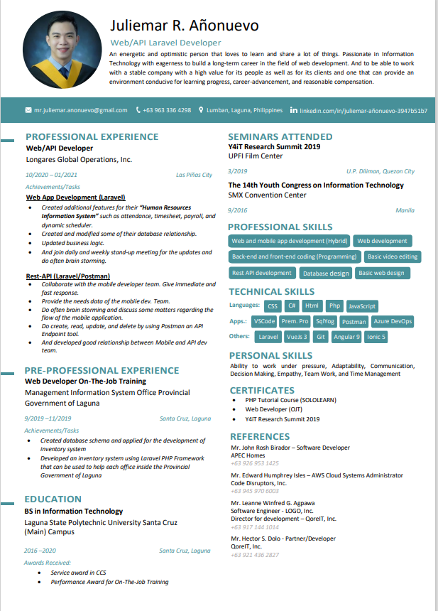**CURRICULUM VITAE OF THE SYSTEM EVALUATORS**

